Name: Date:

ECG Lab
Last updated: 10/18/22

Part 1: Introduction
An ECG (or EKG) is a noninvasive method of measuring the heart’s __________ during the cardiac cycle.

- Name two things doctors can see in an ECG that can help them figure out whether a patient’s heart rate is normal or abnormal, and whether the heart is pumping in a coordinated and efficient manner.

- A single round of the cardiac cycle shows 3 main waves. They include:

Part 2: Heart Conduction System Discussion Questions
- Launch Physiology & Pathology.
- Navigate to the Cardiovascular unit. Under Physiology select 6. Heart Conduction. Read about how the cardiac conduction system delivers electrical impulses to the heart and stimulates contractions.

- Trace the path that electrical impulses take in order to contract and relax the heart. Number the structures below by the order in which the impulse travels.

____ Atrioventricular (AV) node

____ Sinoatrial (SA) node

____ Atrioventricular bundle (bundle of His)

____ Purkinje fibers

____ Right and left bundle branches

- In the image below, label the components of the cardiac conduction system. (Note: The atrioventricular bundle is not visible in this image.)

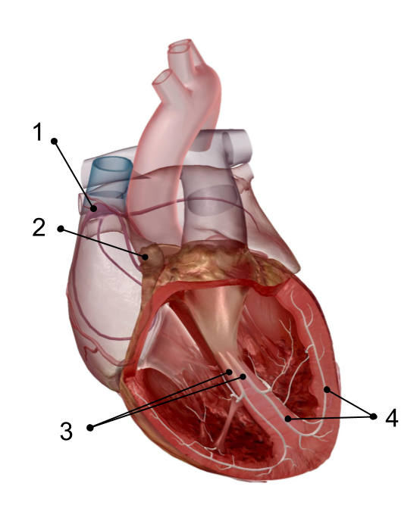

Part 3: Cardiac Cycle
- In the Cardiovascular unit of the app, under Physiology select 5. Cardiac Cycle. Read about the rhythmic sequence of myocardial contractions and relaxations stimulated by the conduction system.

- The cardiac cycle includes all blood flow events the heart accomplishes in one complete heartbeat.
- Describe the events that occur during ventricular diastole.

- Describe the events that occur during ventricular systole.

- Describe the events that occur during atrial diastole.

- Describe the events that occur during atrial systole.

Part 4: Components of an ECG
- Review the ECG waves and intervals (or segments) that measure the cardiac conduction system’s electrical activity using the “Decoding the Heart: What is an ECG?” blog post.

- Using the knowledge you’ve gained, match the following terms to the appropriate description:

____ P wave
____ PR interval
____ QRS wave complex
____ ST interval
____ T wave

a. The wave caused by ventricular depolarization.
b. The time between the P wave and the start of the QRS complex.
c. The wave caused by depolarization of the atria.
d. The time between the QRS complex and the start of the T wave.
e. The wave caused by ventricular repolarization.

- Label the ECG components in the image below.
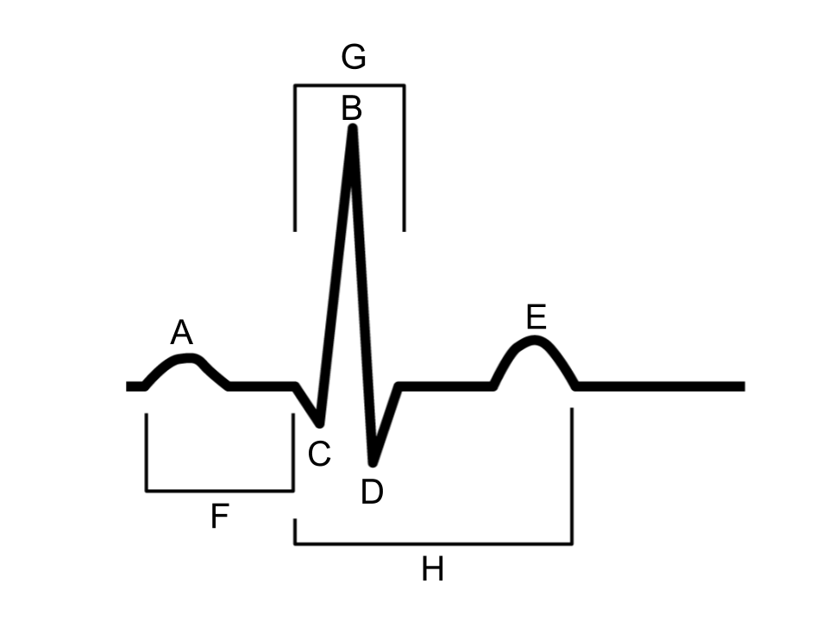

Part 5: ECG Discussion Questions
- Navigate to the Cardiovascular unit in the app. View the different cardiovascular conditions in the Pathology section.

- What conditions might a medical professional be able to diagnose from looking at an ECG?

- Atrial fibrillation is an arrhythmia in which the atria beat irregularly. Where in an ECG would you expect to see a discrepancy caused by this condition?

