Name: Date:

Biology Lab Activities: Human Body (Tissues)

Background Questions

As you’ve learned in class and in your textbook, there are four main types of tissues that make up the human body. Answer the following questions on epithelial, connective, muscle, and nervous tissues.

- Where in the body would you find epithelial tissue?

- What are the six types of connective tissue found in the body?

- What are the three types of muscle tissue found in the body?

- What are the two main types of cells in nervous tissue?

Name: Date:
Lab 1: Epithelial Tissue

Activity 1: Explore the types of epithelial tissue

There are several types of epithelial tissue. Simple (one cell layer) and stratified (multiple cell layers) epithelial tissues cover body surfaces and line tissues and organs. Epithelial tissue is also found in exocrine and endocrine glands. (For more information on epithelial tissue, you can read this OpenStax page: https://openstax.org/books/anatomy-and-physiology/pages/4-2-epithelial-tissue)

Part A: Simple Epithelium

Simple epithelium has one cell layer. Based on the shape of its cells, it can be classified as simple squamous, simple cuboidal, simple columnar, or pseudostratified columnar epithelium.

The following illustration shows the types of simple epithelium and an example of where each type is located in the body. Use this illustration to answer the questions on simple epithelial tissue.

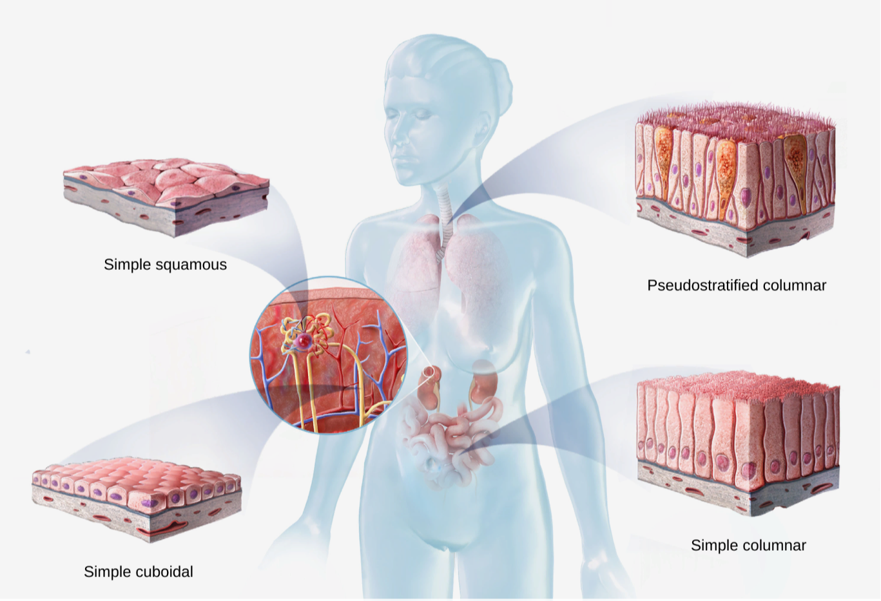

- Based on the simple epithelium illustration, match each type of epithelium with where you’d find it in the body.

Types of Simple Epithelium:
  - Simple squamous epithelium
  - Simple cuboidal epithelium
  - Simple columnar epithelium
  - Pseudostratified columnar epithelium

Locations in Body:
___ Lining the upper respiratory tract (including the trachea) and male
reproductive ducts
___ Lining the renal glomeruli, lung alveoli, heart, circulatory and lymphatic
vessels, and ventral body cavity
___ Lining the digestive tract (including the small intestine), gallbladder, gland
excretory ducts, small bronchi, uterine tubes, and parts of the uterus
___ In the renal collecting tubules, ducts and secretory parts of small glands,
and surface of the ovaries
- All simple epithelia have one cell layer, but they vary in terms of cell shape. Based on what you’ve observed from the simple epithelium illustration, complete the following table to identify the shape of the cells in each type of simple epithelium.

Type of Simple Epithelium | Cell Shape
Simple Squamous
Simple Cuboidal
Simple Columnar
Pseudostratified Columnar

- Based on what you’ve learned about the cell shape and location in the body, match each of the following types of simple epithelium with its function.

Types of Simple Epithelium:
  - Simple squamous epithelium
  - Simple cuboidal epithelium
  - Simple columnar epithelium
  - Pseudostratified columnar epithelium

Functions:
___ The ciliated type facilitates mucus secretion and movement, and the
non-ciliated type facilitates nutrient absorption.
___ It facilitates absorption or secretion of materials into ducts or tubes.
___ The ciliated type facilitates mucus secretion and the removal of foreign
particles, and the non-ciliated type facilitates propulsion of sperm.
___ It facilitates the diffusion or filtration of gases and small molecules into
organs and vessels.

Part B: Stratified Epithelium

Stratified epithelium has multiple cell layers. Based on the shape of the cells on its apical surface, it can be classified as stratified squamous, stratified cuboidal, stratified columnar, or transitional epithelium.

The following illustration shows the types of stratified epithelium and an example of where each type is located in the body. Use this illustration to answer the questions on stratified epithelial tissue.

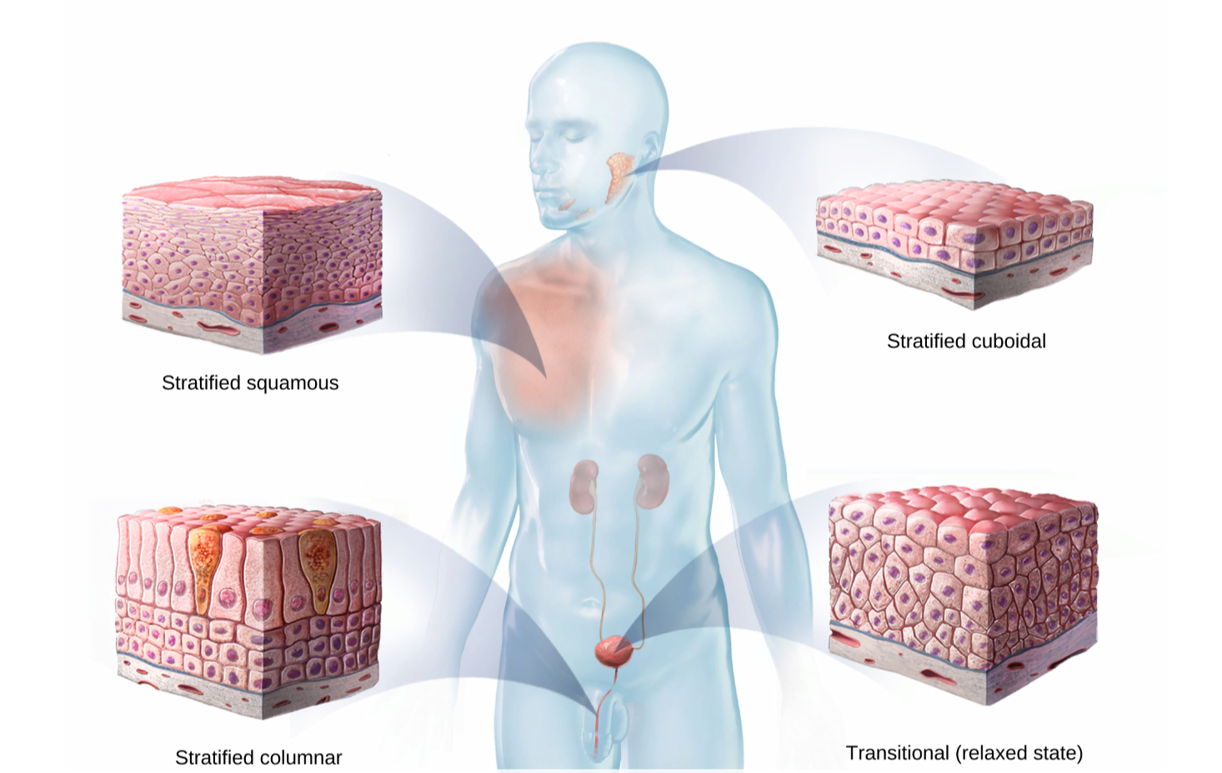

- Based on the stratified epithelium illustration, match each type of epithelium with where you’d find it in the body.

Types of Stratified Epithelium:
  - Stratified squamous epithelium
  - Stratified cuboidal epithelium
  - Stratified columnar epithelium
  - Transitional epithelium

Locations in Body:
___ Lining the bladder, ureters, and part of the urethra
___ In the epidermis of the skin, and lining the esophagus, mouth, vagina,
and cornea
___ In the male urethra, pharynx, and lining some glandular ducts
___ Lining the salivary, sweat, and mammary gland ducts

- All stratified epithelia have multiple cell layers, but they vary in terms of apical (surface) and basal (base or bottom layer) cell shape. Based on what you’ve observed from the stratified epithelium illustration, complete the following table to identify the shape of the apical and basal cells in each type of stratified epithelium.

Type of Simple Epithelium | Apical (Surface) Cell Shape | Basal (Base) Cell Shape
Stratified Squamous
Stratified Cuboidal
Stratified Columnar
Transitional

- Based on what you’ve learned about the cell shape and location in the body, match each type of stratified epithelium with its function.

Types of Stratified Epithelium:
  - Stratified squamous epithelium
  - Stratified cuboidal epithelium
  - Stratified columnar epithelium
  - Transitional epithelium

Functions:
___ It protects large gland ducts from abrasion by the materials passing through them.
___ It flattens to allow organs to expand or distend as they fill with urine.
___ It protects certain tubes and facilitates secretion.
___ It protects underlying structures from abrasion.

- Based on what you’ve learned about simple and stratified epithelial tissue and where they’re located in the body, what are the advantages of having one layer of epithelial cells and what are the advantages of having multiple layers of epithelial cells?

Name: Date:
Lab 1: Epithelial Tissue

Activity 2: Explore the structure and functions of skin

Refer to the following skin illustration and answer the questions about the three layers of the skin and their functions.

- Match the numbered labels in the skin image below to the list included here:
  - Fill in the blanks to label the structures from the list below.

Word List:
Dermis ___
Epidermis ___
Hypodermis ___

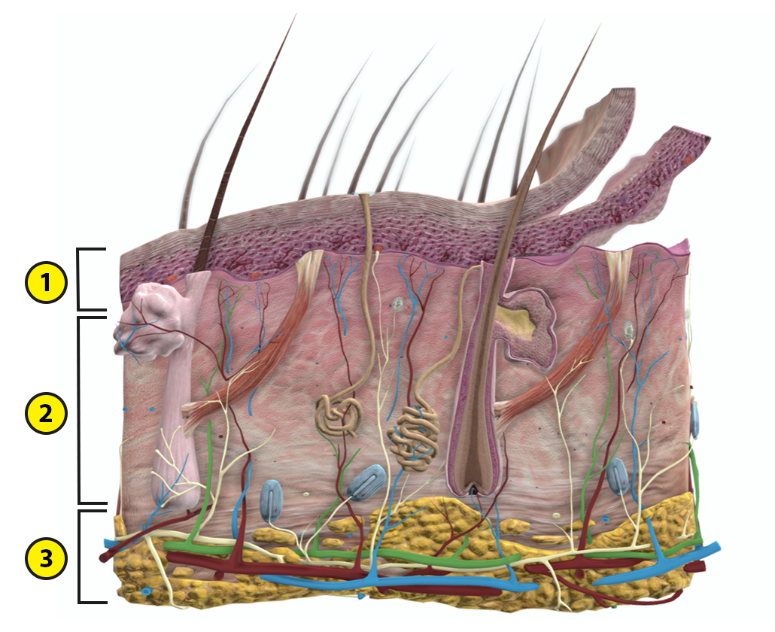

- The epidermis is the ___________ skin layer. It is composed of _______________________ epithelium, which can consist of four or five cell layers, depending on its location in the body.
  - What is the main function of the epidermis?

- The dermis is the ____________ skin layer, and it consists of papillary and reticular regions that are composed of different types of connective tissue.
  - What is the main function of the dermis?

- The hypodermis is the _______________ skin layer, and it consists of adipose (fat) tissue and connective tissue.
  - What is the main function of the hypodermis?

Name: Date:
Lab 2: Connective Tissue

Activity 1: Explore the types of connective tissue

There are several types of connective tissue in the body. Most types of connective tissue consist of cells in an extracellular matrix of amorphous ground substance and collagen, elastic, or reticular fibers. The two exceptions are blood and lymph, atypical connective tissues that have a fluid matrix and no fibers.

Part A: Loose and Dense Connective Tissues

The two main types of connective tissue are loose and dense connective tissues. Loose connective tissue has loosely arranged fibers and abundant ground substance, whereas dense connective tissue has tightly arranged fibers and a very small amount of ground substance. (For more information about connective tissues, you can read this OpenStax page: https://openstax.org/books/anatomy-and-physiology/pages/4-3-connective-tissue-supports-and-protects)

Answer the following questions about loose and dense connective tissues.

- There are three types of loose connective tissue: areolar, adipose (fat), and reticular tissues. There are two types of dense connective tissue: dense regular and dense irregular tissues. Match each type of loose and dense connective tissue with where you’d find it in the body.

Types of Connective Tissue:
  - Areolar tissue
  - Adipose (fat) tissue
  - Reticular tissue
  - Dense regular tissue
  - Dense irregular tissue

Location in Body:
___ In the lymph nodes, bone marrow, and spleen
___ In the papillary dermis of the skin
___ In the reticular dermis of the skin and surrounding organs and joints
___ In tendons and ligaments
___ In the hypodermis of the skin, around internal organs, and in the breasts

- Based on the structure and location of loose and dense connective tissues, what are their functions?

Part B: Connective Tissues of the Skeletal System

The skeletal system is composed of dense regular connective tissue (tendons and ligaments) and two special connective tissues, bone and cartilage, which have a very rigid matrix of tightly bound fibers.

Refer to the Overview of Skeleton (https://www.visiblebody.com/learn/skeleton/overview-of-skeleton) and Joints and Ligaments (https://www.visiblebody.com/learn/skeleton/joints-and-ligaments) articles on the Visible Body Learn Site to answer the following questions about the structure and functions of the connective tissues in the skeletal system.

- Match each of the following types of skeletal connective tissue with its description.

Skeletal Connective Tissues:
  - Bones
  - Ligaments
  - Cartilage
  - Tendons

Descriptions:
___ Strong and flexible tissue that provides cushioning between bones and can
withstand tension and compression
___ Bands of dense and fibrous tissue that attach bone to bone and limit movement
at joints to prevent injury
___ Bands of flexible and fibrous tissue that attach skeletal muscle to bone and help
control movements at joints
___ Composed of the hardest type of connective tissue, they support the body,
provide levers for muscle actions, and store calcium, other minerals, and fat

Part C: Atypical Connective Tissues

Blood and lymph are atypical connective tissues that circulate throughout the blood and lymphatic vessels of the body. These tissues are considered to be atypical because they have a fluid matrix and no fibers.

Refer to the Functions of Blood article on the Visible Body Learn Site (https://www.visiblebody.com/learn/circulatory/circulatory-functions-of-the-blood) to answer the following questions about blood, the most commonly discussed fluid connective tissue.
- Why is blood considered to be a fluid connective tissue instead of just a fluid?

- In 2–3 sentences, explain how blood acts as a connective tissue.

Name: Date:
Lab 3: Muscle Tissue

Activity 1: Compare skeletal, smooth, and cardiac muscle

Refer to the Overview of the Muscular System (https://www.visiblebody.com/learn/muscular/muscular-overview) and
Muscle Tissue Types (https://www.visiblebody.com/learn/muscular/muscle-types) articles on the Visible Body Learn Site to answer the following questions about skeletal, smooth, and cardiac muscle.

- What is the basic function of all muscles?

- Some muscles are voluntary and others are involuntary. What is the difference between these types of muscle?

- Match each type of muscle tissue with its brief description.

Muscle Tissues:
  - Skeletal muscle
  - Smooth muscle
  - Cardiac muscle

Descriptions:
___ Non-striated muscle that contracts involuntarily
___ Striated muscle that contracts involuntarily
___ Striated muscle that contracts voluntarily

- Skeletal muscle facilitates body movements. For more information on skeletal muscle, you can read the following articles on the Visible Body Learn Site: Muscle Attachments and Actions (https://www.visiblebody.com/learn/muscular/muscle-movements) and Muscle Contractions (https://www.visiblebody.com/learn/muscular/muscle-contractions.)

Based on the articles listed above and the following skeletal muscle image, complete the following sentences on the structure and functions of skeletal muscles.

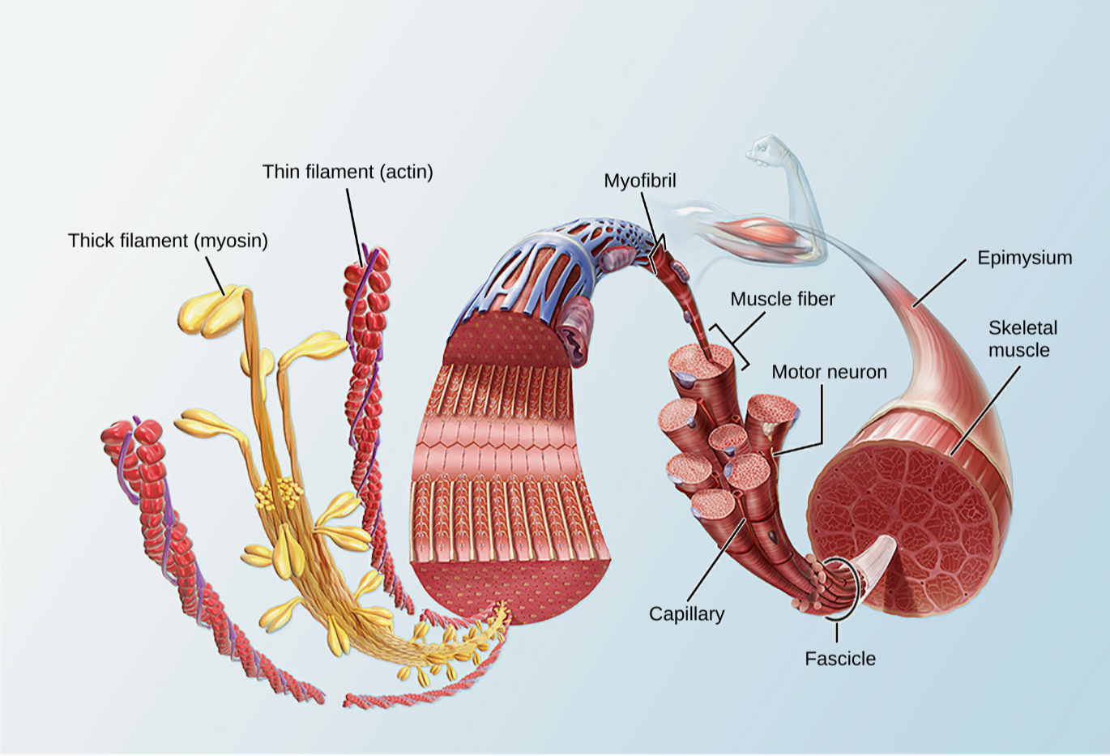

  - Skeletal muscle tissue consists of muscle fibers that are grouped into bundles called _______________.
  - Each muscle fiber contains several myofibrils, long paired chains of thick and thin filaments organized into repeating segments called sarcomeres. The thick filaments are composed of ____________ protein molecules, and the thin filaments are composed of ___________ protein molecules.
  - Skeletal muscles attach to ___________, other muscles, or connective tissues such as ligaments. These muscles attach to these structures at _________________ places.
  - Circle the correct answers in the following sentence. When a skeletal muscle contracts/relaxes, the attachment points are pulled closer together, and when it contracts/relaxes, the attachment points move apart.
  - Muscle contractions occur when messages travel from ____________________ to muscles and trigger chemical reactions. These reactions change the internal structures of muscle fiber cells, ________________ the muscle.

- Smooth muscle tissue is found in the walls of many hollow organs throughout the body. It helps these organs move to facilitate body functions. Answer the following questions on smooth muscle.

  - Where is smooth muscle found in the body?

  - In 3–5 sentences, describe how smooth muscle functions in the alimentary canal, the urinary bladder, artery walls, and the eye.

- Cardiac muscle is responsible for creating the heart’s pumping action. Answer the following questions on cardiac muscle.

  - Where is cardiac muscle found?

  - Cardiac muscle cells, called cardiocytes, are branched and connected to each other by intercalated discs. This structure allows for ___________________ contraction, which maintains a constant heart rate.

Name: Date:
Lab 4: Nervous Tissue

Activity 1: Explore neurons and neuroglia

Nervous tissue is composed of two types of cells: neurons and neuroglia. Refer to the Neurons article on the Visible Body Learn Site (https://www.visiblebody.com/learn/nervous/neurons) to answer the following questions about neurons and neuroglia.

- Nervous system functions are driven by electrical signals sent through neurons, which receive and transmit sensory signals and motor commands. In the following neuron image, label each of the parts in the word list.

Word List:
Axon ___ Axon terminal ___ Soma ___
Axon hillock ___ Dendrites ___

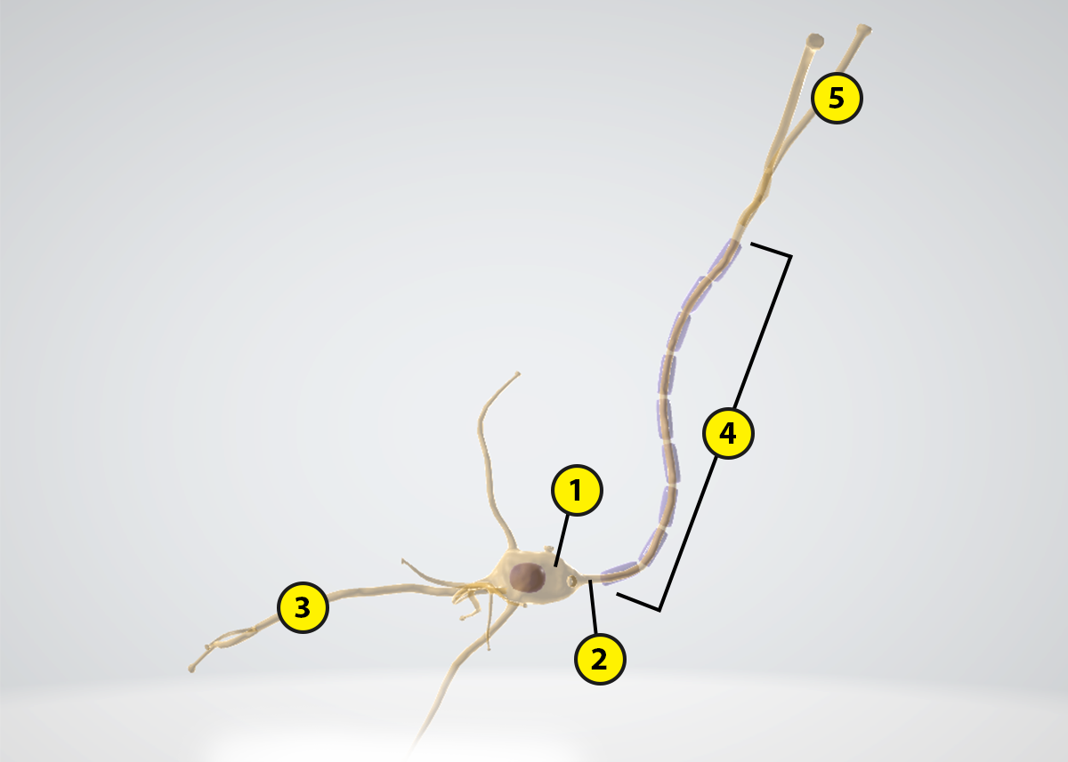

- Refer to your labeled neuron image to match each of the following parts of a neuron with its description.

Neuron Parts:
  - Soma
  - Dendrites
  - Axon
  - Axon terminal
  - Axon hillock

Descriptions:
___ A structure that releases neurotransmitters, chemicals that have an excitatory or
inhibitory effect on their target (another neuron, a muscle fiber, or
a gland cell)
___ The cell body, which contains a nucleus and organelles
___ A long, thin, cylindrical nerve process that generates nerve impulses
___ A structure that initiates action potentials
___ Short, tapering, and branched nerve processes that receive chemical signals
from other neurons and transmit them toward the cell body

- Nervous tissue is composed of __________ matter, which consists of neuron cell bodies, and ___________ matter, which consists of myelinated axons.

- Neuroglia support neurons and other structures that supply and surround nervous tissue. Some of them, including Schwann cells, form myelin sheaths around axons. What is the function of these myelin sheaths?

