Name: Date:

Biology Lab Activities: Human Body (Musculoskeletal System)

Background Questions

Read through the Overview of the Skeleton article on the Visible Body Learn Site (https://www.visiblebody.com/learn/skeleton/overview-of-skeleton).

Based on what you’ve learned in class, in your textbook, and from the Learn Site article, answer the following questions about the musculoskeletal system.

- What are the general functions of the skeletal system?

- What type of muscle attaches to bones via tendons to move the body?

- How is the nervous system involved in musculoskeletal movements?

- What is the name for a place where two bones meet?

- Besides muscles, there are three types of connective tissue that help join bones together. Complete the following sentences to identify them.
  - _______________ are fibrous bands that connect bone to bone.
  - _______________ are fibrous bands that connect muscle to bone.
  - _______________ is a protective covering that prevents friction at joints.

Name: Date:
Lab 1: The Musculoskeletal System and Body Movements

Activity 1: Label a skeletal muscle

- Read the skeletal muscle section of the Muscle Tissue Types article on the Visible Body Learn Site (https://www.visiblebody.com/learn/muscular/muscle-types).
- Match the numbered labels in the image below to the list included here:
  - Explore the skeletal muscle image to find the structures you need to label.
  - Fill in the blanks to label the structures from the list below.

Word List:
Capillary ___ Motor neuron ___
Fascicle ___ Muscle fiber ___

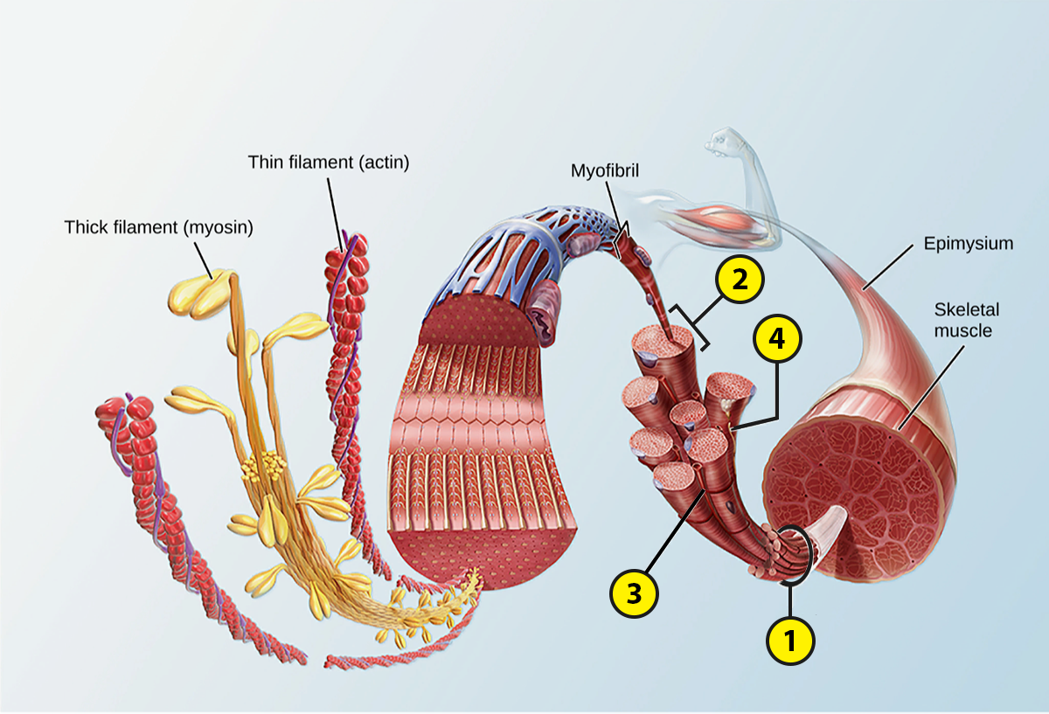

Name: Date:
Lab 1: The Musculoskeletal System and Body Movements

Activity 2: Explore the structure and functions of skeletal muscle

Skeletal muscle facilitates body movements. Refer to your labeled skeletal muscle image from Activity 1, as well as the Overview of the Muscular System (https://www.visiblebody.com/learn/muscular/muscular-overview), Muscle Attachments and Actions (https://www.visiblebody.com/learn/muscular/muscle-movements), and Muscle Contractions (https://www.visiblebody.com/learn/muscular/muscle-contractions) articles on the Visible Body Learn Site, to answer the following questions about the structure and functions of skeletal muscles.

- Complete the following sentences on the structure of skeletal muscles.
  - Skeletal muscle tissue consists of muscle fibers that are grouped into bundles called _______________.
  - Each muscle fiber contains several myofibrils—long paired chains of thick and thin filaments organized into repeating segments called sarcomeres. The thick filaments are composed of ____________ protein molecules, and the thin filaments are composed of ____________ protein molecules.

- Skeletal muscles attach to bones, other muscles, or connective tissues such as ligaments at two or more places. What are these attachment points called?

  - Complete the following sentence about these attachment points. The ______________ point is immobile and the ______________ point moves during a muscle action.

- Circle the correct answers in the following sentence. When a skeletal muscle contracts/relaxes, the attachment points are pulled closer together, and when it contracts/relaxes, the attachment points move apart.

- Muscles move the body in a series of paired muscle actions, such as flexion and extension. Match each of the following muscle actions with its brief description.

Muscle Actions:
  - Flexion
  - Extension
  - Abduction
  - Adduction
  - Pronation
  - Supination

Descriptions:
___ Moving a limb toward the body’s midline
___ Bending a limb to decrease the angle between two bones
___ Rotating the forearm so the palm is facing forward or up
___ Moving a limb away from the body’s midline
___ Rotating the forearm so the palm is facing backward or down
___ Straightening a limb to increase the angle between two bones

- In muscle actions, each muscle can be classified based on the role it plays in the action. Match each of the following classifications with its description.

Classifications:
  - Prime mover (agonist)
  - Antagonist
  - Synergist
  - Stabilizer

Descriptions:
___ Provides resistance or reverses the movement of the muscle action
___ Keeps bones immobile when needed
___ Provides the main force that drives the muscle action
___ Assists in carrying out the muscle action

- Complete the following sentences about how muscle contractions occur.
  - The nervous system generates an ______________________.
  - This signal travels through a motor neuron, which releases the neurotransmitter ___________________ into the ___________________________, the place where the neuron and muscle fiber meet.
  - The neurotransmitter causes an influx of ____________ ions into the muscle fiber, causing the release of stored _____________ ions to diffuse into the muscle fiber.
  - The presence of these ions causes the long chains of _______________ in the muscle fibers to interact with each other, leading to the shortening of the sarcomeres and the _______________ of the muscle.

Name: Date:
Lab 2: Joints

Activity 1: Explore the types of joints

When two bones meet, they form a joint. Refer to the Joints article on the Visible Body Learn Site (https://www.visiblebody.com/learn/skeleton/joints-and-ligaments) to answer the following questions on the different types of joints.

- Joints can be grouped based on their range of motion. Some joints have no movement, some have little movement, and some have full movement. Match the following joints with their range of motion.

Joints:
  - Elbow, shoulder, and ankle joints
  - Joint between the tibia and fibula and the pubic symphysis
  - Skull sutures, articulations between the teeth and the mandible, and the joint between the first pair of ribs and the sternum

Range of Motion:
___ Little movement
___ No movement
___ Full movement

- Joints can also be grouped into three types, based on their structure. What are they?

Name: Date:
Lab 2: Joints

Activity 2: Explore the types of synovial joints and how they move

Synovial joints are found throughout the body and they have the widest range of motion. Refer to the Joints article on the Visible Body Learn Site (https://www.visiblebody.com/learn/skeleton/joints-and-ligaments) to answer the following questions on the types of synovial joints and how they move.

- Synovial joints are characterized by the presence of _________________________ between the two joined bones. Bone surfaces at synovial joints are protected by a coating of _________________________.

- What structures support and reinforce synovial joints by limiting movement to prevent injury?

- Match the numbered labels in the image below to the list included here:
  - Explore the synovial joints image to find the joint types you need to label.
  - Fill in the blanks to label the structures from the list below.

Word List
Ball and socket ___ Hinge ___
Condyloid ___ Pivot ___
Gliding ___ Saddle ___
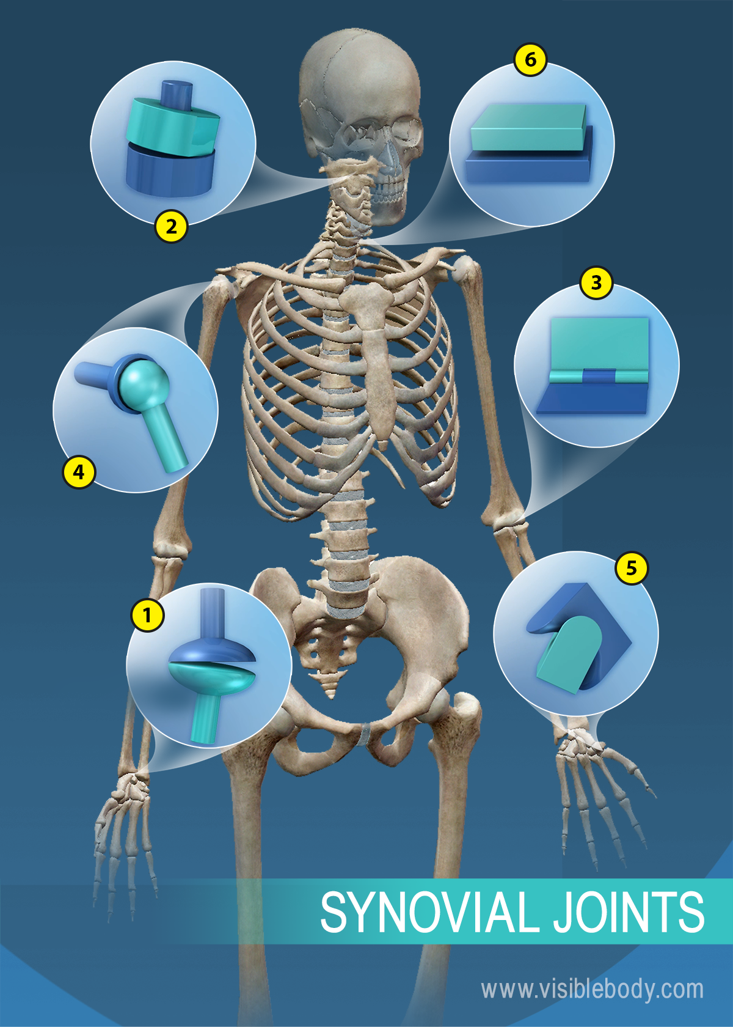

- Complete the following table on the range of movements and examples of each type of synovial joint.

Type of Joint | Movements | Examples
Gliding joints | Move against each other on a single plane | Intervertebral joints and wrist and ankle joints
Hinge joints
Pivot joints
Condyloid joints
Saddle joints
Ball-and-socket joints

