Name: Date:

Biology Lab Activities: Human Body (Digestion and Excretion)
Last updated: 11/1/22

Background Questions

Read the Digestive System Overview article on the Visible Body Learn Site and explore the 3D model of the small intestine. Use what you’ve learned to answer the following questions.

- Where does digestion begin?

- What is a bolus?

- Food is moved through the digestive system by way of involuntary smooth muscle contractions called _______________.

- What is chyme and where is it created?

- Where does most nutrient absorption occur?

- Nutrients absorbed from chyme are passed into the _________________.

- Where is indigestible waste compacted?

Name: Date:

Lab 1: Digestive System Overview

Activity 1: Label the key structures of the digestive system

- Review the Digestive System Overview article and read the Digestive System Glossary on the Visible Body Learn Site.

- Label the digestive structures in the head and neck by matching the numbered labels in the image below to the list included here.
  - Explore this 3D model of the oral cavity in your browser or in AR to find the structures you need to label.
  - Fill in the blanks to label the structures from the list.

Word List
Esophagus
Oral cavity
Salivary glands
Tongue
___
___
___
___

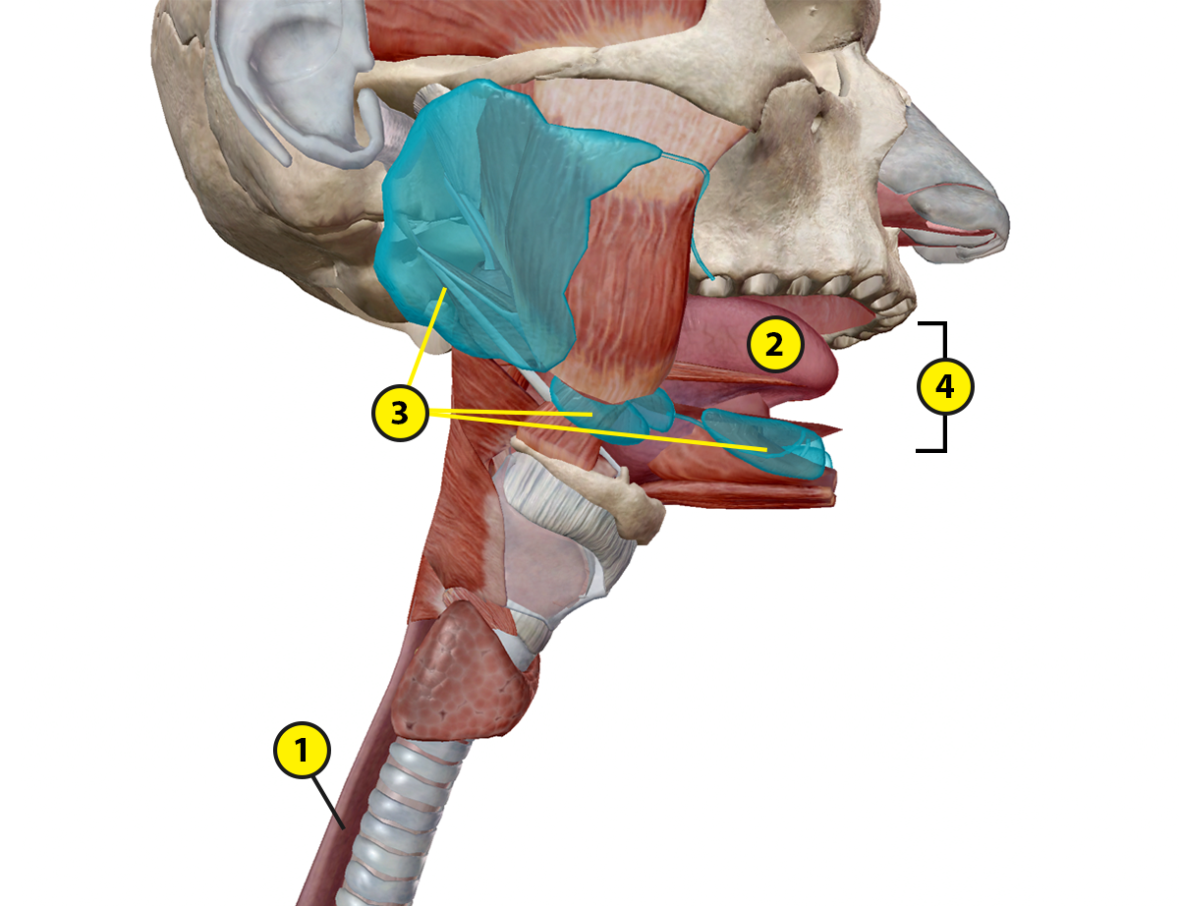

- Label the digestive structures in the abdomen and pelvis by matching the numbered labels in the image below to the list included here.
  - Explore the 3D model of the lower digestive structures in your browser or in AR to find the structures you need to label.
  - Fill in the blanks to label the structures from the list.

Word List:
Anal canal
Large intestine
Rectum
Small intestine
Stomach
___
___
___
___
___

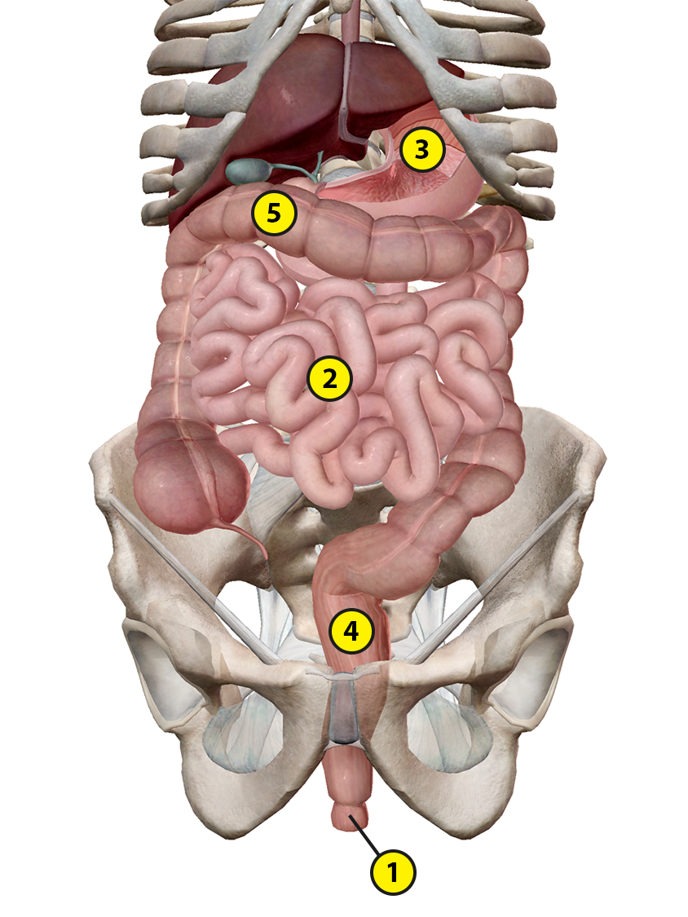

Name: Date:

Lab 1: Digestive System Overview

Activity 2: Explore the functions of digestive system structures

Refer to your labeled digestive system image from Activity 1 and use what you’ve learned from the Learn Site article and glossary to match each of the following structures with its description.

Structures:
- Anal canal
- Epiglottis
- Esophagus
- Large intestine
- Oral cavity
- Salivary glands
- Small intestine
- Stomach
- Tongue
- Rectum

Descriptions:
___ Structures that secrete saliva to aid in chewing and swallowing of the bolus,
beginning chemical digestion
___ A structure that contains the teeth, tongue, and hard and soft palates
___ A muscular organ that mixes food in the oral cavity and works with the teeth to
break down food into small masses that can be swallowed
___ A long, hollow, muscular tube that extends from the pharynx to the stomach
___ A structure that prevents choking by folding down to close off the larynx and
trachea, directing the bolus into the esophagus
___ A structure that has four regions and three muscle layers, provides food storage,
and breaks down ingested food into chyme
___ The final segment of the large intestine, which primarily stores and expels solid
waste
___ A structure, located at the distal end of the rectum, that extends to the anus and
temporarily stores solid waste that’s ready to be eliminated from the body
___ A structure that has three regions: the duodenum, jejunum, and ileum
___ A structure—composed of the colon, cecum, appendix, rectum, and anal
canal—that carries out the final phases of digestion, absorption, and elimination
Name: Date:

Lab 2: Accessory Organs of the Digestive System

Activity 1: Label the accessory digestive organs

- Read the Accessory Organs article on the Visible Body Learn Site.

- Match the numbered labels in the image below to the list included here:
  - Explore the 3D model of the liver in your browser or in AR to find the structures you need to label.
  - Fill in the blanks to label the structures from the list below.

Word List:
Common bile duct
Common hepatic duct
Cystic duct
Gallbladder
Liver
Pancreas
___
___
___
___
___
___

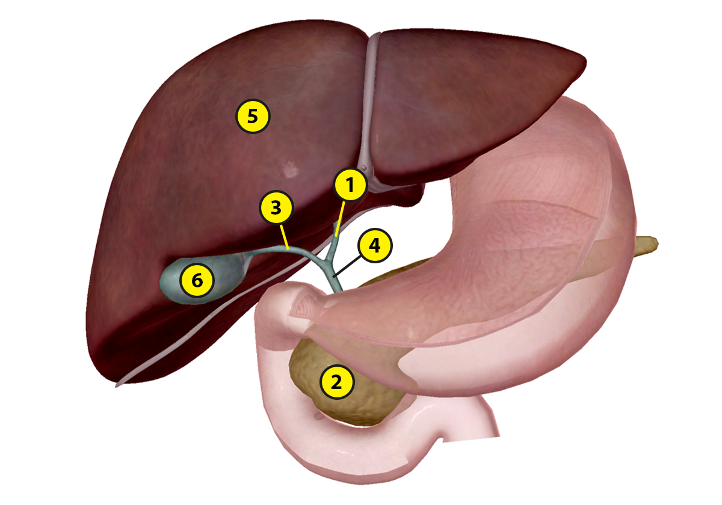
Name: Date:

Lab 2: Accessory Organs of the Digestive System

Activity 2: Explore the functions of the accessory digestive organs

Refer to your labeled accessory digestive organs image from Activity 1 and use what you’ve learned from the Digestive System Glossary on the Visible Body Learn Site to answer the following questions.

- The liver secretes ________ to emulsify ________ in the small intestine.

- If bile is not needed immediately for digestion, it flows up the cystic duct into the _______________. When necessary, this organ releases bile into the duodenum of the _________ intestine.

- What does the pancreas produce and secrete into the small intestine?

- What is the endocrine role of the pancreas?

Name: Date:

Lab 3: Digestion, Absorption, and Elimination

Activity 1: Explore how food travels through the digestive system

- Read the Propulsion and Peristalsis article on the Visible Body Learn Site and explore the 3D model of the esophagus to see how it connects the pharynx to the stomach.

- Number the following statements, from 1 to 10, to accurately show the path food takes through the digestive system.

___ Gastric juices, produced in the gastric gland and containing hydrochloric acid and enzymes,
digest food into chyme.

___ Solid waste is temporarily stored in the rectum before it is passed through the anal canal.

___ The tongue rises to the roof of the mouth, directing the bolus out of the oral cavity.

___ Food is consumed and taken into the oral cavity.

___ Pancreatic juice passes through the pancreatic ducts into the duodenum to aid digestion in the
small intestine.

___ The bolus passes from the oral cavity to the pharynx and into the esophagus.

___ Chyme travels through the small intestine, where nutrients are absorbed into the bloodstream.

___ Food is chewed and mixed with saliva secreted by the salivary glands to break it down into a
small mass called the bolus.

___ Chyme travels through the large intestine, where water and specific vitamins are absorbed and
the remaining waste materials pass to the rectum.

___ Peristaltic waves move the bolus down the esophagus into the stomach.
Name: Date:

Lab 3: Digestion, Absorption, and Elimination

Activity 2: Simulate digestion
Adapted from Explorit Science Center’s Science Assembly Program at the University of California, Davis

Introduction:

In this lab, you will mimic the stages of digestion, using the supplies provided. After completing each step, use the appropriate term from the word list to fill in the chart identifying what each activity item represents.

Directions:

- Add a sleeve of saltine crackers and 4 tablespoons of baking soda to the plastic bag and securely seal the bag.
- Crush the saltine crackers using your knuckles.
- Add ¼ cup of water to the bag.
- Add ⅓ cup of vinegar to the bag.
- Mash the contents of the bag, so the liquid mixture fully coats the crackers.
- Insert the sponge into the plastic bag and seal it.
- Move the cracker mixture around to coat the sponge until the water is absorbed.
- Remove the sponge and air from the plastic bag.
- Seal the bag and roll it from the bottom to the top.
- Hold the rolled up bag over the trash can.
- Cut one end of the bag and squeeze the contents into the trash can.

Word List:
Bolus
Chyme
Food
Saliva
Small and large intestines
Stomach acid

Table 1
Activity Items | Gastrointestinal Structure/Object
Crackers
Water
Vinegar
Crackers mixed with water
Crackers mixed with vinegar
Sponge

Discussion Questions:

Use what you’ve learned from Activities 1 and 2, as well as the Propulsion and Peristalsis article on the Visible Body Learn Site, to answer the following questions.

- What step in Activity 2 represents mechanical digestion? Explain why.

- What step in Activity 2 represents chemical digestion? Explain why.

- What is the role of saliva in digestion?

- What is the role of stomach acid in digestion?
- Inflammatory bowel diseases, such as Crohn’s disease and ulcerative colitis (UC), involve chronic inflammation of the small and large intestines.
  - Which stage or stages of digestion would be affected by these conditions?

  - How would you modify the activity you just did to model this?

- Which element of the gastrointestinal system would cause irritation of the esophagus in GERD (gastroesophageal reflux disease)?

Name: Date:

Lab 3: Digestion, Absorption, and Elimination

Activity 3: Explore the structures involved in absorption and elimination

Read the Absorption and Elimination article on the Visible Body Learn Site and explore the 3D model of the large intestine. Use what you’ve learned to complete the following activities.

- The small intestine is where most nutrient absorption takes place. _________ that line the walls of the small intestine absorb nutrients into _______________ of the circulatory system and ____________ of the lymphatic system.

- The large intestine, also called the _________, compacts liquid waste into solid waste, called _________.

- Number the following structures, from 1 to 7, to accurately show the path waste takes through the large intestine.

___ Ascending colon
___ Anal canal
___ Cecum
___ Descending colon
___ Rectum
___ Sigmoid colon
___ Transverse colon

- In a process called ______________, the body expels waste products from digestion through the rectum and anus. This reflex is mostly ______________, controlled by the autonomic nervous system, but the somatic nervous system helps control the timing of elimination.

Name: Date:

Lab 4: Urinary System Overview

Activity 1: Explore urinary system structures

Read the Urinary System Structures article and the Urinary System Glossary on the Visible Body Learn Site. Use what you’ve learned to answer the following questions.

- The main role of the urinary system is to filter _________ and remove _________ from the body.

- Urine is produced in the ___________ and stored in the ___________. Which structure does the urine pass through to get from the kidneys to the bladder?

- What structure allows urine to be excreted from the bladder out of the body?

- One of the principal differences between the male and female urinary system is the structure of the urethra. The female urethra is about 4 cm long, extending from the bladder neck to the external urethral orifice in the vestibule of the vagina. The male urethra is __________ than the female urethra. It is divided into _________ sections as it extends from the bladder neck through the prostate and the penis to the urethral orifice.

Name: Date:

Lab 4: Urinary System Overview

Activity 2: Compare female and male urinary anatomy

As you learned in Activity 1, the size and position of lower urinary structures varies with male and female anatomy. The position and size of the kidneys and ureters is essentially the same across the male and female urinary systems.

- Label the female urinary system structures by matching the numbered labels in the image below to the list included here:
  - Explore the female urinary anatomy images in the Urinary System Glossary on the Visible Body Learn Site to find the structures you need to label.
  - Fill in the blanks to label the structures from the list below.

Word List:
Bladder
Kidney
Renal artery
Renal vein
Ureter
Urethra
___
___
___
___
___
___

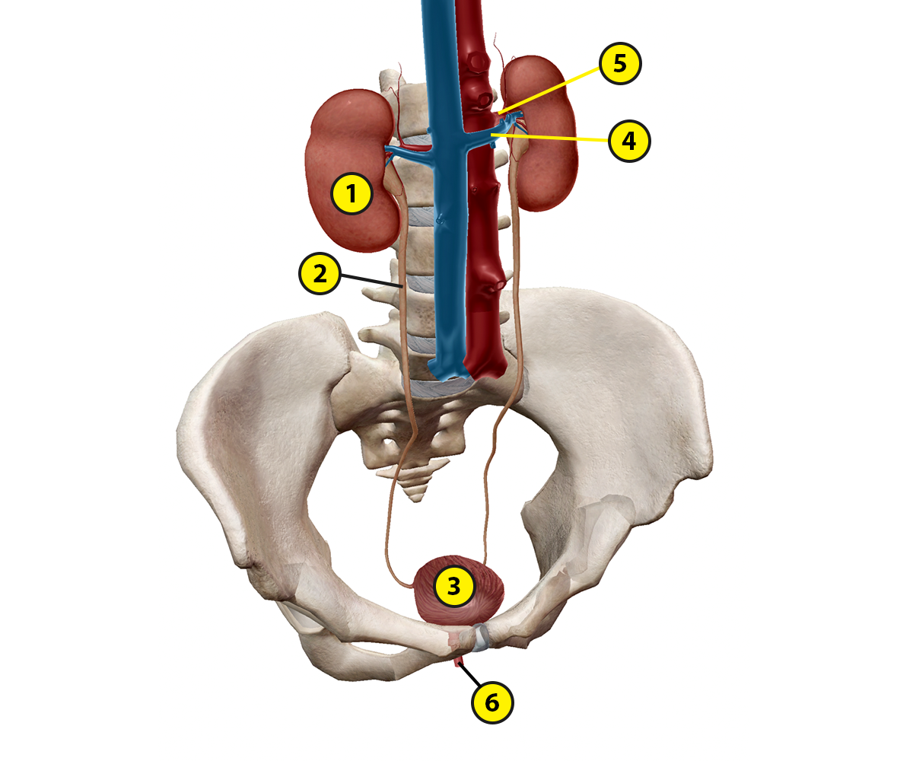

- Label the male urinary system structures by matching the numbered labels in the image below to the list included here:
  - Explore the 3D model of the male urethra on the Urinary System Structures page of the Visible Body Learn Site to find the structures you need to label.
  - Fill in the blanks to label the structures from the list below.

Word List:
Bladder
Membranous urethra
Prostate
Prostatic urethra
Spongy urethra
Ureter
___
___
___
___
___
___

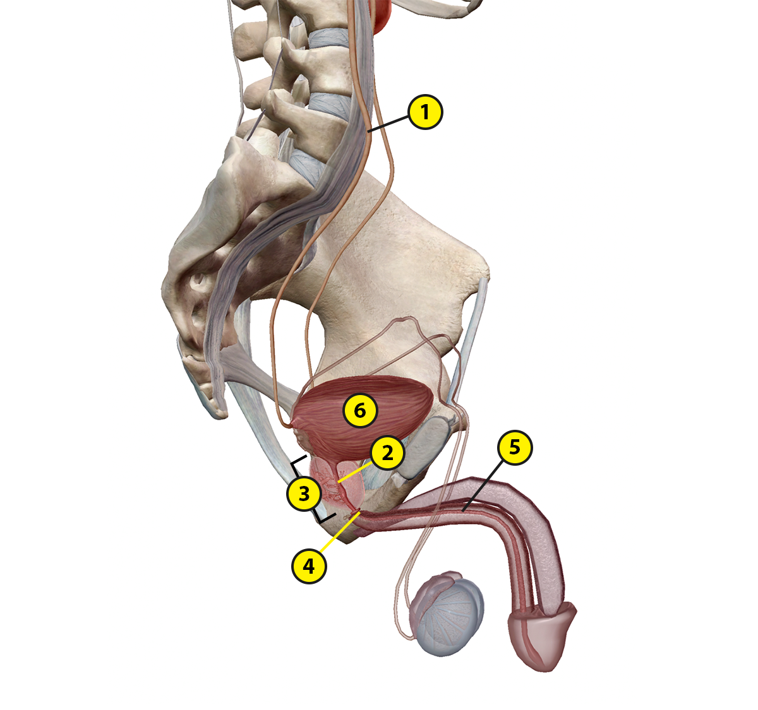
Name: Date:

Lab 5: Urine Creation, Storage, and Elimination

Activity 1: Explore the three stages of urine creation that occur in the kidneys

Read the Urine Creation article on the Visible Body Learn Site and use what you’ve learned to answer the following questions.

- The kidneys filter unwanted substances from the blood and produce urine to excrete them. What are the three main steps of urine formation?

- Complete the following sentences about the three main steps of urine formation.
  - Each kidney contains over 1 million tiny structures called __________. Each of these structures contains a glomerulus, the site of blood filtration. _________ and small solutes are filtered out of the blood during this step of urine formation.

  - Within the glomerulus, the _____________________ keeps blood cells and large proteins in the bloodstream. Fluid that has passed through this structure is called ____________.

  - Filtrate leaves the glomerulus and passes into the renal tubule for the second step of urine formation, ________________. During this step, water, essential ions, glucose, amino acids, and smaller proteins are reabsorbed into ______________.

  - _____________, the third step of urine formation, occurs at the same time as the second step. During this step, waste ions and hydrogen ions pass from the capillaries into the renal tubule.

- Urine is about _____% water and _____% waste products, such as urea, creatinine, ammonia, and uric acid. Ions such as sodium, potassium, hydrogen, and calcium are also excreted in urine.

Name: Date:

Lab 5: Urine Creation, Storage, and Elimination

Activity 2: Explore the structure of the bladder and the process of micturition

Read the Urine Storage and Elimination article on the Visible Body Learn Site and use what you’ve learned to answer the following questions.

- The bladder is shaped like a ___________ when it is empty.

- Which structures allow the bladder to expand as it fills with urine?

- What triggers the micturition reflex?

- What involuntary muscle actions occur during micturition?

- The ____________ urethral sphincter has voluntary control over micturition.

- Urinary tract infections, or UTIs, occur when bacteria enter the urethra and infect the urinary tract. (See the CDC’s website for more information about UTIs.)

Using the Urinary System Glossary on the Visible Body Learn Site, review the differences in structure between the male and female urethra. What elements of the female urethra would increase the risk of a UTI?

