Name: Date:

Biology Lab Activities: Human Body (Circulation)
Last updated: 11/1/22

Background Questions

Read through the Blood Vessels article on the Visible Body Learn Site. Based on what you’ve learned in class, in your textbook, and from the Learn Site article, answer the following questions about the circulatory system.

- The blood that flows through the circulatory system’s network of vessels supplies the body with three key things. What are they? (Hint: Two are specific molecules, and the other is a category of molecules.)

- What muscular organ pumps to keep blood moving throughout the body?

- The circulatory system contains three main types of blood vessels. Complete the following sentences to identify these vessels.
  - ____________ carry blood away from the heart.
  - ____________ carry blood to the heart.
  - Blood and body tissues exchange gases, nutrients, and wastes via ____________.
- As blood moves through the circulatory system, it puts pressure on the walls of the blood vessels. What are three factors that influence the amount of pressure on the blood vessel walls?

Name: Date:

Lab 1: Blood and Blood Vessels

Activity 1: Explore the components and functions of blood

Read through the Functions of Blood article on the Visible Body Learn Site. Based on what you’ve learned about the components of blood, complete the following exercises.

- Match each of the following components of blood with its description.

Components:
- Red blood cells
- White blood cells
- Plasma
- Platelets

Descriptions:
___ The liquid portion that makes up 55% of blood.
___ These disc-shaped cells transport oxygen from the lungs to the body cells.
___ These disease-fighting cells make up only 1% of the blood, but they multiply during infection or inflammation.
___ These cell fragments work together with plasma proteins to clot blood at sites of
injury.

- Complete the following sentences describing the functions of blood.
  - Blood plays an important role in gas exchange, providing the body’s cells with __________ and removing __________________.
  - Blood also transports water, _____________, and ____________ throughout the body to help the tissues carry out their functions.
  - Blood absorbs and distributes heat throughout the body to regulate ___________________.
  - Blood brings waste products to the lungs, ___________, and _________.

Name: Date:

Lab 1: Blood and Blood Vessels

Activity 2: Compare veins, arteries, and capillaries

Based on what you’ve learned about the structure and functions of the different types of blood vessels in class, from your textbook, and from the Background Questions, fill in the following table. Use the Blood Vessels article from the Visible Body Learn Site for reference.

 | Veins | Arteries | Capillaries

What direction do they carry blood?

What kind of blood (oxygenated or deoxygenated) do they carry in systemic circulation?

How thick and elastic are their walls, when compared to other vessel types?
Do they typically have higher or lower blood pressure? |  |  | Not applicable
Do they have valves? |  |  | Not applicable

Name: Date:

Lab 2: Circulation

Activity 1: Compare pulmonary and systemic circulation

Read the Pulmonary and Systemic Circulation article on the Visible Body Learn Site, and refer back to the Blood Vessels article you read in Lab 1.

Use what you’ve learned from these Learn Site articles and in Lab 1 to answer the following questions.

- The pumping of the heart powers two types of circulation. The vessels of the ____________ loop move blood between the heart and the rest of the body. The vessels of the _____________ loop move blood between the heart and lungs.

- Complete the following sentences about the role of blood and capillaries in gas exchange.
  - In the lungs, capillaries absorb __________ from inhaled air into the bloodstream and release carbon dioxide for ______________.
  - Elsewhere in the body, __________ and nutrients diffuse from blood in the capillaries to the ____________ they supply. The capillaries absorb ___________________ and other waste products from the tissues.

- The circulatory and respiratory systems work together to supply the body’s tissues with oxygen. Complete the following table to compare the circulatory–respiratory relationships between the pulmonary and systemic loops.

 | Pulmonary Loop | Systemic Loop

Which type of respiration (internal or external) does it participate in?

Which molecule enters the blood?

Which molecule leaves the blood?

Name: Date:

Lab 3: The Heart

Activity 1: Label the key structures of the heart

- Read the Heart Anatomy and Function article on the Visible Body Learn Site.
- Match the numbered labels in the image below to the list included here:
  - Explore the 3D model of the heart in your browser or in AR to find the structures you need to label.
  - Fill in the blanks to label the structures from the list below.

Word List:
Aorta
Left atrium
Left ventricle
Pulmonary arteries (base of)
Pulmonary veins (base of)
Right atrium
Right ventricle
Superior vena cava
___
___
___
___
___
___
___
___
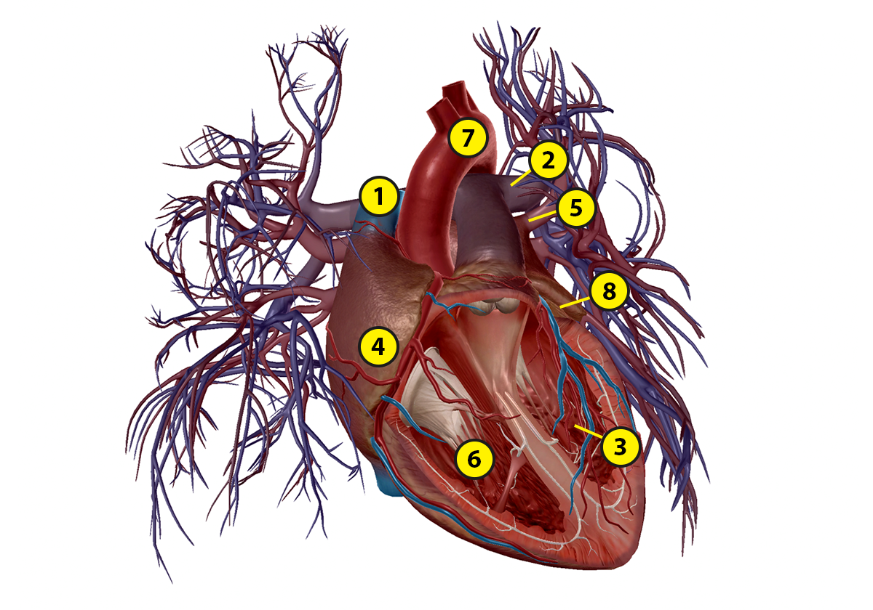
Name: Date:

Lab 3: The Heart

Activity 2: Explore the functions of heart chambers and valves

Using what you’ve learned from Activity 1, including your labeled heart, match each of the following structures with its description.

Structures:
- Heart
- Right atrium
- Left atrium
- Right ventricle
- Left ventricle
- Valves
- Superior vena cava
- Aorta
- Pulmonary veins
- Pulmonary arteries

Descriptions:
___ Receives oxygenated blood from the left ventricle and branches into the systemic arterial network that supplies the body
___ Regulate and support blood flow through and out of the heart
___ Receives deoxygenated blood returning from the body
___ Pumps oxygenated blood throughout the body and deoxygenated blood to the lungs
___ Receives oxygenated blood returning from the lungs
___ Receives oxygenated blood from the left atrium and empties into the aorta
___ Brings deoxygenated blood from the body to the right atrium
___ Carry oxygenated blood from the lungs to the heart
___ Carry deoxygenated blood from the heart to the lungs
___ Receives deoxygenated blood from the right atrium and sends it to the
pulmonary arteries
Name: Date:

Lab 3: The Heart

Activity 3: Explore how blood moves through the heart
Look at the images below and follow the arrows to see the flow of deoxygenated (blue) and oxygenated (purple) blood through the heart.

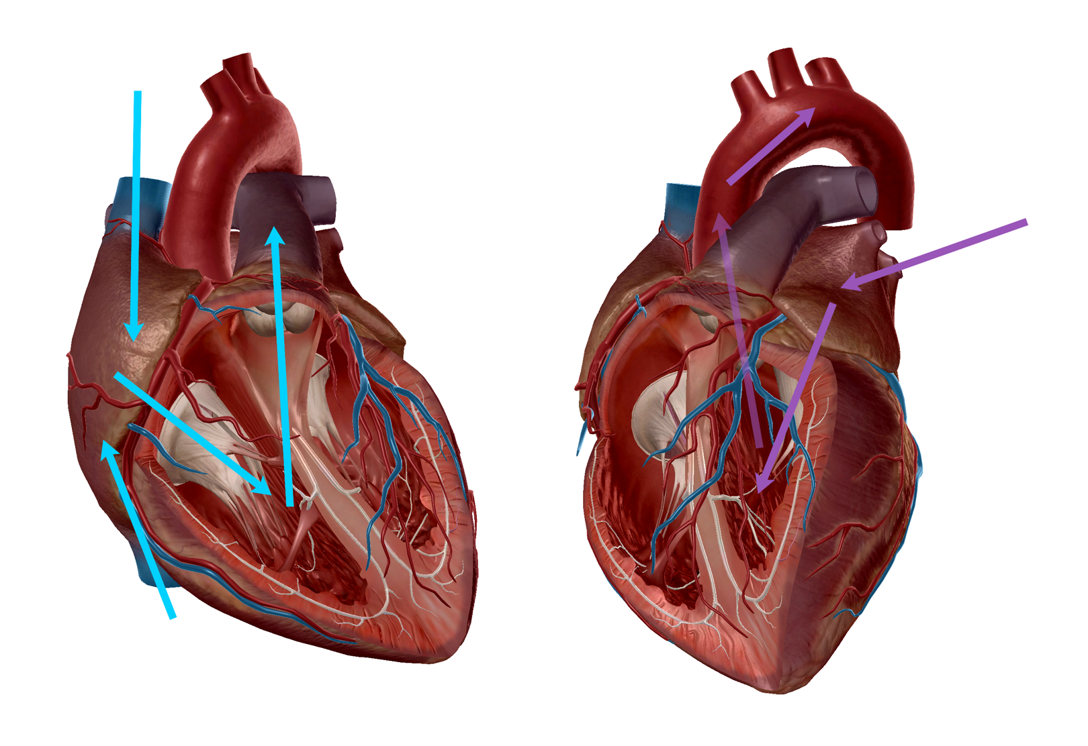
Using the previous heart images, the Heart article on the Learn Site, and what you’ve learned in class and from your textbook, complete the following table to organize the structures from the word list into two groups: structures that carry deoxygenated blood and structures that carry oxygenated blood.

Word List:
- Aorta
- Left atrium
- Left ventricle
- Pulmonary arteries
- Pulmonary veins
- Right atrium
- Right ventricle
- Superior vena cava

Structures That Carry Deoxygenated Blood | Structures That Carry Oxygenated Blood

For an extra challenge, try putting the elements from the word list in order, according to how blood moves through the heart after it enters through the superior and inferior venae cavae.

- Superior and inferior venae cavae
- ___________________
- ___________________
- ___________________
- ___________________
- ___________________
- ___________________
- ___________________

Name: Date:

Lab 4: Heart Rate

Activity 1: Measure heart rate changes
Adapted from the American Heart Association

During exercise, there is a high demand from your muscles to receive more oxygen. To keep up with the demand, your heart beats faster to get more oxygen to power your activity. In this lab, you will observe how changes in your activity will either increase or decrease your heart rate. The number of times your heart beats while working at its maximum capacity is called your maximum heart rate. Your target heart rate is a healthy range that represents the number of times your heart should beat during physical activity.
To begin, calculate your maximum heart rate and target heart rate using the following equations:
- Maximum Heart Rate (MHR) = 220 − age _____
- Target Heart Rate Zone (THRZ) = 50% to 85% of maximum heart rate _____

- To measure your heart rate, you will need to use a timer. You can use an app on your phone or computer or a stopwatch. Follow these instructions for checking your pulse. When you’ve found your pulse, count the number of beats you feel in 15 seconds and multiply that by four to calculate your heart rate in beats per minute.

Measure your heart rate and record it after completing each activity in the following table. Between activities, you should remain seated for 3–5 minutes. In the second part of this lab, you’ll use the information you record in this table to plot a bar graph.

Physical Activities | Your Heart Rate

1. Sit in a chair, relaxed (3–5 minutes)

2. Stand, relaxed (3–5 minutes)

3. Walk at a leisurely pace for 3 minutes

4. Speed walk for 2 minutes

5. Jog in place for 2 minutes

6. Do 25 jumping jacks

7. Run in place for 1 minute

- Review what you recorded in the previous table and plot it on the graph provided below.

Create your graph here:

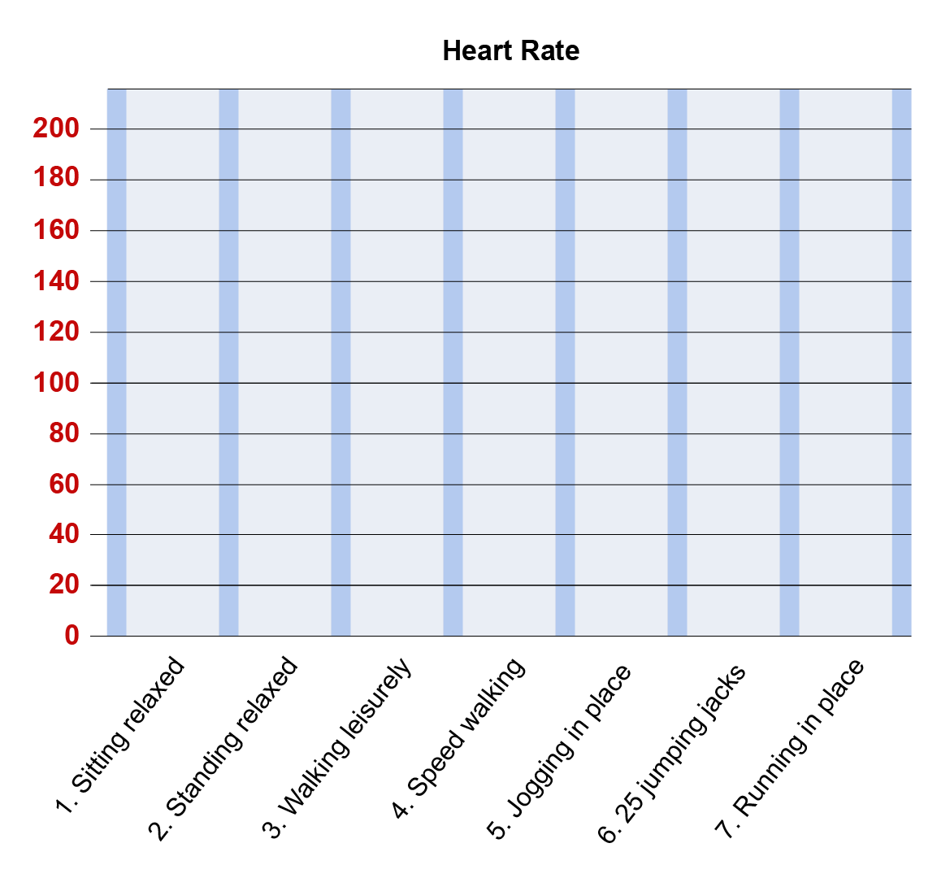

Name: Date:

Lab 4: Heart Rate

Activity 2: Explore how your heart rate changes

Using the measurements, observations, and heart rate graph you made in Activity 1, answer the following questions.

- When you look at your tracked heart rate data, what activity were you doing when your heart beat the fastest?

- During the recovery time after an activity, what happened to your heart rate?

- Describe how you felt physically during activity and at rest.

  - During activity:

  - At rest:

- Could you tell when your heart rate was increasing or decreasing?

- Could you tell when your heart rate was within your target heart rate zone? What activity or activities were you doing when you were in your target heart rate zone?

- Could you tell when your heart rate was at or close to your maximum heart rate? What activity or activities were you doing when you reached your maximum heart rate?

- Why does your heart rate need to change with various levels of activity? What would happen if your heart rate did not change?

