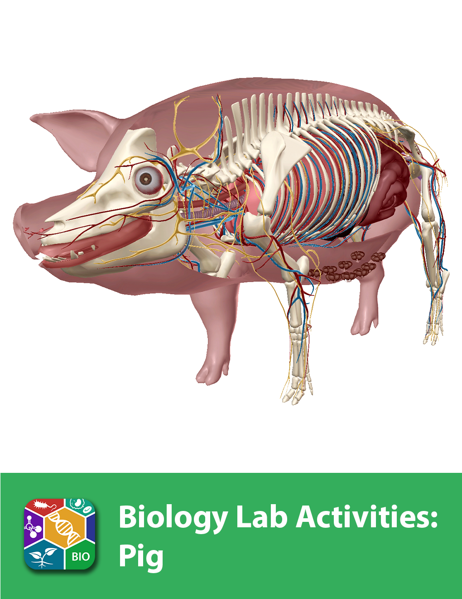
This lab manual is intended for use with the Visible Biology product.

Where to find 3D models
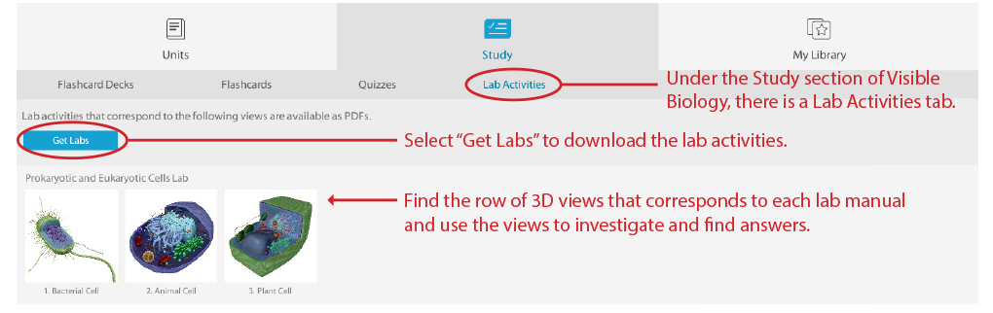
How to save answers
- Have Adobe Reader installed on your computer.
Windows: https://get.adobe.com/reader/
Mac: https://helpx.adobe.com/acrobat/kb/install-reader-dc-mac-os.html

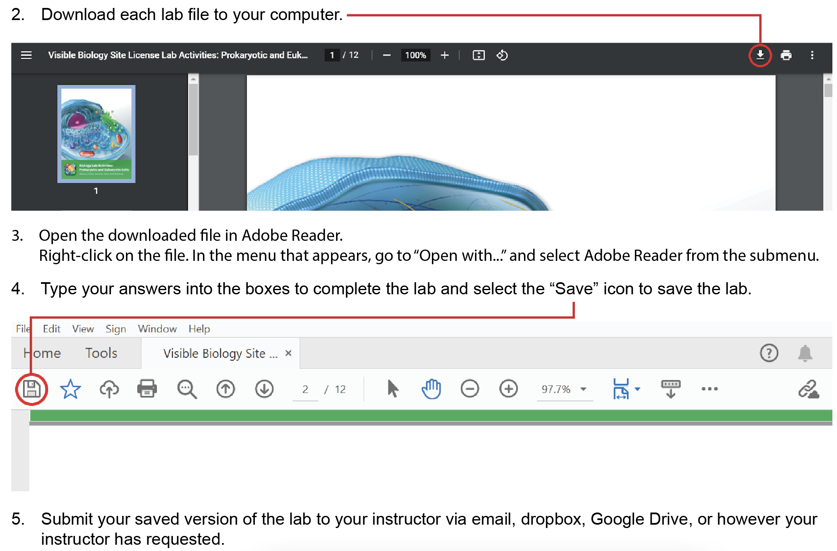

Any questions? visiblebiology.com

Name: Date:

Biology Lab Activities: Pig
Last updated: 5/18/2023

Background Questions

Based on what you’ve learned in class, in your textbook, and from using Visible Biology, answer the following questions about the pig.

- What type of body symmetry is present in pigs?

- Pigs are terrestrial vertebrates. Since pigs are mammals, they share many characteristics with other mammals, including __________. For example, the pig’s skin layers contain __________ follicles and sweat glands.

- Pigs are ______________, meaning they eat a wide variety of animals and plants. They use their long snouts to root in the soil for food.

- Pigs are part of the phylum Chordata. In 1–2 sentences, explain the characteristics the pig shares with other animals in this phylum.

For the text that's underlined in the following question, circle the correct answers.

- Pigs reproduce asexually/sexually. Fertilization occurs internally/externally.
  - The female pig’s body cavity includes its gonads, the __________. These structures produce _____________, such as estrogen and progesterone, as well as germ cells that mature into __________.
  - The male pig’s gonads are the __________.

Name: Date:

Lab 1: Pig Structure and Function

Activity 1: Label the pig

- Launch the view
  - Launch Visible Biology.
  - Navigate to Study/Lab Activities, and find the Animal Structure and Function Lab section.
  - Select view 4. Pig.
- Label the image below
  - Explore the 3D model of the pig to find the structures you need to label. You can use the Systems Tray, located on the left side of the screen, to isolate specific body systems in the pig model.
  - Fill in the blanks to label the structures from the list below.
Part A: Label the structures of the pig’s exterior and head region.

Word List:
Epidermis and dermis
Nostrils (external nares)
Teats
Teeth

___
___
___
___
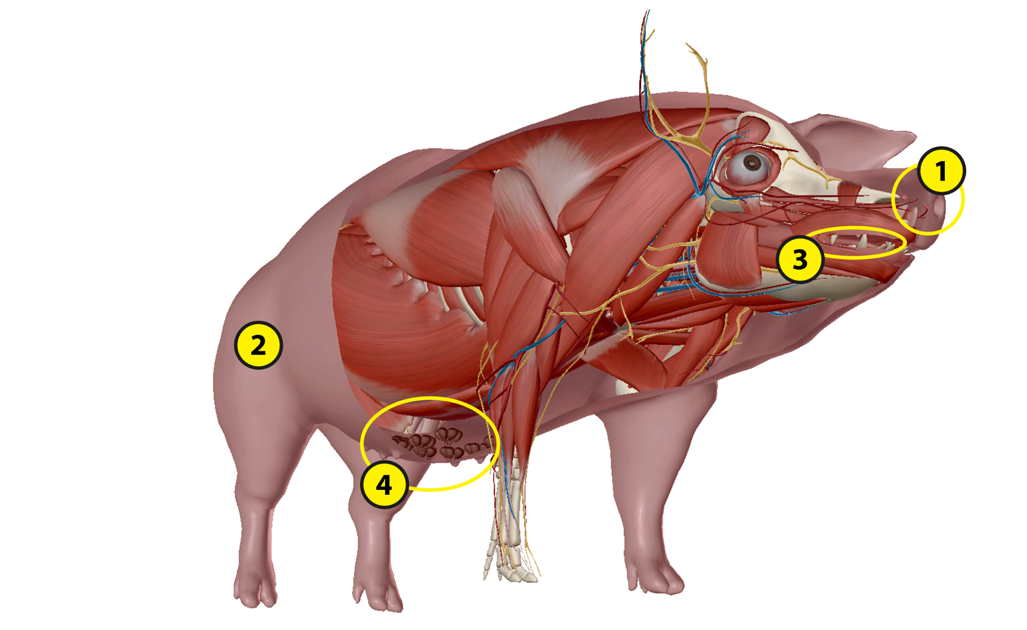

Part B: Label the structures of the pig’s support system.

Word List:
Caudal vertebrae
Femur
Humerus
Phalanges
Ribs
Scapula
Skull
___
___
___
___
___
___
___
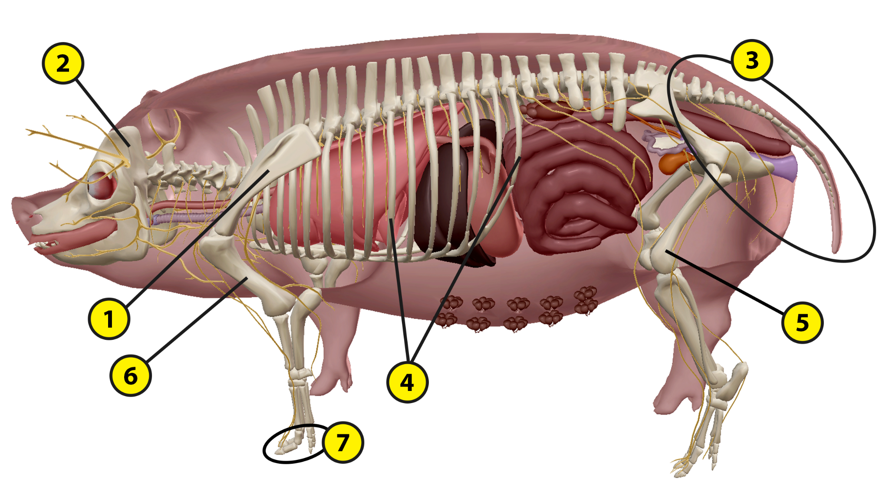

Part C: Label the structures of the pig’s nervous system.

Word List:
Brain
Cranial nerves
Eyes
Peripheral nerves
Spinal cord
Spinal nerves
___
___
___
___
___
___

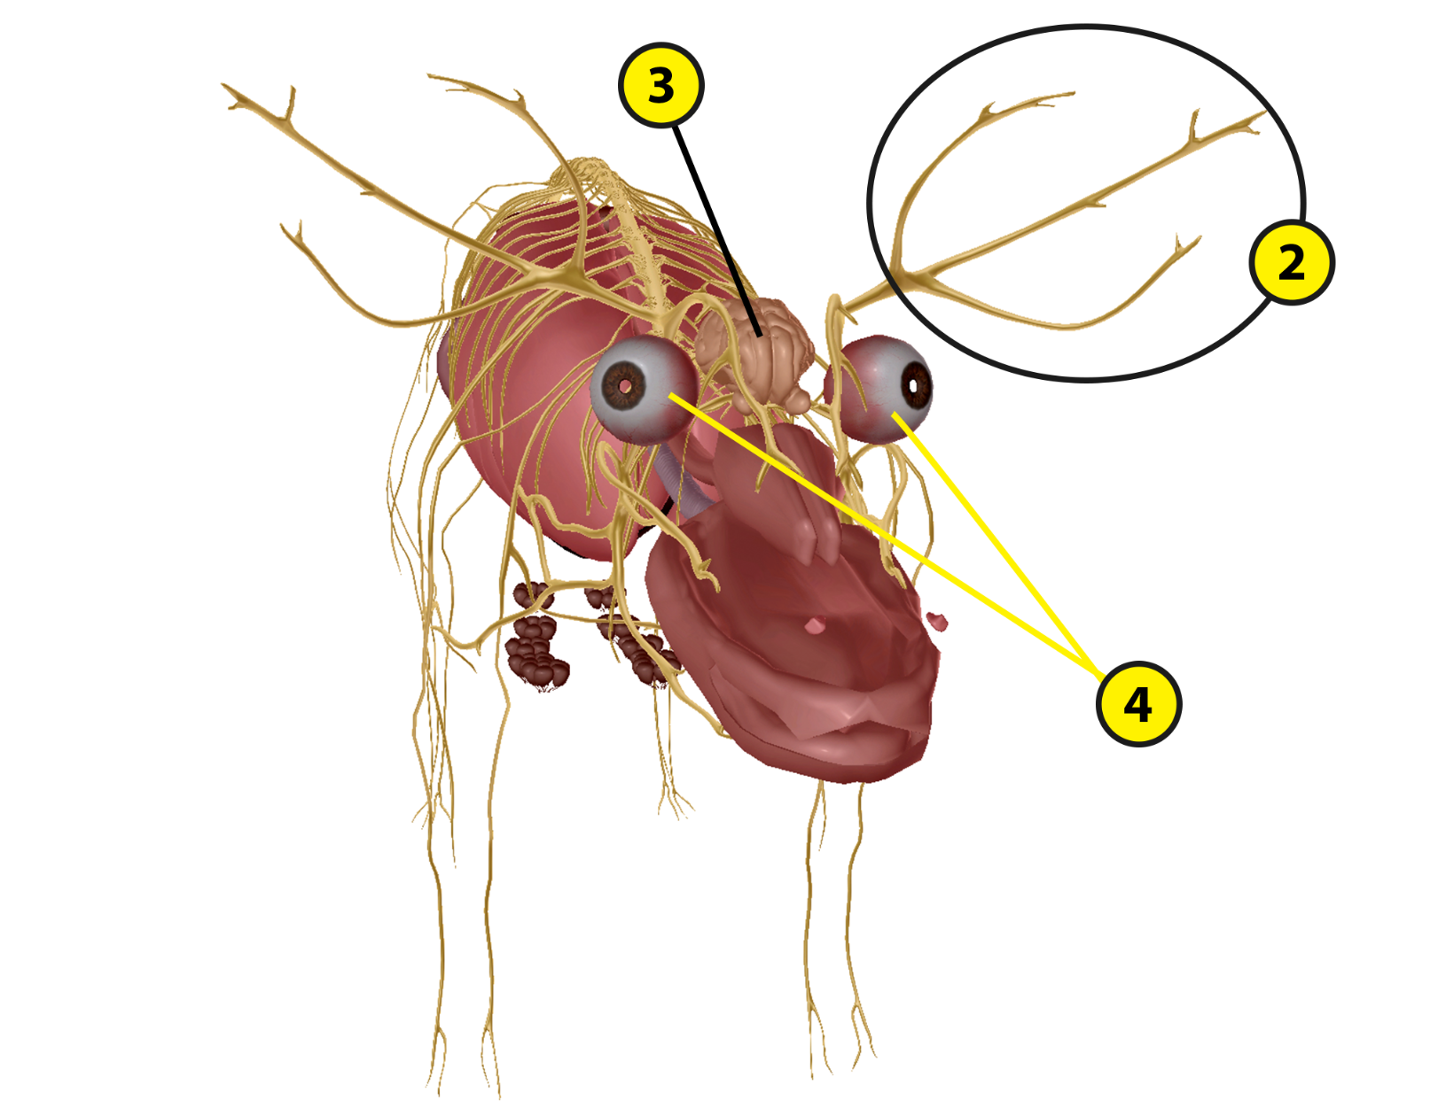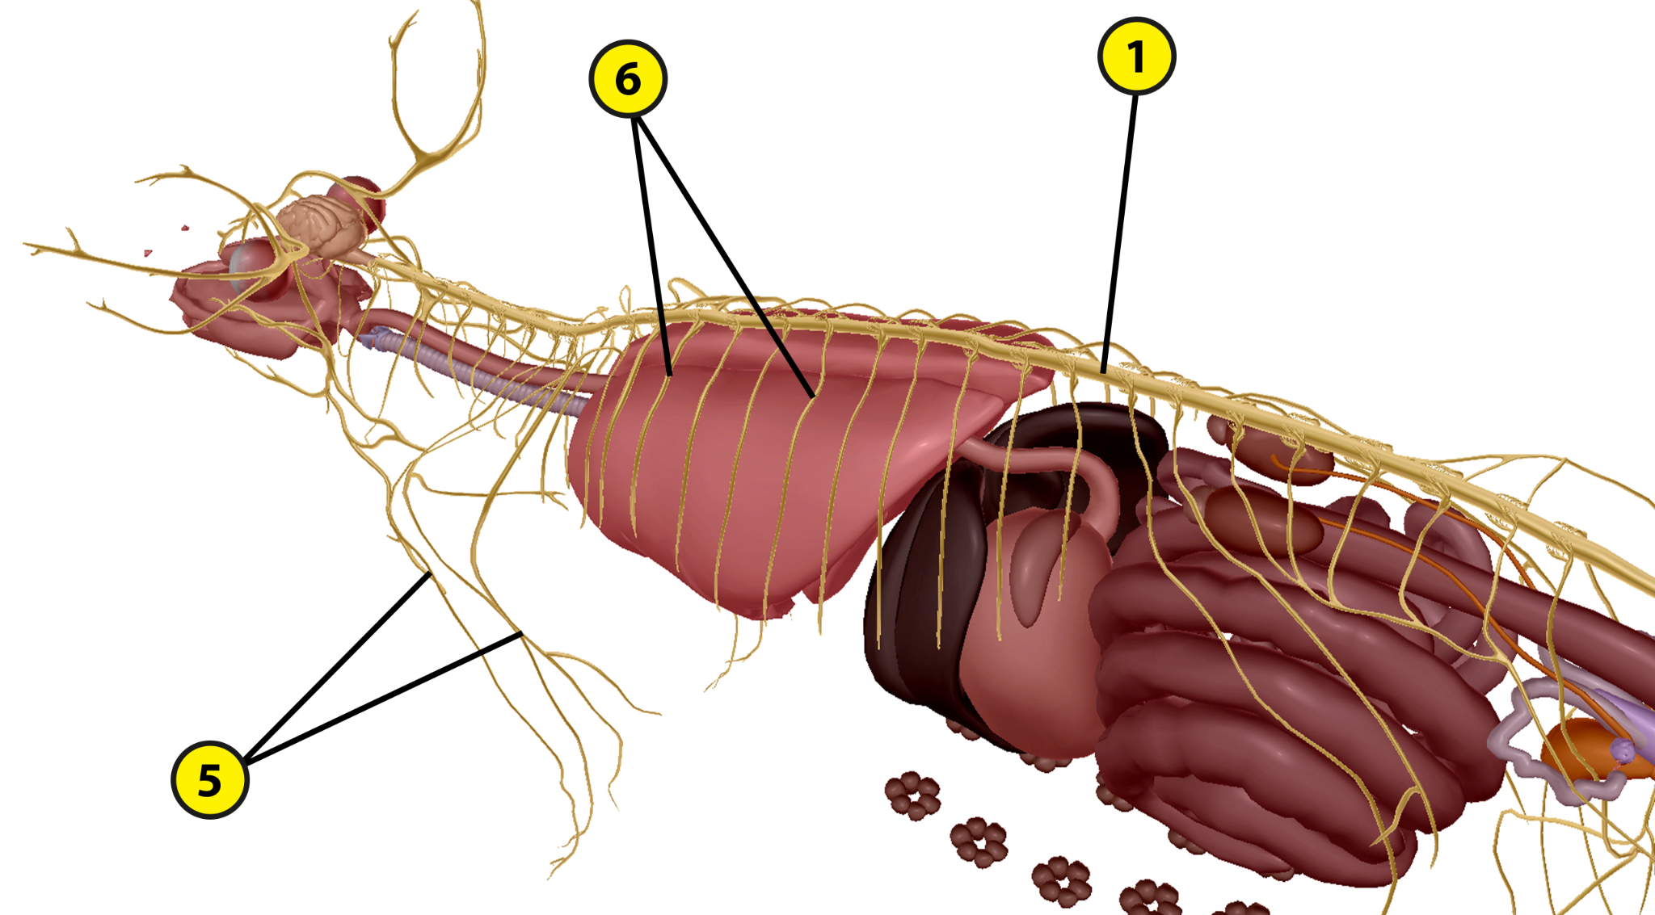

Part D: Label the structures of the pig’s circulatory system.

Word List:
Aorta
Arteries
Coronary arteries
Left atrium
Posterior vena cava
Pulmonary veins
Right ventricle
Spleen
Veins

___
___
___
___
___
___
___
___
___
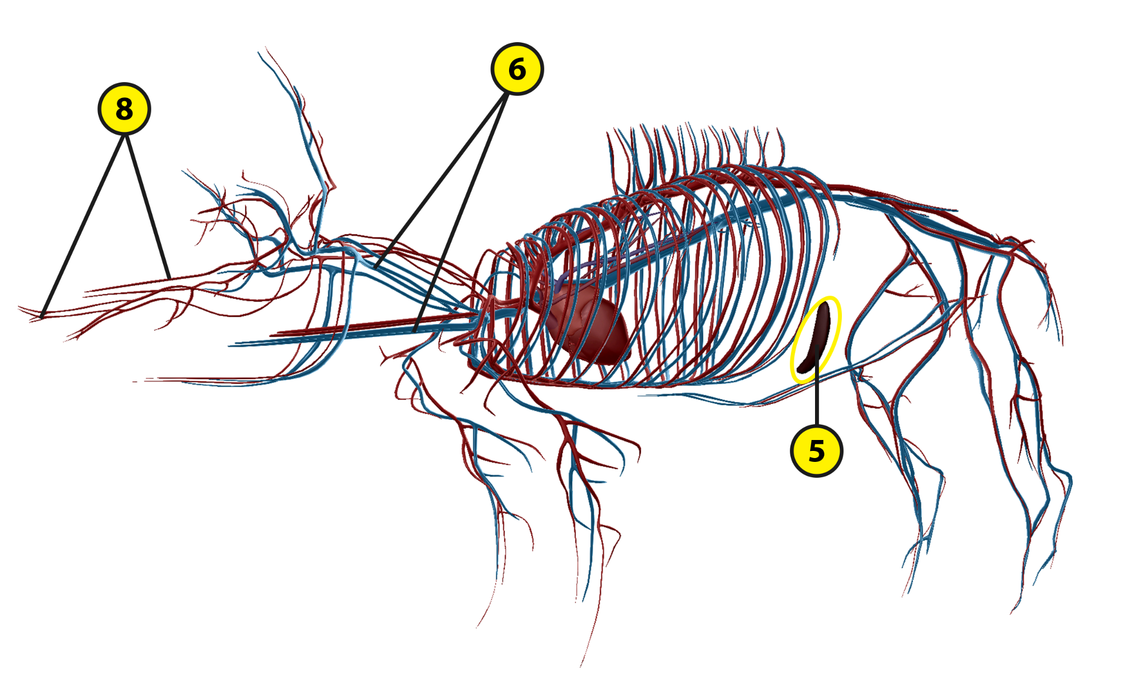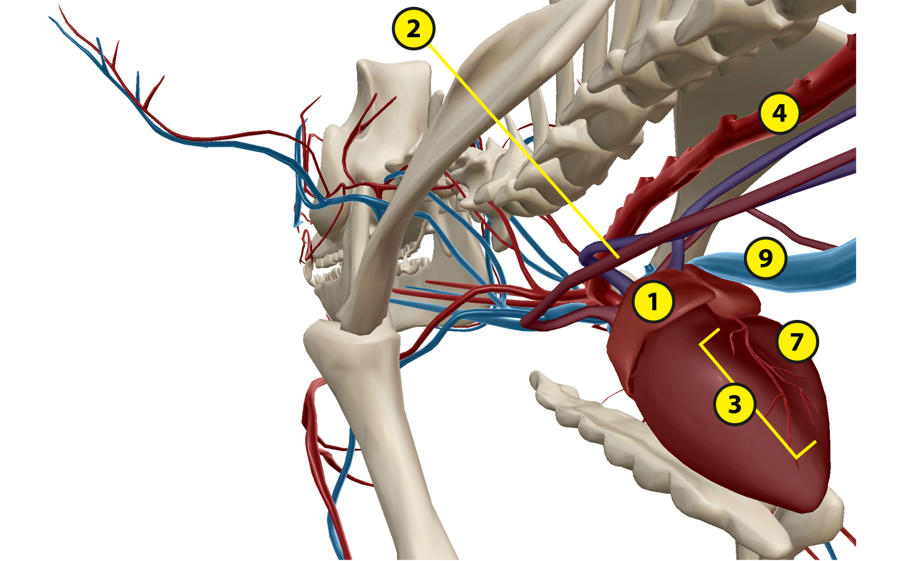
Part E: Label the structures of the pig’s digestive and respiratory systems.

Word List
Bronchi
Esophagus
Large intestine
Larynx
Liver
Lungs
Nasal cavity
Pancreas
Small intestine
Stomach
Trachea
___
___
___
___
___
___
___
___
___
___
___
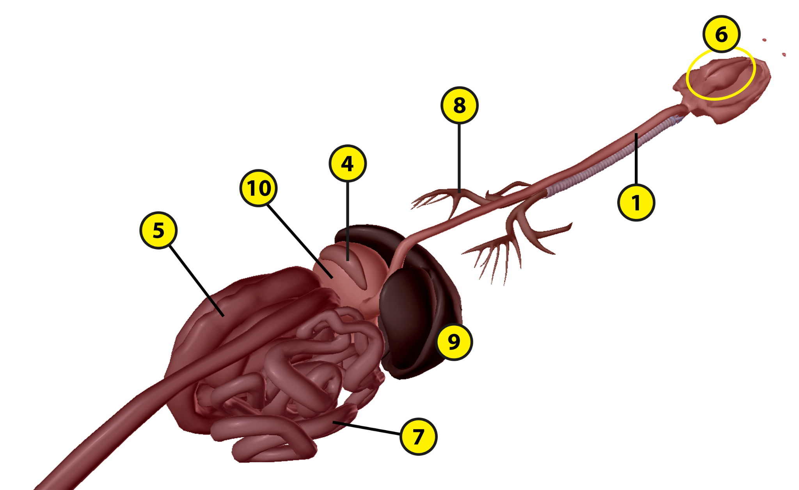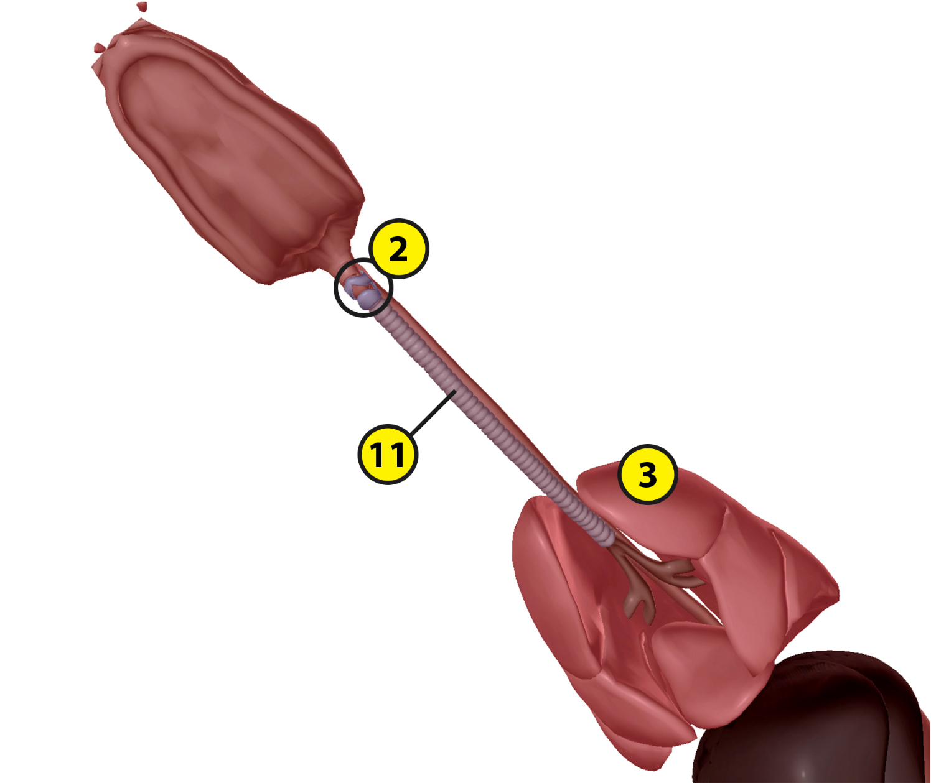
Part F: Label the structures of the pig’s reproductive and excretory (urogenital) systems.

Word List:
Adrenal glands
Bladder
Kidneys
Mammary glands
Ovaries
Ureters
Uterine horns
Uterus
Vulva

___
___
___
___
___
___
___
___
___
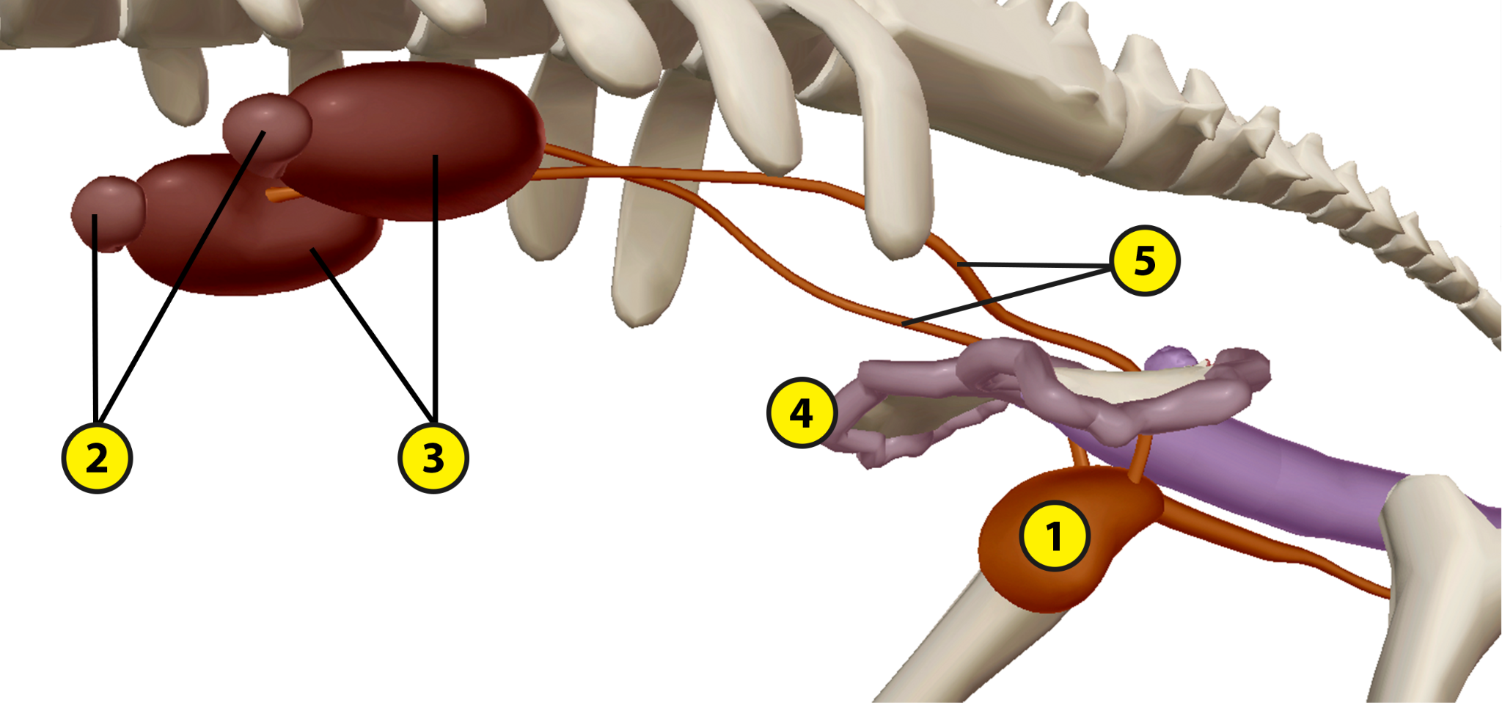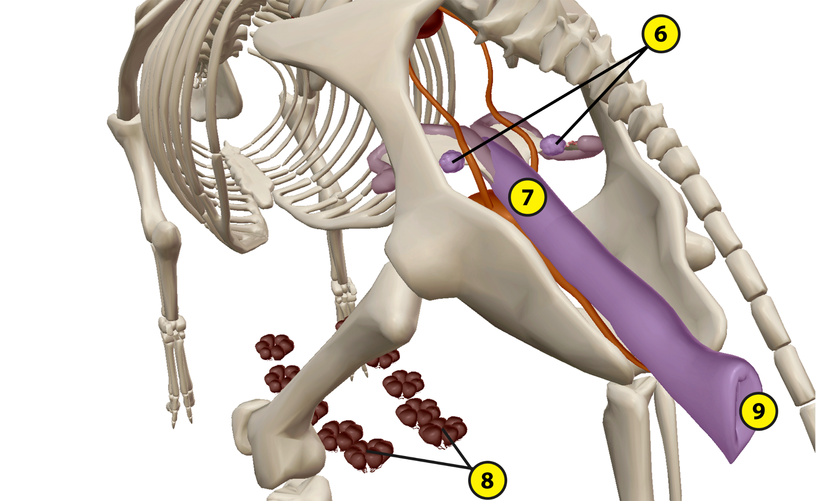
Name: Date:

Lab 1: Pig Structure and Function

Activity 2: Explore the structures of the pig and their functions

Refer to your labeled pig images from Activity 1 and the content in Visible Biology. Based on what you’ve learned, match each of the following structures with the brief description of its function.

Part A: Circulatory and Nervous Systems
Structures:
- Aorta
- Arteries
- Brain
- Coronary arteries
- Cranial nerves
- Eyes
- Left ventricle
- Peripheral nerves
- Posterior vena cava
- Pulmonary veins
- Right atrium
- Spinal cord
- Spinal nerves
- Spleen
- Veins

Descriptions:
___ This structure, the pig’s largest artery, carries oxygenated blood from the heart to the body.
___ This structure stores mature blood cells and cleans the blood by removing old red blood cells.
___ These structures supply blood to the heart tissue.
___ This structure carries deoxygenated blood from the posterior end of the body to the heart.
___ This structure processes sensory information and generates motor commands.
___ This heart chamber receives deoxygenated blood from the anterior and posterior venae cavae.
___ These structures carry blood from the heart to the body tissues.
___ These structures connect to the optic nerves to relay visual stimuli.
___ These structures relay information between the brain and the sensory organs and other structures within the head and upper body.
___ These structures carry deoxygenated blood from the body tissues to the heart.
___ These structures carry sensory and motor signals between the brain, spinal cord, and body.
___ This structure processes the pig’s reflexes and relays information between the brain and the spinal nerves.
___ These structures carry oxygenated blood from the lungs to the heart.
___ This heart chamber pumps oxygenated blood out to the body.
___ These structures branch out from the spinal cord and carry nervous signals throughout the body.

Part B: Digestive and Respiratory Systems
Structures:
- Bronchi
- Esophagus
- Large intestine
- Larynx
- Liver
- Lungs
- Nasal cavity
- Pancreas
- Small intestine
- Stomach
- Trachea

Descriptions:
___ After passing through the pharynx, food moves through this structure on its way to the stomach.
___ This structure absorbs water to help prevent dehydration and consolidates indigestible matter into waste.
___ This structure produces bile to help fully break down food into absorbable nutrients.
___ This structure produces insulin and glucagon to regulate blood sugar levels.
___ Air moves through this cartilaginous and membranous structure to the lungs.
___ This structure receives bile and pancreatic juices to help it break down and absorb nutrients from food.
___ This structure contains digestive enzymes that break down food into nutrients.
___ These structures branch out from the trachea and divide into smaller respiratory units.
___ This structure contains the vocal cords.
___ After air passes through the trachea, it enters these lobed structures.
___ After air enters via the nostrils, it passes through this structure on its way to the trachea.

Part C: Reproductive and Excretory Systems
Structures:
- Adrenal glands
- Bladder
- Kidneys
- Mammary glands
- Ovaries
- Ureters
- Uterine horns
- Uterus
- Vulva

Descriptions:
___ These structures create the pig’s germ cells that mature into eggs.
___ These structures secrete hormones that help regulate stress responses, blood pressure, and metabolism.
___ These structures carry urine into the bladder.
___ This external structure includes the vaginal opening.
___ This structure stores urine before it is excreted.
___ The cervix allows sperm to enter this structure during sexual reproduction.
___ These structures connect to the teats on the pig’s abdomen to provide milk to its offspring.
___ These structures filter urea and other waste products out of the blood.
___ These structures include folds, where fertilized eggs implant and fetal development occurs.

Part D: Exterior of the Pig and Support System
Structures:
- Caudal vertebrae
- Epidermis and dermis
- Femur
- Humerus
- Nostrils (external nares)
- Phalanges
- Ribs
- Scapula
- Skull
- Teeth

Descriptions:
___ In mammals, these structures contain hair follicles and sweat glands.
___ These structures allow air to enter the nasal cavity.
___ These structures at the end of the vertebral column form the pig’s tailbone.
___ Each hoof contains three of these structures.
___ This structure articulates with the tibia and fibula to form the knee joint.
___ These axial skeleton structures connect to the sternum via the costal cartilages.
___ These structures are used to chew the pig’s food.
___ This structure articulates with the radius and ulna to form the elbow joint.
___ This structure is composed of bones that protect the brain.
___ This structure is a part of the shoulder girdle.
Name: Date:

Lab 2: Pig Dissection

Introduction
Pigs are terrestrial vertebrates with bilateral symmetry. These mammals are part of the phylum Chordata, which is characterized by a notochord, a dorsal nerve cord, an endostyle or thyroid gland, pharyngeal slits, and a post-anal tail. Several adaptations help pigs survive in their environment, including a strong skeleton, a strong sense of smell, and hair and tusks that provide protection. A key adaptation that allows pigs to live in various locations is that they are omnivores that can eat a wide variety of animals and plants. They use their long snouts to root in the soil for food, which passes through their esophagus and stomach to the intestines, where nutrients and water are absorbed. Waste is excreted through the anus. Pigs breathe through their nostrils, passing air through their larynx, trachea, and bronchi into the lungs, where gas exchange occurs. Pigs reproduce sexually through internal fertilization. Multiple eggs (ova) can be fertilized in female pigs during mating, and multiple births are common. Pigs are deuterostomes, meaning their embryos develop the anus before the mouth. Pigs share many characteristics with other mammals, including humans—a four-chambered heart, hair, mammary glands, and endothermic metabolism. Like other large, hooved mammals, pigs can move by walking, trotting, and galloping.

In this activity, you will examine a pig and learn about its external and internal structures.

Materials
- Pig (virtual or preserved)
- Dissecting scissors
- Dissecting forceps
- Dissecting pins and probes
- Dissecting tray
- Spool of string
- Lab gloves
- Safety goggles

Dissection
Observe the external structures of the pig

Observe the pig’s external surface. Many of its adaptive features help it move throughout its environment and protect itself against predators.

- Observe the following external structures:
  - Anus
  - Epidermis and dermis (skin)
  - Nostrils (external nares)
  - Eyes
  - Hooves
  - Tail
  - Teats
  - Tusks

If using the Visible Biology virtual pig, follow these steps
Note: Use the Hide button to hide individual structures. You can use the Systems Tray to toggle individual body systems on or off in the view. Within the view, you can zoom in/out or rotate the model as needed to observe the pig’s structures.
- First, select the epidermis and dermis and use the book icon to learn more about the pig’s skin. Then, use the Systems Tray to remove the entire integumentary system from the view.
- Next, observe some of the pig’s muscles, including the forelimb (arm) and hind limb (leg) muscles that help the pig walk, trot, and gallop. Then, rotate the pig and hide individual muscles as necessary to observe the following muscles. Use the book icon to read about them as you go. Once you have examined each muscle, use the Systems Tray to remove the entire muscular system from the view.
  - Biceps femoris
  - Diaphragm
  - External oblique (r, l)
  - Gracilis (r, l)
  - Intercostals (r, l)
  - Masseter (r, l)
  - Rectus abdominis (r, l)
  - Sternomastoid (r, l)
  - Trapezius (r, l)
- Then, observe the following support/skeletal system structures. Select each of the following structures and use the book icon to learn more about it. Once you have examined each support structure, use the Systems Tray to remove the entire support system from the view.
  - Broad ligament
  - Calcaneus (r, l)
  - Femur (r, l)
  - Mandible
  - Pelvic bones (innominate bones)
  - Phalanges (r, l)
  - Ribs
  - Scapula (r, l)
  - Skull
  - Sternum
  - Thoracic vertebrae
  - Ulna (r, l)
- Next, observe the nervous system structures. Select each of the following structures and use the book icon to learn more about it. Once you have examined each nervous structure, use the Systems Tray to remove the entire nervous system from the view.
  - Brain
  - Cranial nerves
  - Eyes
  - Peripheral nerves
  - Spinal cord
  - Spinal nerves
- Then, observe the circulatory system structures. The first structures you will notice are the veins and arteries. Click on these, read their definitions, and use the Hide button to remove as many as necessary to create a clear view of the other internal structures. Remove the lungs to better view the heart structures. Select each of the following structures and use the book icon to learn more about it. Once you have examined each circulatory structure, use the Systems Tray to remove the entire circulatory system from the view.
  - Aorta
  - Coronary arteries
  - Descending aorta
  - Left atrium
  - Left ventricle
  - Posterior vena cava
  - Pulmonary arteries
  - Pulmonary veins
  - Right atrium
  - Right ventricle
- Now, observe the respiratory and digestive system structures. You will need to click on the lungs icon in the Systems Tray to bring the lungs back into the view. Select each of the following structures and use the book icon to learn more about it. Once you have examined each respiratory and digestive structure, use the Systems Tray to remove the entire respiratory and digestive systems from the view.
  - Bronchi
  - Esophagus
  - Large intestine
  - Larynx
  - Liver
  - Lungs
  - Oral cavity
  - Pancreas
  - Small intestine
  - Stomach
  - Trachea
- Finally, observe the reproductive and excretory system structures. Select each of the following structures and use the book icon to learn more about it.
Note: If you want to view these internal organs in context, you can use the Systems Tray to add back any of the systems you removed in previous steps. You can also hide individual structures on the list below after you have examined them to get a clearer view of specific structures.
  - Adrenal glands
  - Bladder
  - Cervix
  - Kidneys
  - Mammary glands
  - Ovaries
  - Ureters
  - Uterine horns
  - Uterus
  - Vagina
  - Vulva
If using a preserved specimen, cut into your pig to observe its internal structures
- Before you begin your dissection, observe the pig’s external structures, starting with the outer epidermis. In the pig’s head region, notice the eyes, ears, snout/external nares (nostrils), and tusks. Whether you have a male or female pig, you’ll notice two rows of teats on its abdomen. However, the mammary glands only develop in maturing female pigs. To determine the sex of your pig, look for the scrotal sac (males) or urogenital opening (females). In addition, note the pig’s four limbs, hooves, and tail. After you have observed the external structures, place the pig on the dissecting tray with its ventral (belly) side facing up.
- First, you will need to secure the pig to the dissecting tray. Tie a piece of string to one of the pig’s front limbs. Loop the string underneath the dissecting tray; then, bring it back to the top of the dissecting tray to tie it around the other front limb. Repeat these steps with the hind limbs.
- Open the pig’s mouth to view the internal structures within the head region.
- Observe the following internal structures:
  - Digestive System: Oral cavity, pharynx, and tongue
  - Support System: Teeth
- To view the pig’s internal structures, you will need to cut through the skin and muscle layers. Make an incision from the pig’s throat, down the midline of the chest and abdomen.
Note: When making this incision, be careful not to cut too deep into the pig’s internal organs.
- If working with a fetal pig, cut around the umbilical cord in the shape of an upside down U, and then continue the two incisions down the length of the pig’s body toward its pelvic region.
- Make two sets of lateral incisions. The first incision should intersect with the cut down the pig’s midline at the base of the ribs. The second incisions should be made at each of the hind limbs, connecting with the incisions that extend from the cut around the umbilical cord.
- Once these incisions are made, you can make the incisions deeper to cut through the muscle layers.
- From the incision down the midline of the pig’s body, make lateral incisions that cut through the pig’s ribs to remove the chest plate.
- Peel back the skin flaps, which are connected to the muscle layers, and pin them to the dissecting tray.
- Observe the following internal structures:
  - Circulatory System: Heart (right and left atria and right and left ventricles) and spleen
  - Digestive System: Large intestine, liver, small intestine, and stomach
  - Respiratory System: Bronchi, larynx, lungs, and trachea
- Once you have observed these structures, fold up the stomach and liver to reveal more of the pig’s internal structures.
- Observe the following internal structures:
  - Digestive System: Gallbladder and pancreas
- Next, carefully remove the entire digestive system.
- Observe the following internal structures:
  - Excretory System: Bladder, kidneys, and ureters
  - Reproductive System: Ovaries, uterine horns, and uterus (female); Testes (male)

Questions
Based on your observations during this lab activity and what you’ve learned about the pig’s structures and their functions, answer the following questions.

- What are the digestive functions of the pig’s teeth?

- The pig’s eggs are fertilized in the oviducts before moving to the uterus for development. What unique feature of the pig’s uterus helps it reproduce more efficiently?

- Compare the pig’s heart to the human’s heart.

- What role do the pig’s cranial nerves play in the pig’s ability to sense its surroundings?

