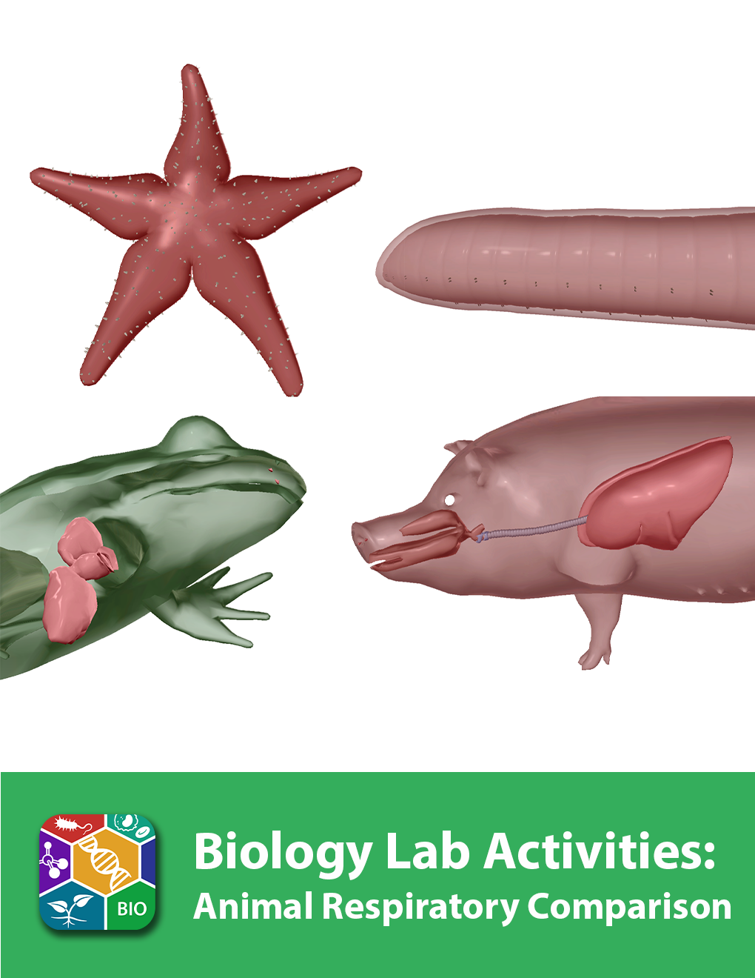
This lab manual is intended for use with the Visible Biology product.

Where to find 3D models
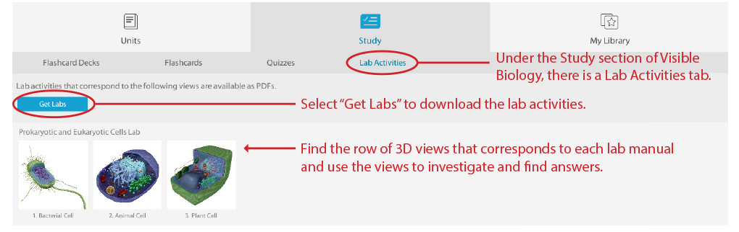
How to save answers
- Have Adobe Reader installed on your computer.
Windows: https://get.adobe.com/reader/
Mac: https://helpx.adobe.com/acrobat/kb/install-reader-dc-mac-os.html

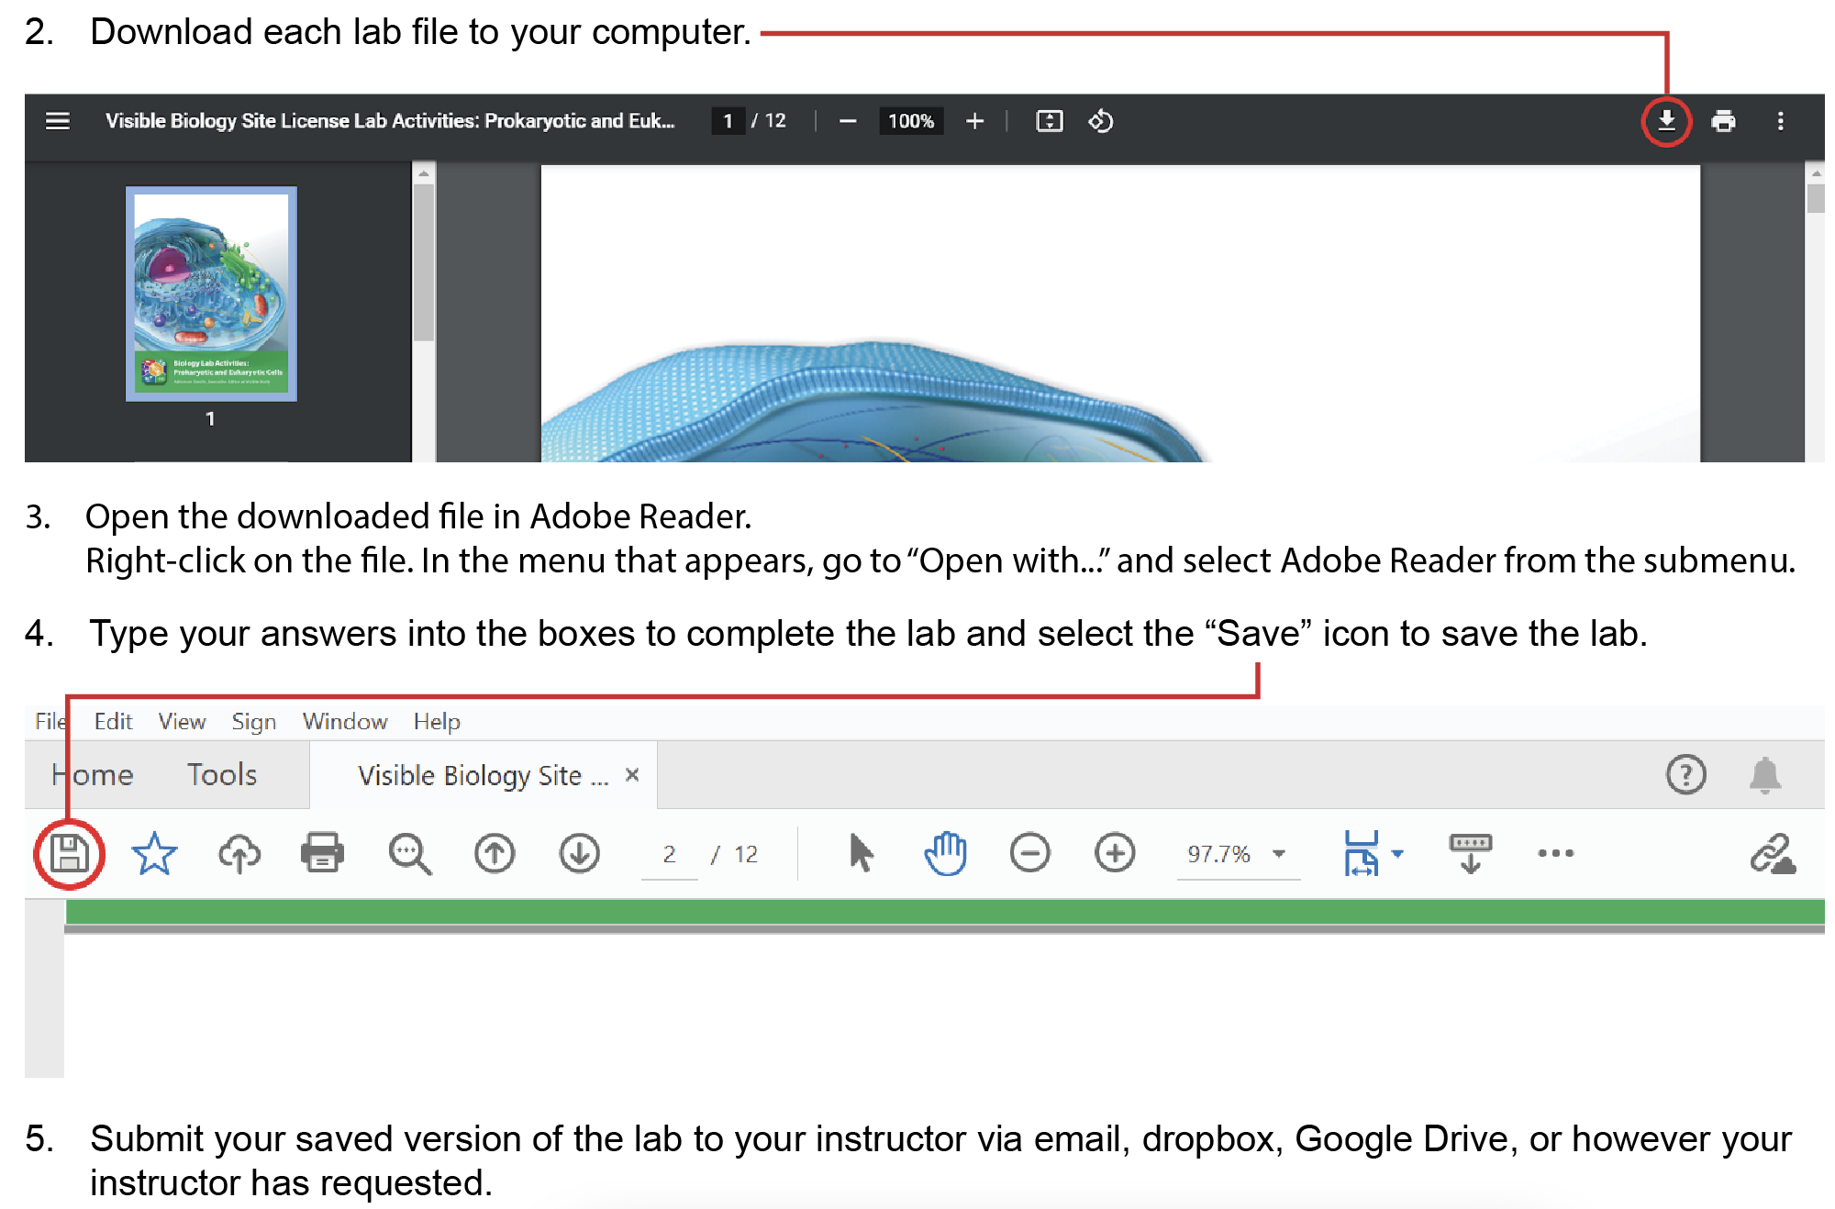

Any questions? visiblebiology.com

Name: Date:

Biology Lab Activities: Animal Respiratory Comparison
Last updated: 5/3/2023

Background Questions

Based on what you’ve learned in class, in your textbook, and from using Visible Biology, answer the following questions about the respiratory structures and functions of the sea star, earthworm, frog, and pig.

- Sea stars, earthworms, frogs, and pigs all have respiratory structures that allow them to exchange gases with the environment around them.
  - Sea stars, earthworms, frogs, and pigs take in ____________ from the air or water around them and pass ____________________ back into the surrounding environment.
  - For sea stars, earthworms, and frogs, their __________ has respiratory functions. They exchange gases with their environment via a process called ______________.
  - Like pigs, frogs also have __________, which allow them to breathe on land.

- Animals have evolved to breathe in a variety of ways. In 3–5 sentences, describe the different ways these four animals receive gases from their environments and the structures they use to do so.

Name: Date:

Lab 1: Respiratory Structures

Activity 1: Label the sea star’s respiratory structures

- Launch the view
  - Launch Visible Biology.
  - Navigate to Study/Lab Activities, and find the Evolution: Animal Diversity Lab section.
  - Select view 13. Sea Star, Respiratory.
- Label the image below
  - Explore the 3D model of the sea star to find the structures you need to label.
  - Fill in the blanks to label the structures from the list below.
Word List
Carbon dioxide
Oxygen
Skin (epidermis)
Skin gills
___
___
___
___

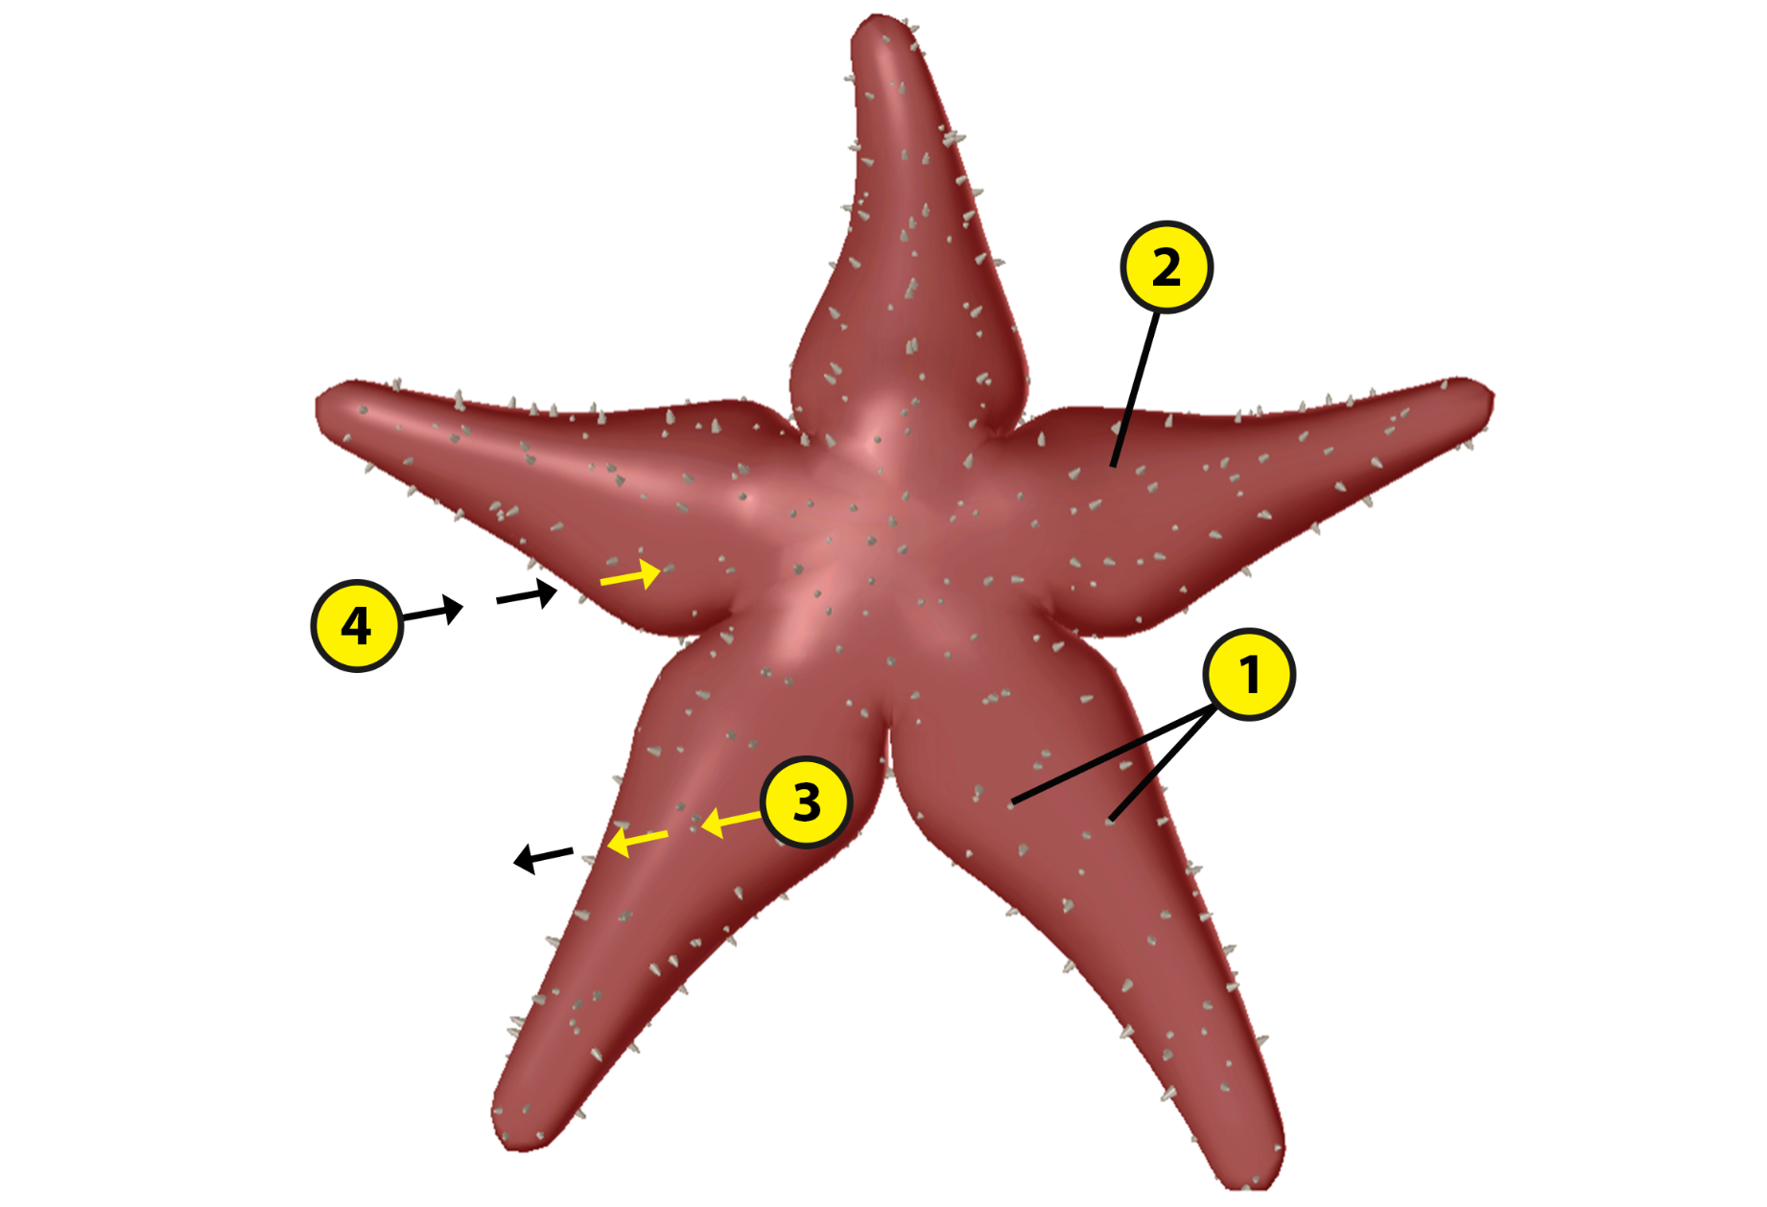
Name: Date:

Lab 1: Respiratory Structures

Activity 2: Label the earthworm’s respiratory structures

- Launch the view
  - Launch Visible Biology.
  - Navigate to Study/Lab Activities, and find the Evolution: Animal Diversity Lab section.
  - Select view 14. Earthworm, Respiratory.
- Label the image below
  - Explore the 3D model of the earthworm to find the structures you need to label.
  - Fill in the blanks to label the structures from the list below.
Word List:
Carbon dioxide
Cuticle
Oxygen
Skin (epidermis)
___
___
___
___

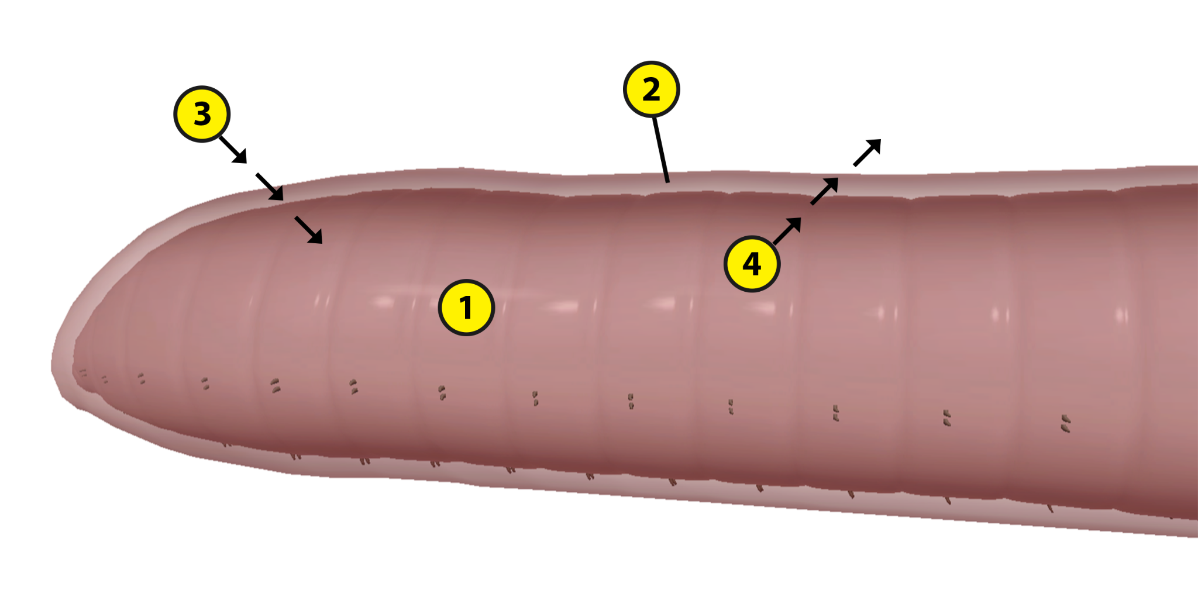

Name: Date:

Lab 1: Respiratory Structures

Activity 3: Label the frog’s respiratory structures

- Launch the view
  - Launch Visible Biology.
  - Navigate to Study/Lab Activities, and find the Evolution: Animal Diversity Lab section.
  - Select view 15. Frog, Respiratory.
- Label the image below
  - Explore the 3D model of the frog to find the structures you need to label.
  - Fill in the blanks to label the structures from the list below.

Word List:
Carbon dioxide
Glottis
Larynx
Lungs
Nostrils
Oxygen
Skin (epidermis and dermis)
___
___
___
___
___
___
___

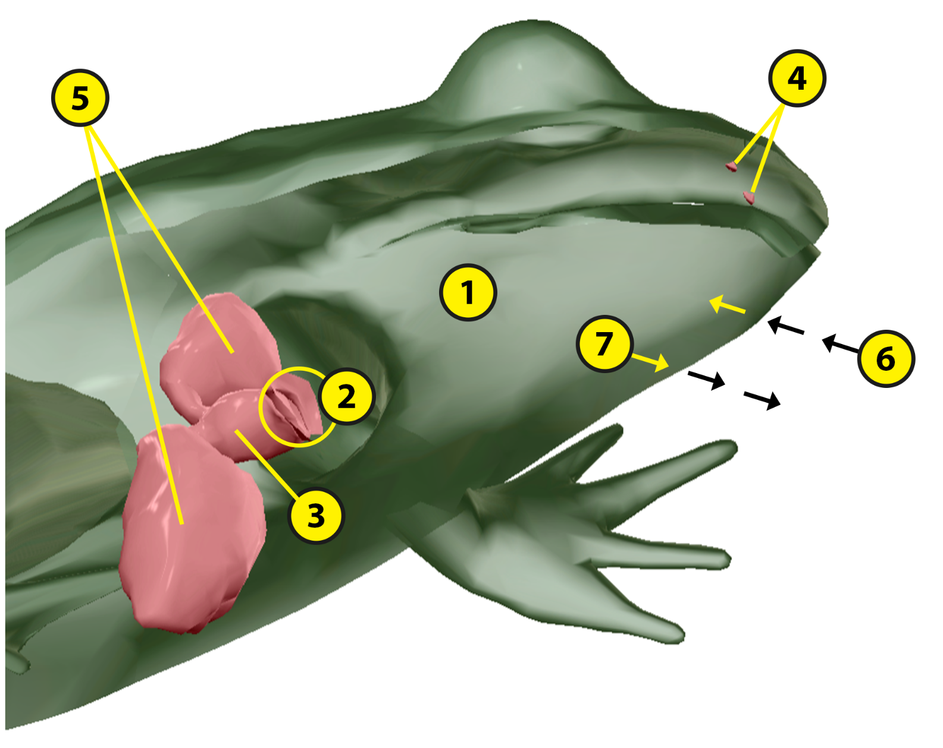

Name: Date:

Lab 1: Respiratory Structures

Activity 4: Label the pig’s respiratory structures

- Launch the view
  - Launch Visible Biology.
  - Navigate to Study/Lab Activities, and find the Evolution: Animal Diversity Lab section.
  - Select view 16. Pig, Respiratory.
- Label the image below
  - Explore the 3D model of the pig to find the structures you need to label.
  - Fill in the blanks to label the structures from the list below.
Word List
Bronchi
Larynx
Lungs
Nasal cavity
Nostrils
Pharynx
Trachea
___
___
___
___
___
___
___
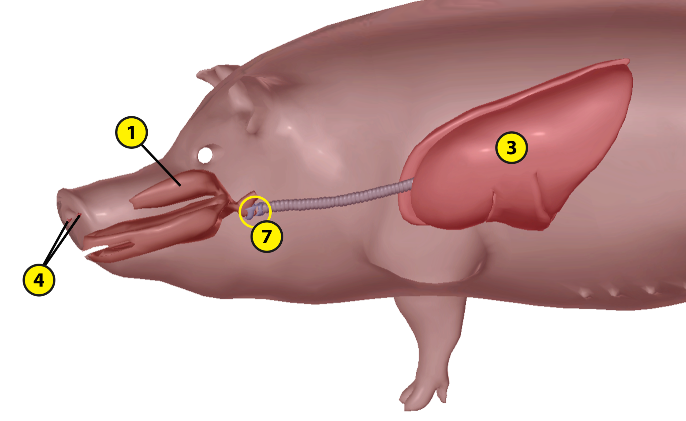
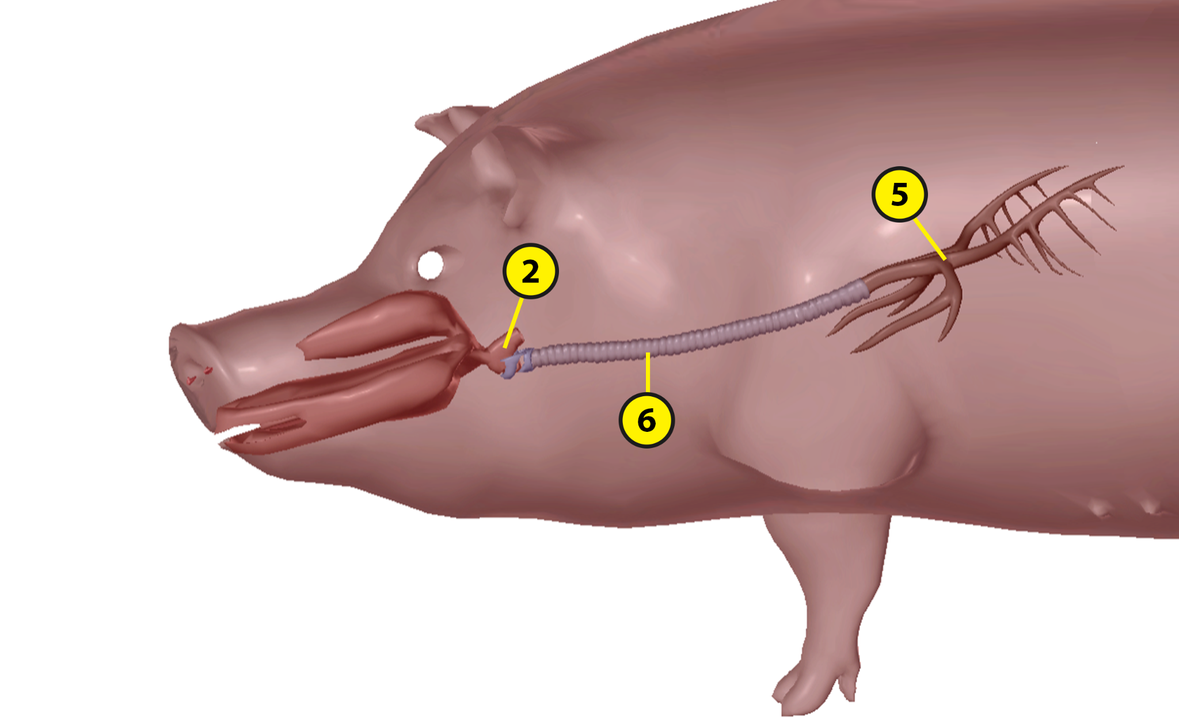

Name: Date:

Lab 2: Respiratory Functions

Activity 1: Explore the respiratory structures of the sea star and their functions

Refer to your labeled sea star image from Lab 1, Activity 1 and the content in Visible Biology. Based on what you’ve learned, match each of the following structures with the brief description of its function.

Structures:
- Skin (epidermis)
- Skin gills

Descriptions:
___ These structures exchange oxygen and carbon dioxide with the water surrounding the sea star.
___ This structure diffuses oxygen from the surrounding water into the sea star’s body.

Name: Date:

Lab 2: Respiratory Functions

Activity 2: Explore the respiratory structures of the earthworm and their functions

Refer to your labeled earthworm image from Lab 1, Activity 2 and the content in Visible Biology. Based on what you’ve learned, match each of the following structures with the brief description of its function.

Structures:
- Cuticle
- Skin (epidermis)

Descriptions:
___ This structure helps the earthworm exchange gases with its environment.
___ This structure diffuses oxygen into capillaries just below its surface.

Name: Date:

Lab 2: Respiratory Functions

Activity 3: Explore the respiratory structures of the frog and their functions

Refer to your labeled frog image from Lab 1, Activity 3 and the content in Visible Biology. Based on what you’ve learned, match each of the following structures with the brief description of its function.

Structures:
- Glottis
- Larynx
- Lungs
- Nostrils
- Skin (epidermis and dermis)

Descriptions:
___ These structures take in oxygen from the air surrounding the frog.
___ These structures allow the frog to breathe while on land.
___ This structure opens into the larynx and allows air to flow between the mouth and the lungs.
___ This structure diffuses oxygen into the frog’s body when it is under water.
___ Air from the mouth moves through the glottis and this structure on its way to the lungs.
Name: Date:

Lab 2: Respiratory Functions

Activity 4: Explore the respiratory structures of the pig and their functions

Refer to your labeled pig images from Lab 1, Activity 4 and the content in Visible Biology. Based on what you’ve learned, match each of the following structures with the brief description of its function.

Structures:
- Bronchi
- Larynx
- Lungs
- Nasal cavity
- Nostrils
- Pharynx
- Trachea

Descriptions:
___ Air moves through this cartilaginous and membranous structure to the lungs.
___ These lobed structures contain alveoli, which facilitate gas exchange.
___ Air moves from the pharynx through this structure to the trachea.
___ This structure receives air from both the oral and nasal cavities.
___ These structures branch out from the trachea into the lungs, dividing into smaller airways.
___ This structure receives air that enters through the nostrils.
___ These structures take in air from the surrounding environment.
Name: Date:

Lab 3: Evolutionary Similarities and Differences

Based on what you’ve learned about the respiratory structures of the sea star, earthworm, frog, and pig, answer the following questions about their evolutionary similarities and differences and the adaptations that help them survive in their environments.

- All animals have respiratory structures that exchange gases with their environments. The sea star, earthworm, frog, and pig have some similarities in their respiratory structures and functions.
  - All four animals receive ____________ from the air or water around them and pass ____________________ back into their environments.
  - Sea stars, earthworms, and frogs can all diffuse gases through their __________. For this structure to carry out its respiratory functions, it must remain __________, either from the surrounding environment or from substances produced by the animal.
  - Like pigs, frogs also have __________, which allow them to breathe on land. This means that frogs and pigs can both breathe via ______________ respiration.

- These animals also have some unique respiratory structures that distinguish them from each other. They developed these unique structures to help them survive in their environments.
  - What are two unique structures the sea star has that help it exchange gases with the water around it?

  - What role does the earthworm’s cuticle play in gas exchange?

  - The frog has some unique respiratory system adaptations that help it survive on land and in water.
    - When the frog is on land, air enters through the ____________ and passes through the oral cavity and a slit that opens into the larynx, called the ____________, on its way to the lungs.
    - In addition to breathing through their lungs, frogs can also receive oxygen via ______________ respiration through the skin. Glands throughout the __________ secrete watery mucus that keeps the skin moist, helping to facilitate gas exchange.
  - Like humans and other mammals, pigs have a more complex respiratory system. Air enters through the pig’s nostrils and mouth and passes through several structures on its way to the lungs.
    - Air passes from the nasal and oral cavities into the ____________, a respiratory and digestive structure that connects to the larynx and esophagus. From this structure, air moves over the __________________ in the larynx, causing them to vibrate and create the pig’s sounds.
    - Next, air moves through a cartilaginous and membranous tube, called the ____________, which branches into smaller airways called ____________ and bronchioles.
    - From these small airways, air moves into the lungs. The pig’s right lung is divided into __________ lobes and its left lung is divided into __________ lobes. The lungs contain the smallest respiratory units, the ____________, which facilitate gas exchange.

- Match each of the following animals with the description of how it takes in oxygen from its environment.

Animals:
- Sea star
- Earthworm
- Frog
- Pig

Digestive Adaptations:
___ This animal breathes through its nose and mouth, passing air into its lobed lungs, where gas exchange occurs.
___ This animal diffuses oxygen through its skin into capillaries below the skin’s surface.
___ This animal diffuses oxygen into its body through its skin, skin gills, and tube feet.
___ This animal can breathe in the water and on land via its skin and lungs.

- Based on what you’ve learned by labeling the respiratory structures of these animals in Lab 1 and matching the structures with their functions in Lab 2, put these animals in order, from simplest to most complex (where 1 has the simplest respiratory system and 4 has the most complex respiratory system).
___ Earthworm
___ Pig
___ Sea star
___ Frog

