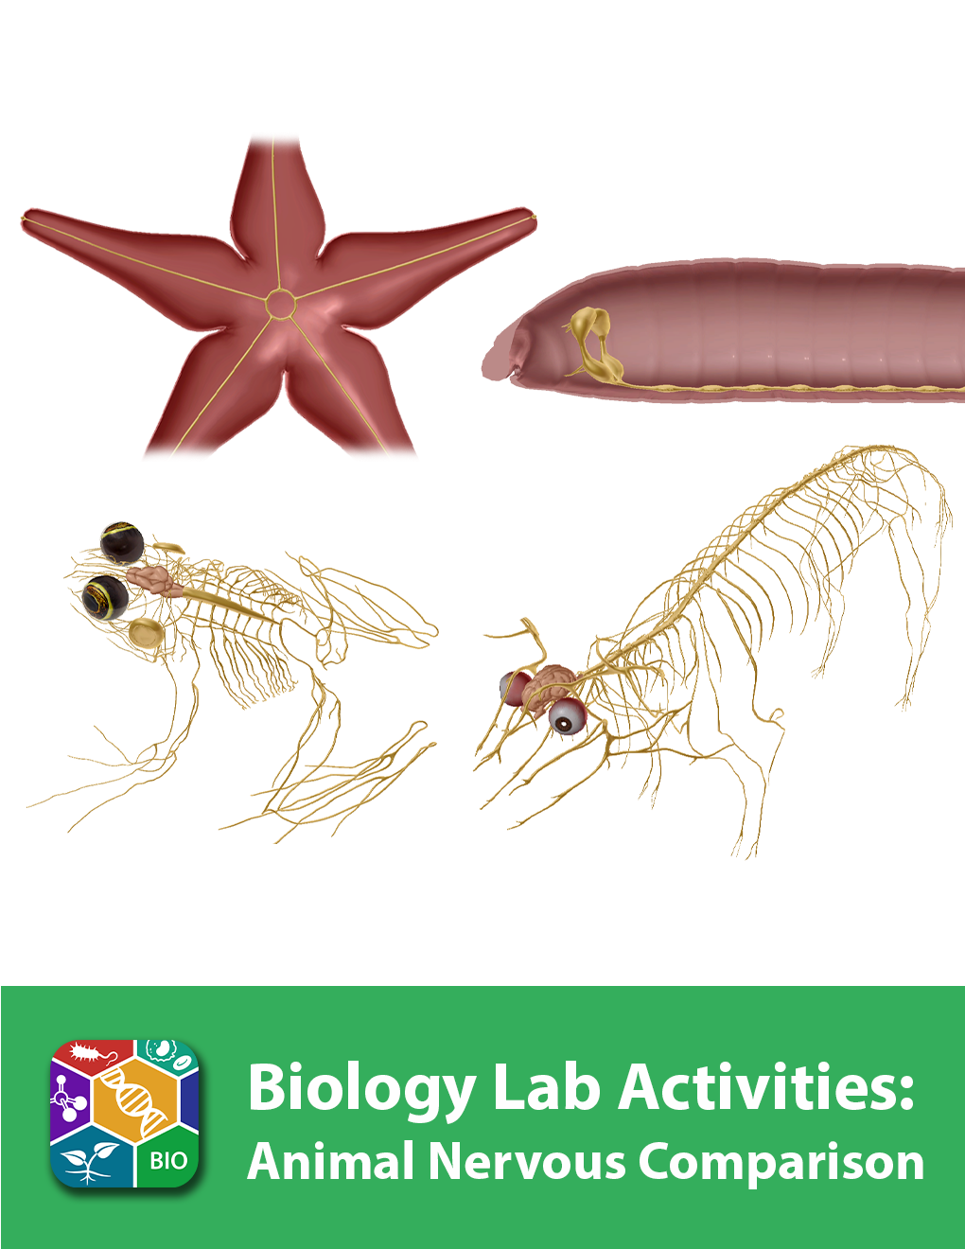
This lab manual is intended for use with the Visible Biology product.

Where to find 3D models
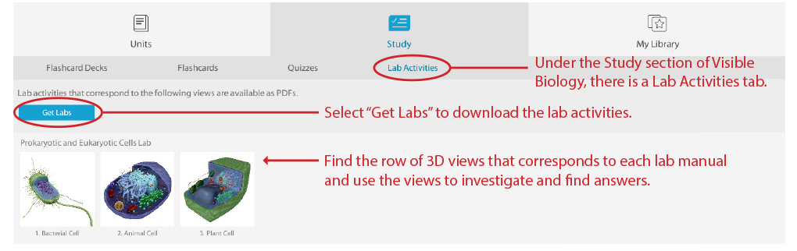
How to save answers
- Have Adobe Reader installed on your computer.
Windows: https://get.adobe.com/reader/
Mac: https://helpx.adobe.com/acrobat/kb/install-reader-dc-mac-os.html

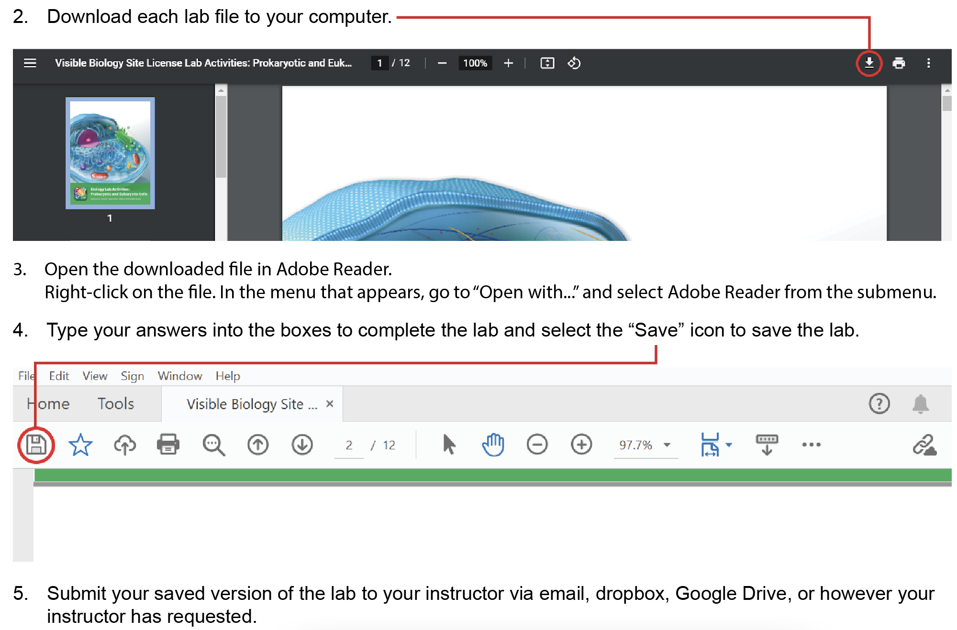

Any questions? visiblebiology.com

Name: Date:

Biology Lab Activities: Animal Nervous Comparison
Last updated: 3/24/2023

Background Questions

Based on what you’ve learned in class, in your textbook, and from using Visible Biology, answer the following questions about the nervous structures and functions of the sea star, earthworm, frog, and pig.

- Earthworms, frogs, and pigs all have central and peripheral nervous systems. The sea star has a much simpler nervous system.
  - Earthworms, frogs, and pigs all have a __________ that processes sensory signals and transmits motor commands throughout the body. Sea stars lack this structure.
  - Frogs and pigs have a __________________ that processes their reflexes and carries nervous signals between the brain and the body. The earthworm has a similar structure, the ________________________, which carries nervous signals between the brain and peripheral nerves in each body segment.
  - Sea stars have ______________ in the epidermis that receive touch and smell information from their environment. They also have ______________ at the end of their arms that detect light intensity from their environment. Their nerves carry these sensory signals to the rest of the body.

- Although each of these animals has some unique nervous structures, the process for moving nervous signals throughout the body is similar in all of them. In 2–3 sentences, describe how nervous signals are sent throughout the body.

Name: Date:

Lab 1: Nervous Structures

Activity 1: Label the sea star’s nervous structures

- Launch the view
  - Launch Visible Biology.
  - Navigate to Study/Lab Activities, and find the Evolution: Animal Diversity Lab section.
  - Select view 9. Sea Star, Nervous.
- Label the image below
  - Explore the 3D model of the sea star to find the structures you need to label.
  - Fill in the blanks to label the structures from the list below.
Word List:
Eyespot
Nerve ring
Radial nerves
___
___
___

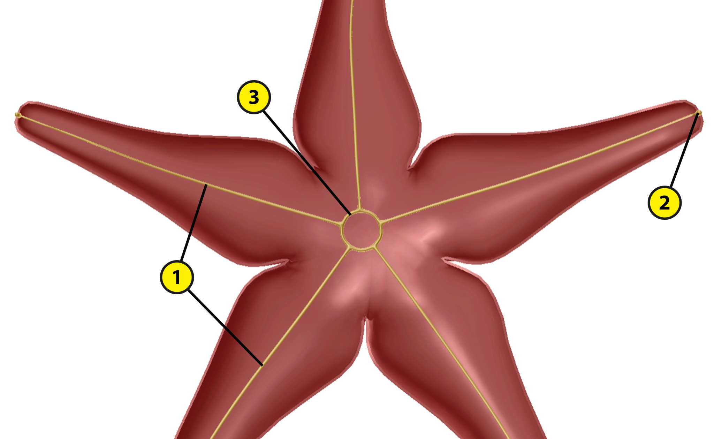

Name: Date:

Lab 1: Nervous Structures

Activity 2: Label the earthworm’s nervous structures

- Launch the view
  - Launch Visible Biology.
  - Navigate to Study/Lab Activities, and find the Evolution: Animal Diversity Lab section.
  - Select view 10. Earthworm, Nervous.
- Label the image below
  - Explore the 3D model of the earthworm to find the structures you need to label.
  - Fill in the blanks to label the structures from the list below.
Word List:
Brain (cerebral ganglia)
Subpharyngeal ganglia
Ventral nerve cord
___
___
___

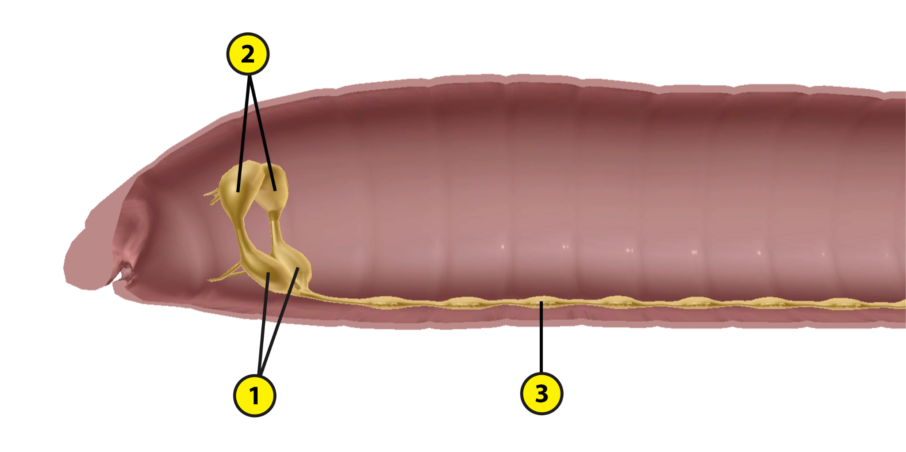

Name: Date:

Lab 1: Nervous Structures

Activity 3: Label the frog’s nervous structures

- Launch the view
  - Launch Visible Biology.
  - Navigate to Study/Lab Activities, and find the Evolution: Animal Diversity Lab section.
  - Select view 11. Frog, Nervous.
- Label the image below
  - Explore the 3D model of the frog to find the structures you need to label.
  - Fill in the blanks to label the structures from the list below.

Word List:
Brain
Eyes
Nerves
Nictitating membrane
Spinal cord
Tympanic membranes

___
___
___
___
___
___

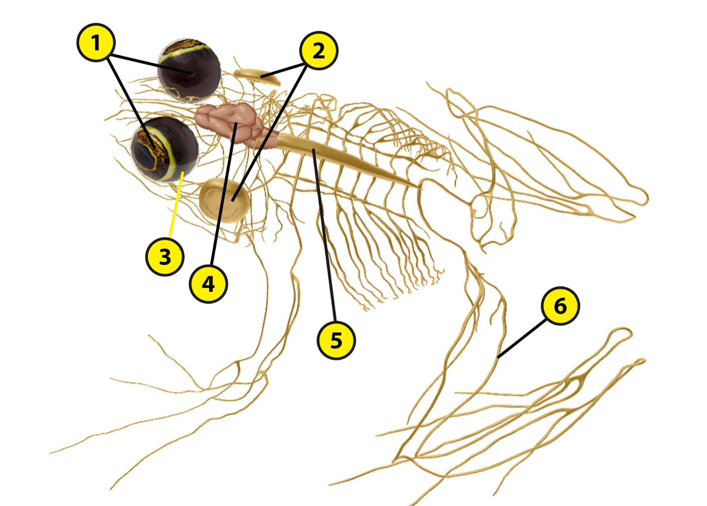

Name: Date:

Lab 1: Nervous Structures

Activity 4: Label the pig’s nervous structures

- Launch the view
  - Launch Visible Biology.
  - Navigate to Study/Lab Activities, and find the Evolution: Animal Diversity Lab section.
  - Select view 12. Pig, Nervous.
- Label the image below
  - Explore the 3D model of the pig to find the structures you need to label.
  - Fill in the blanks to label the structures from the list below.
Word List
Brain
Cranial nerves
Eyes
Peripheral nerves
Spinal cord
Spinal nerves

___
___
___
___
___
___

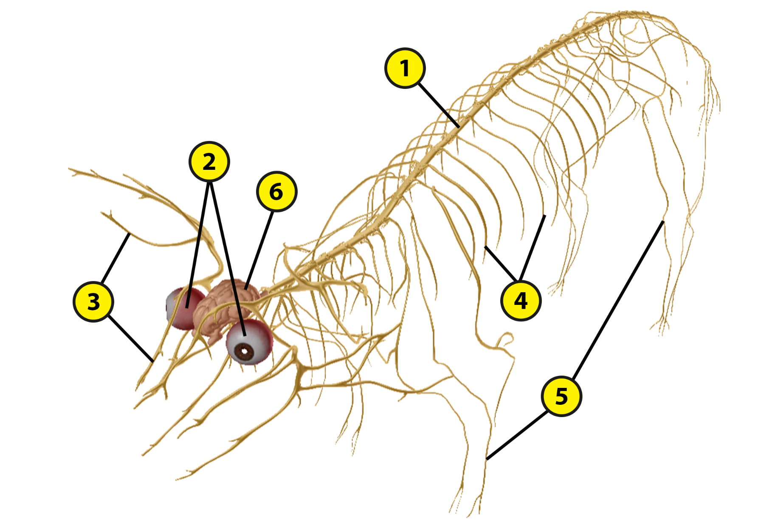
Name: Date:

Lab 2: Nervous Functions

Activity 1: Explore the nervous structures of the sea star and their functions

Refer to your labeled sea star image from Lab 1, Activity 1 and the content in Visible Biology. Based on what you’ve learned, match each of the following structures with the brief description of its function.

Structures:
- Eyespots
- Nerve ring
- Radial nerves

Descriptions:
___ These structures carry nervous signals along each of the sea star’s arms.
___ These structures detect light intensity within the sea star’s environment.
___ This structure carries nervous signals around the central disk and into the nerves in the arms.
Name: Date:

Lab 2: Nervous Functions

Activity 2: Explore the nervous structures of the earthworm and their functions

Refer to your labeled earthworm image from Lab 1, Activity 2 and the content in Visible Biology. Based on what you’ve learned, match each of the following structures with the brief description of its function.

Structures:
- Brain (cerebral ganglia)
- Subpharyngeal ganglia
- Ventral nerve cord

Descriptions:
___ These structures connect the brain to the ventral nerve cord.
___ This structure carries nervous signals between the brain and the peripheral nerves in each body segment.
___ This structure processes sensory signals from the body segments and sends motor commands to move the earthworm.
Name: Date:

Lab 2: Nervous Functions

Activity 3: Explore the nervous structures of the frog and their functions

Refer to your labeled frog image from Lab 1, Activity 3 and the content in Visible Biology. Based on what you’ve learned, match each of the following structures with the brief description of its function.

Structures:
- Brain
- Eyes
- Nerves
- Nictitating membranes
- Spinal cord
- Tympanic membranes

Descriptions:
___ These structures prevent the eyes from drying out and protect them from debris.
___ These structures connect to the optic lobes of the forebrain via the optic nerves, allowing the frog to process visual information rapidly.
___ These structures transmit sound vibrations to the inner ear.
___ These structures carry sensory and motor signals between the brain, spinal cord, and body.
___ This structure processes sensory information and generates motor commands.
___ This structure processes the frog’s reflexes and relays information between the brain and the nerves.
Name: Date:

Lab 2: Nervous Functions

Activity 4: Explore the nervous structures of the pig and their functions

Refer to your labeled pig image from Lab 1, Activity 4 and the content in Visible Biology. Based on what you’ve learned, match each of the following structures with the brief description of its function.

Structures:
- Brain
- Cranial nerves
- Eyes
- Peripheral nerves
- Spinal cord
- Spinal nerves

Descriptions:
___ This structure processes the pig’s reflexes and relays information between the brain and the spinal nerves.
___ These structures connect to the optic nerves to relay visual stimuli.
___ This structure processes sensory information and generates motor commands.
___ These structures branch out from the spinal cord and carry nervous signals throughout the body.
___ These structures relay information between the brain and the sensory organs and other structures within the head and upper body.
___ These structures carry sensory and motor signals between the brain, spinal cord, and body.
Name: Date:

Lab 3: Evolutionary Similarities and Differences

Based on what you’ve learned about the nervous structures of the sea star, earthworm, frog, and pig, answer the following questions about their evolutionary similarities and differences and the adaptations that help them survive in their environments.

- All animals have structures that move nervous signals throughout the body. The sea star, earthworm, frog, and pig have some similarities in their nervous structures and functions.
  - All four animals have nerves that run throughout their bodies.
    - Sea stars have a ______________ that runs around the central disk and __________ nerves that run along the arms.
    - Earthworms have a ________________________ that runs the length of its body, connecting the brain to ______________ nerves that carry nervous signals to the body segments.
    - Frogs and pigs both have __________ nerves that relay information between the brain and the sensory organs and other structures in the head and upper body. They also have __________ nerves that branch from the spinal cord and carry nervous signals between the brain and the body.
  - Earthworms, frogs, and pigs all have __________ and ______________ nervous systems. All three of these animals have a __________ that processes and generates nervous signals.

- These animals also have some unique nervous structures that distinguish them from each other. They developed these unique structures to help them receive sensory signals from their environments and generate motor commands to help them move through their environments.
  - What makes the sea star’s nervous system unique from the other animals?

  - What two unique nervous structures does the earthworm have that the other animals don’t?

  - The frog has some unique nervous system adaptations that help it survive on land and in water.
    - The frog’s eyes extend from its brain, connecting to the optic lobes of the forebrain via ________________. This allows the frog to process visual information quickly and from any angle with its __________ degree vision.
    - The frog has __________________________ that protect its eyes from drying out when the frog is on land. They also protect the eyes from debris when the frog is swimming, sleeping, or hibernating.
    - The frog relies on its hearing to find mates and protect its territory. It has ________________________ that transmit sound to the inner ear. The ________________________ connect the inner ear to the throat and equalize pressure in the frog’s inner ear when it is underwater.
  - Like humans, frogs and pigs have a central nervous system, with a brain and spinal cord.
    - The brain and spinal cord are composed of __________ and white matter tissue. They are protected by layers of membranes, called ______________.
    - The spinal cord extends posteriorly from the ______________________ of the brain, down the vertebral column.
    - As vertebrates, the frog and pig have a __________ that protects the brain and ______________ that protect the spinal cord.
    - The largest part of the brain, the ______________, is divided into two hemispheres. Located behind this structure are the ________________, which ensures smooth body movements, and a brainstem that connects the brain to the spinal cord.

- Match each of the following animals with the description of how it receives sensory information from its environment.

Animals:
- Sea star
- Earthworm
- Frog
- Pig

Digestive Adaptations:
___ This animal receives sensory information mostly through its ears and eyes.
___ This animal detects light intensity through its eyespots and touch and smell information through receptors in its epidermis.
___ This animal receives sensory information through its eyes, ears, nostrils, and skin.
___ This animal receives light and dark, tactile, taste, smell, and chemical signals through receptors in its epidermis.

- Based on what you’ve learned by labeling the nervous structures of these animals in Lab 1 and matching the structures with their functions in Lab 2, put these animals in order, from simplest to most complex (where 1 has the simplest nervous system and 4 has the most complex nervous system).
___ Earthworm
___ Pig
___ Sea star
___ Frog

