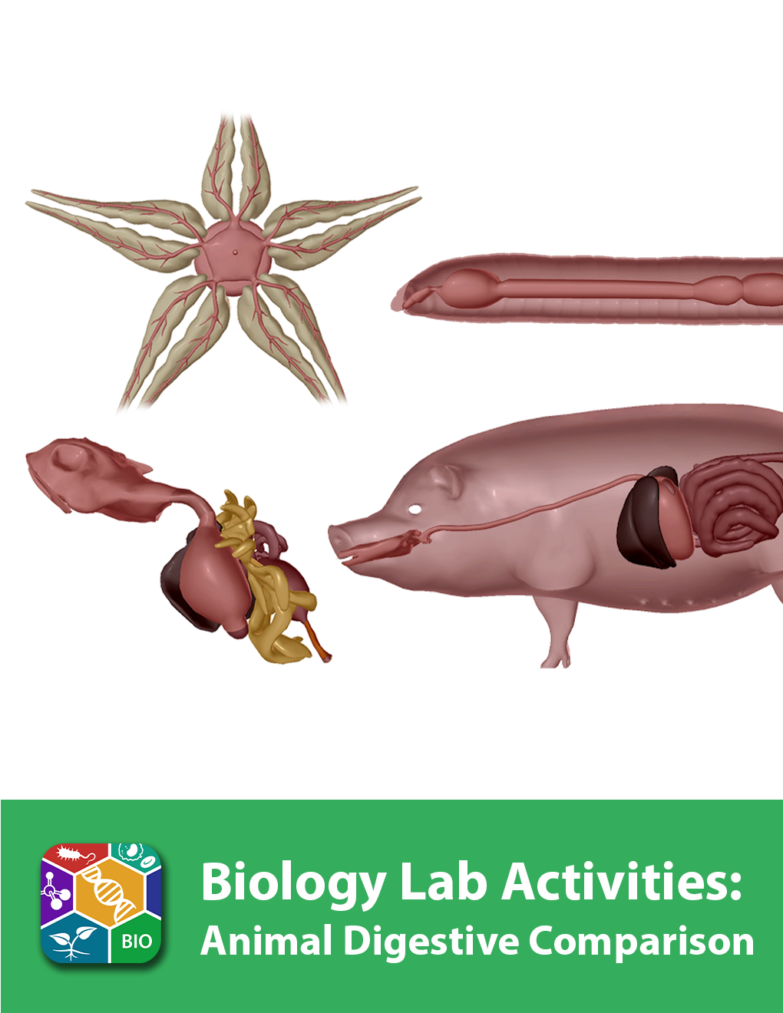
This lab manual is intended for use with the Visible Biology product.

Where to find 3D models
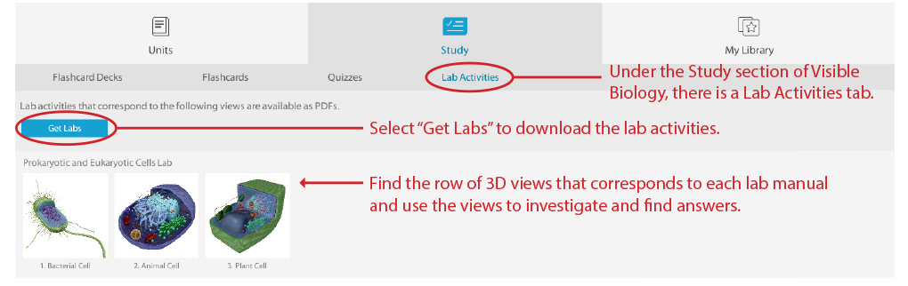
How to save answers
- Have Adobe Reader installed on your computer.
Windows: https://get.adobe.com/reader/
Mac: https://helpx.adobe.com/acrobat/kb/install-reader-dc-mac-os.html

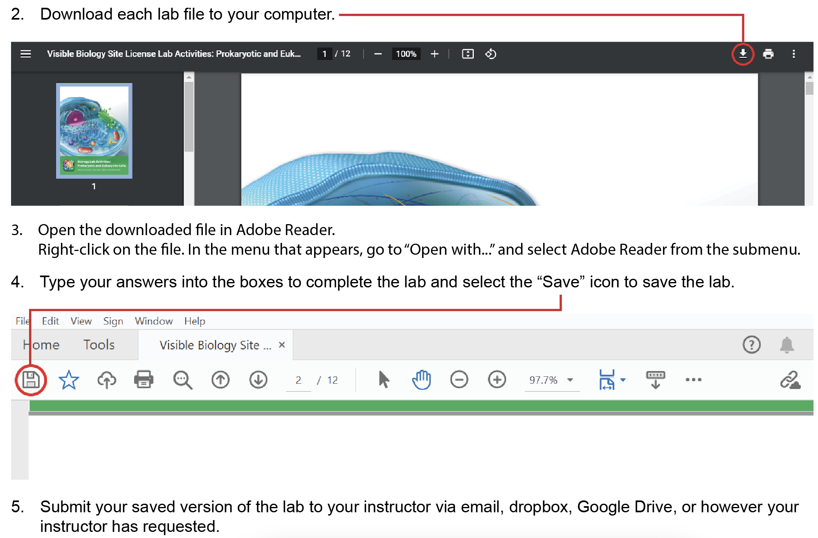

Any questions? visiblebiology.com
Name: Date:

Biology Lab Activities: Animal Digestive Comparison
Last updated: 2/23/2023

Background Questions

Based on what you’ve learned in class, in your textbook, and from using Visible Biology, answer the following questions about the digestive structures and functions of the sea star, earthworm, frog, and pig.

- Where an animal lives impacts the type of food it eats and how it eats.
  - Sea stars live in the water, and they eat coral, sponges, oysters, clams, and mussels. They ingest small food particles through the __________, and they can push the ____________________ out of the mouth to engulf or penetrate prey or to wedge open shells to eat the prey inside.
  - Earthworms live in the soil, and they are decomposers or detritivores that eat plants, bacteria, and fungi. They ingest food through the __________ as they move through the soil.
  - Frogs live on land and in the water, and they eat small invertebrates, including insects, spiders, and worms. They catch live prey with a retractable __________, and the food remains alive until it reaches the __________.
  - Pigs live on the land, and they are omnivores that eat plants and animals. They root in the soil for food, using a long __________ and __________, which are canine teeth that project out of the mouth.

- Although each of these animals has some unique digestive structures, the digestive process is similar in all of them. In 2–3 sentences, describe how animals ingest and digest food and pass waste.

Name: Date:

Lab 1: Digestive Structures

Activity 1: Label the sea star’s digestive structures

- Launch the view
  - Launch Visible Biology.
  - Navigate to Study/Lab Activities, and find the Evolution: Animal Diversity Lab section.
  - Select view 1. Sea Star, Digestive.
- Label the image below
  - Explore the 3D model of the sea star to find the structures you need to label.
  - Fill in the blanks to label the structures from the list below.
Word List:
Anus
Cardiac stomach
Mouth
Pyloric caeca (glands)
Pyloric ducts
Pyloric stomach

___
___
___
___
___
___
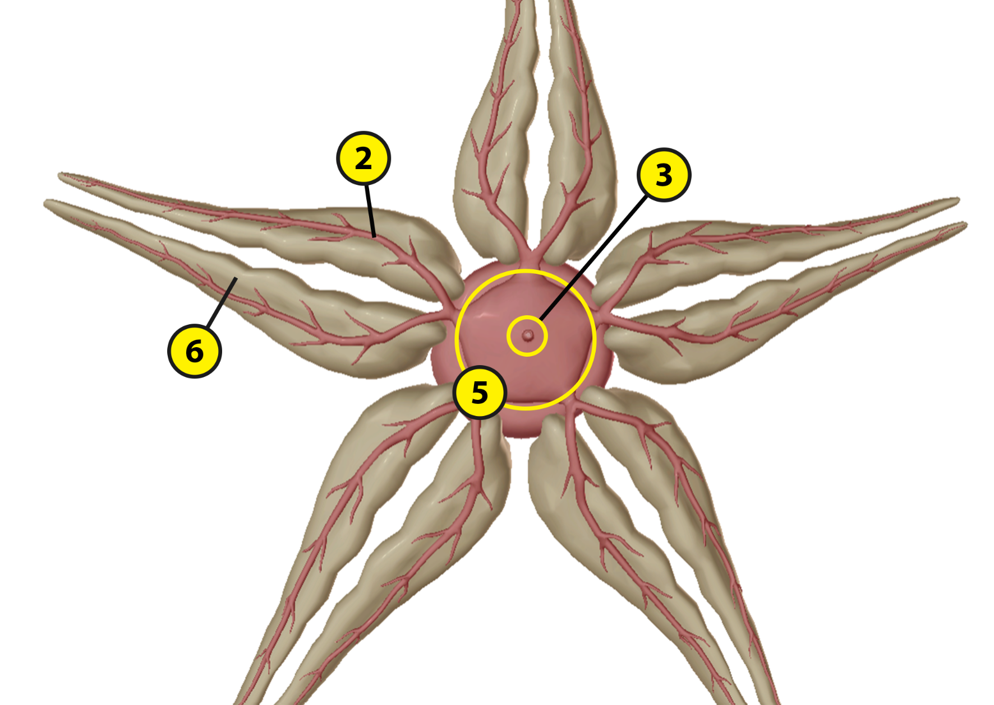
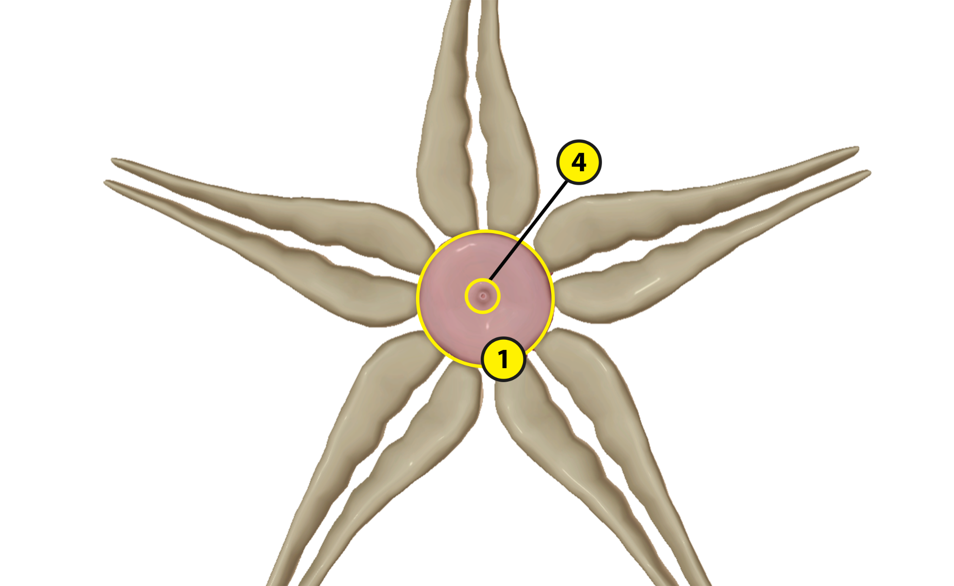

Name: Date:

Lab 1: Digestive Structures

Activity 2: Label the earthworm’s digestive structures

- Launch the view
  - Launch Visible Biology.
  - Navigate to Study/Lab Activities, and find the Evolution: Animal Diversity Lab section.
  - Select view 2. Earthworm, Digestive.
- Label the image below
  - Explore the 3D model of the earthworm to find the structures you need to label.
  - Fill in the blanks to label the structures from the list below.
Word List:
Anus
Crop
Esophagus
Gizzard
Intestine
Mouth
Pharynx

___
___
___
___
___
___
___

Name: Date:

Lab 1: Digestive Structures

Activity 3: Label the frog’s digestive structures

- Launch the view
  - Launch Visible Biology.
  - Navigate to Study/Lab Activities, and find the Evolution: Animal Diversity Lab section.
  - Select view 3. Frog, Digestive.
- Label the image below
  - Explore the 3D model of the frog to find the structures you need to label.
  - Fill in the blanks to label the structures from the list below.

Word List:
Anus
Cloaca (vent)
Esophagus
Fat bodies
Gallbladder
Large intestine (colon)
Liver
Oral cavity
Pancreas
Small intestine
Stomach

___
___
___
___
___
___
___
___
___
___
___

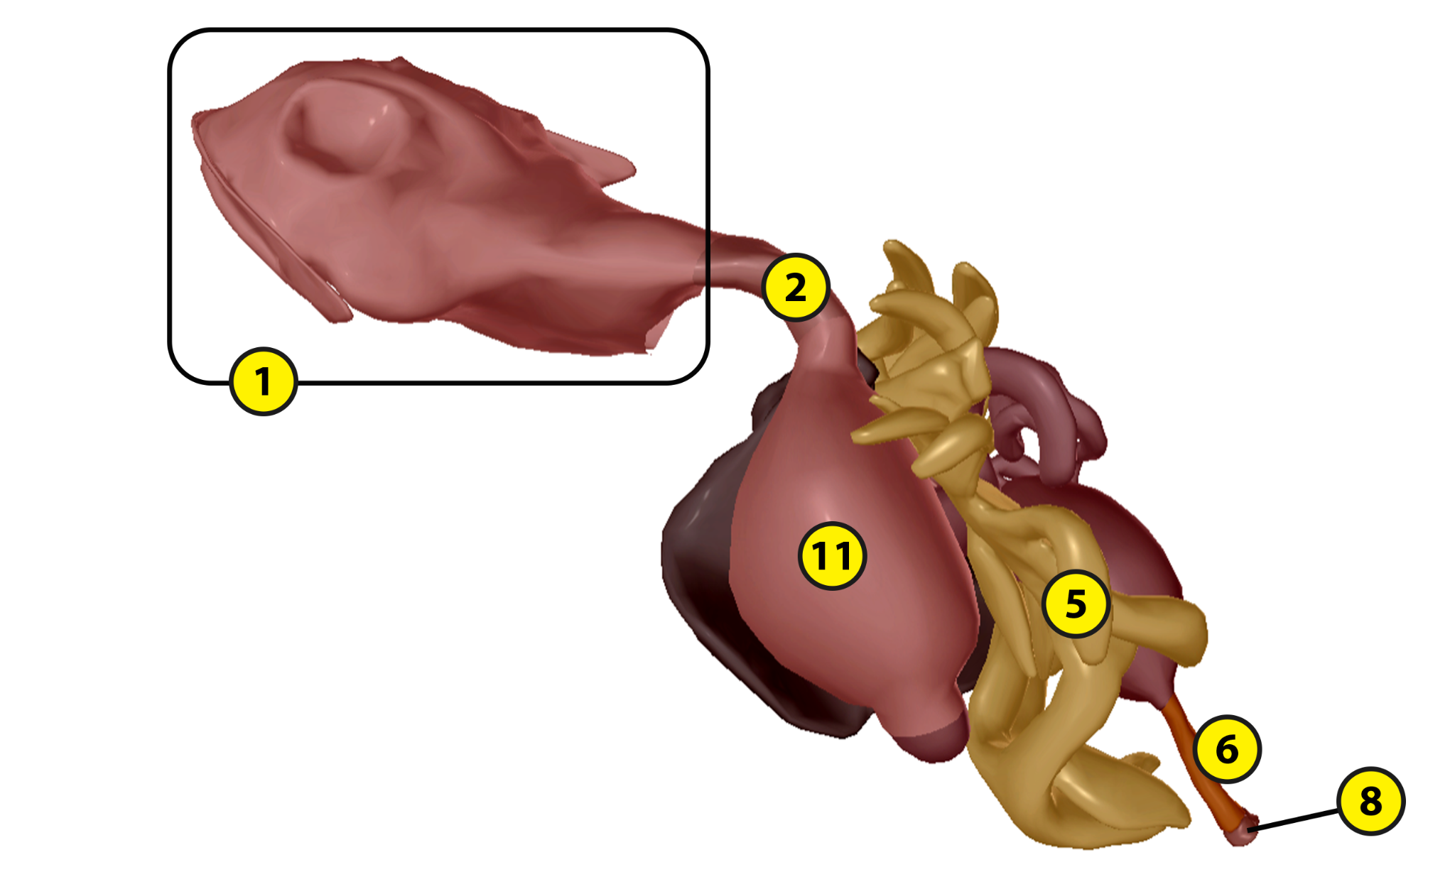
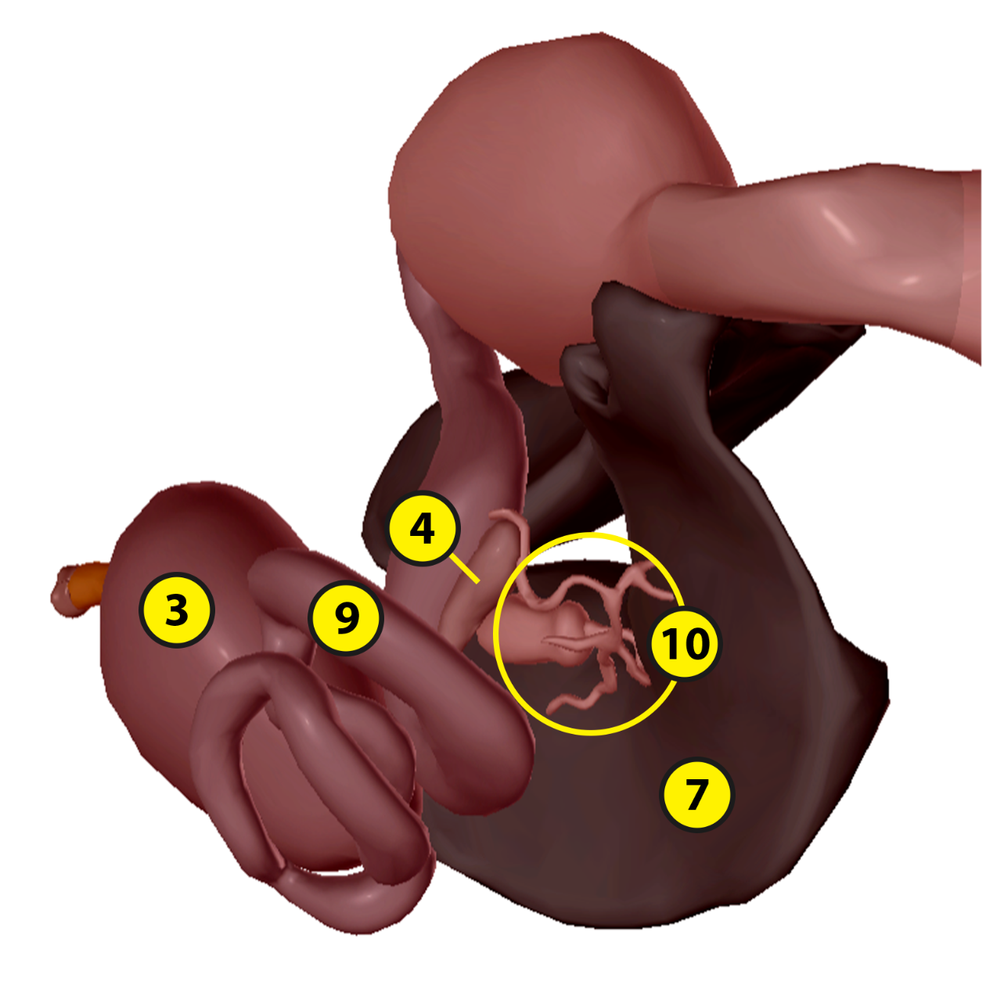
Name: Date:

Lab 1: Digestive Structures

Activity 4: Label the pig’s digestive structures

- Launch the view
  - Launch Visible Biology.
  - Navigate to Study/Lab Activities, and find the Evolution: Animal Diversity Lab section.
  - Select view 4. Pig, Digestive.
- Label the image below
  - Explore the 3D model of the pig to find the structures you need to label.
  - Fill in the blanks to label the structures from the list below.
Word List
Anus
Esophagus
Gallbladder
Large intestine
Liver
Oral cavity
Pancreas
Pharynx
Rectum
Small intestine
Stomach

___
___
___
___
___
___
___
___
___
___
___

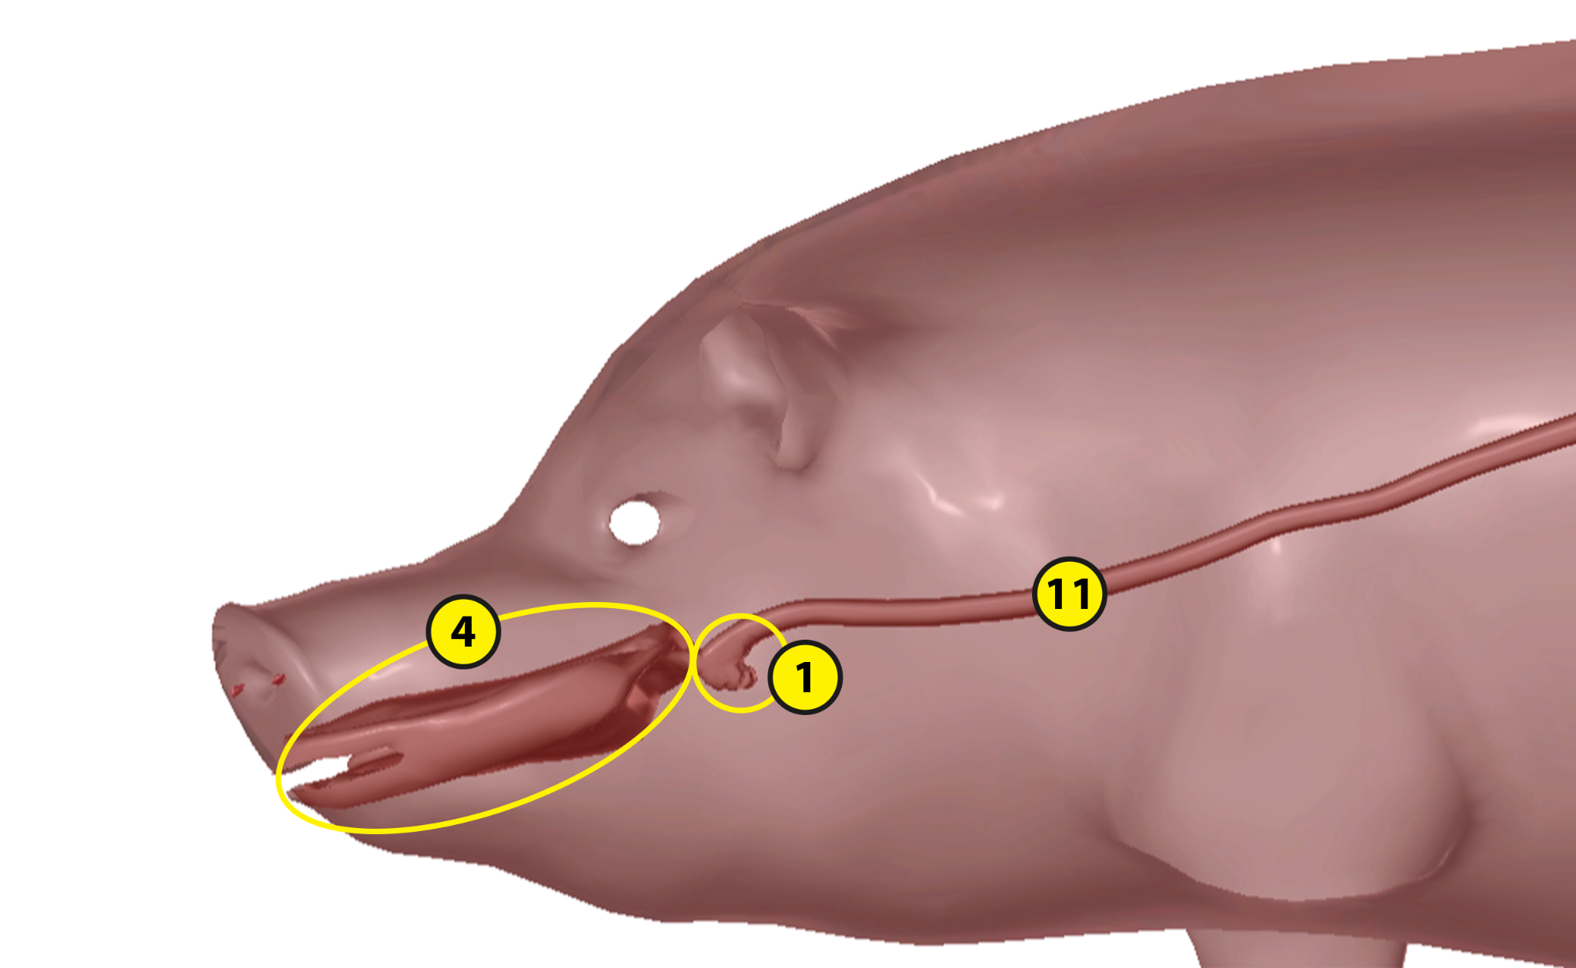

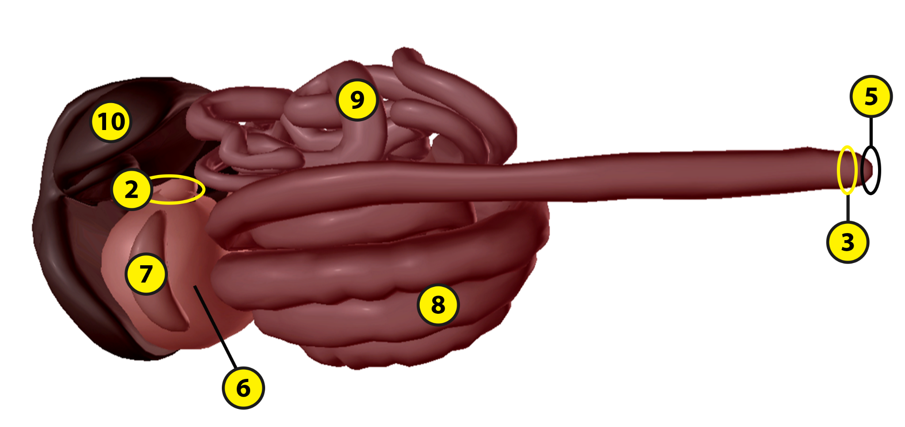
Name: Date:

Lab 2: Digestive Functions

Activity 1: Explore the digestive structures of the sea star and their functions

Refer to your labeled sea star images from Lab 1, Activity 1 and the content in Visible Biology. Based on what you’ve learned, match each of the following structures with the brief description of its function.

Structures:
- Anus
- Cardiac stomach
- Mouth
- Pyloric caeca (glands)
- Pyloric ducts
- Pyloric stomach

Descriptions:
___ This structure excretes waste.
___ These structures excrete enzymes to be used during digestion.
___ These structures carry enzymes to the pyloric stomach.
___ This structure can be pushed through the sea star’s mouth to start digesting food outside the body.
___ Food travels from the cardiac stomach to this structure, where enzymes break down food into nutrients.
___ This structure, located on the oral surface of the sea star, can ingest small food particles.
Name: Date:

Lab 2: Digestive Functions

Activity 2: Explore the digestive structures of the earthworm and their functions

Refer to your labeled earthworm images from Lab 1, Activity 2 and the content in Visible Biology. Based on what you’ve learned, match each of the following structures with the brief description of its function.

Structures:
- Anus
- Crop
- Esophagus
- Gizzard
- Intestine
- Mouth
- Pharynx

Descriptions:
___ This structure secretes enzymes to break down food into absorbable nutrients.
___ This structure stores food before it moves through the gizzard and intestine.
___ Within this structure, muscle contractions allow the earthworm to swallow food.
___ This structure excretes waste.
___ This structure uses stones that collect over time to grind down food.
___ In this structure, calcium is pumped in to balance the blood calcium levels and the food’s pH levels.
___ Food is ingested through this structure.
Name: Date:

Lab 2: Digestive Functions

Activity 3: Explore the digestive structures of the frog and their functions

Refer to your labeled frog images from Lab 1, Activity 3 and the content in Visible Biology. Based on what you’ve learned, match each of the following structures with the brief description of its function.

Structures:
- Cloaca (vent)
- Esophagus
- Fat bodies
- Large intestine (colon)
- Liver
- Small intestine
- Stomach

Descriptions:
___ This structure reabsorbs water from food to help prevent dehydration and solidify waste.
___ These structures provide extra nourishment for the frog during periods of hibernating or the breeding season.
___ This structure contains digestive enzymes that break down food into nutrients.
___ Waste passes through this structure to the anus.
___ This structure receives bile and pancreatic juices to help it break down and absorb nutrients from food.
___ This structure produces bile to help fully break down food into absorbable nutrients.
___ Within this structure, muscle contractions move food into the stomach.
Name: Date:

Lab 2: Digestive Functions

Activity 4: Explore the digestive structures of the pig and their functions

Refer to your labeled pig images from Lab 1, Activity 4 and the content in Visible Biology. Based on what you’ve learned, match each of the following structures with the brief description of its function.

Structures:
- Esophagus
- Gallbladder
- Large intestine
- Liver
- Oral cavity
- Pancreas
- Pharynx
- Small intestine
- Stomach

Descriptions:
___ This structure contains digestive juices that help break down food into nutrients and villi that help with nutrient absorption.
___ This structure absorbs water to help prevent dehydration and consolidates indigestible matter into waste.
___ This structure produces and secretes bile, which helps break down fats in the small intestine.
___ This structure contains digestive juices that start to break down food.
___ This structure stores bile for later use to help break down fats.
___ Swallowed food moves through this structure on its way to the esophagus.
___ After passing through the pharynx, food moves through this structure on its way to the stomach.
___ Within this structure, the teeth grind down food and mix it with digestive enzymes in the saliva, starting the digestive process.
___ This structure secretes digestive juices for the small intestine and produces insulin and glucagon to regulate blood sugar levels.
Name: Date:

Lab 3: Evolutionary Similarities and Differences

Based on what you’ve learned about the digestive structures of the sea star, earthworm, frog, and pig, answer the following questions about their evolutionary similarities and differences and the adaptations that help them survive in their environments.

- All animals need nutrients to survive. The sea star, earthworm, frog, and pig have some similarities in their digestive structures and functions.
  - All four animals eat other animals as part of their diet. Earthworms and __________ are both omnivores, and __________ and frogs are both carnivores.
  - Within their digestive structures, all four animals produce __________ that break down the food into absorbable nutrients.
  - What are two digestive structures that the sea star, earthworm, frog, and pig all have? (Hint: one structure receives food and the other expels waste.)

- These animals also have some unique digestive structures that distinguish them from each other. They developed these unique structures to help them break down their food into the nutrients they need to survive in their environments.
  - Which two structures does the earthworm have that the other animals don’t and what do these structures do?

  - How is the sea star able to break the shell of its prey and eat prey that’s bigger than it is?

  - What is the function of the frog’s fat bodies?

  - Unlike sea stars and earthworms, frogs and pigs both have teeth, but they use them in different ways. In 2–3 sentences, describe how each of these animals uses its teeth.

- Match each of the following animals with one of its key digestive adaptations.

Animals:
- Sea star
- Earthworm
- Frog
- Pig

Digestive Adaptations:
___ This animal can ingest soil and process nutrients from organic matter, including plants, bacteria, and fungi.
___ This animal roots in the soil for food and has an omnivorous diet that allows it to live in many different environments.
___ This animal can push its cardiac stomach out of its mouth to start digesting food outside its body.
___ This animal uses its retractable tongue to catch and eat live prey.

- Based on what you’ve learned by labeling the digestive structures of these animals in Lab 1 and matching the structures with their functions in Lab 2, put these animals in order, from simplest to most complex (where 1 has the simplest digestive structures and 4 has the most complex digestive structures).
___ Earthworm
___ Pig
___ Sea star
___ Frog

