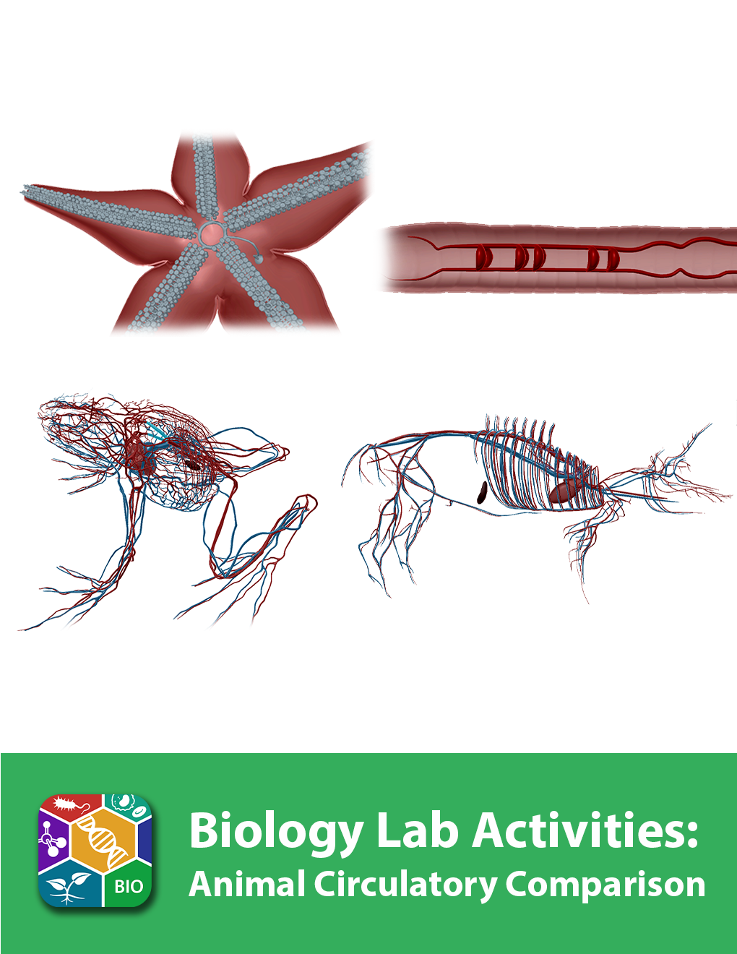
This lab manual is intended for use with the Visible Biology product.

Where to find 3D models
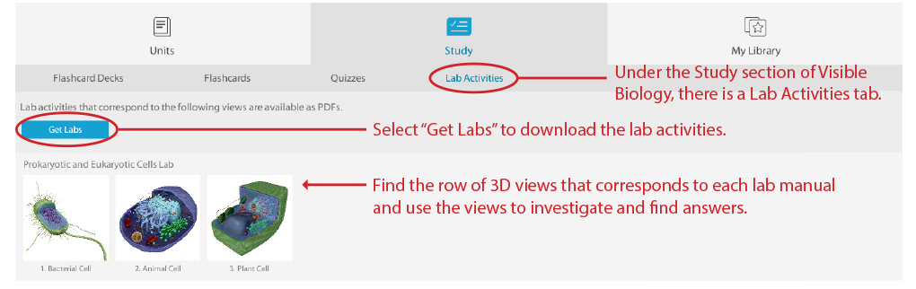
How to save answers
- Have Adobe Reader installed on your computer.
Windows: https://get.adobe.com/reader/
Mac: https://helpx.adobe.com/acrobat/kb/install-reader-dc-mac-os.html

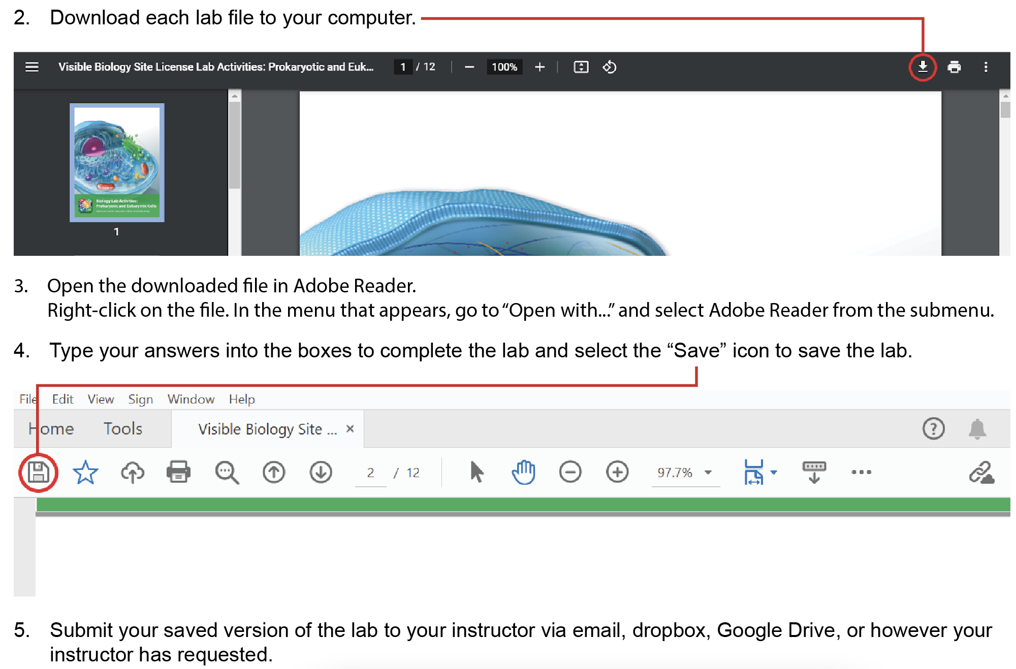

Any questions? visiblebiology.com

Name: Date:

Biology Lab Activities: Animal Circulatory Comparison
Last updated: 3/17/2023

Background Questions

Based on what you’ve learned in class, in your textbook, and from using Visible Biology, answer the following questions about the circulatory structures and functions of the sea star, earthworm, frog, and pig.

- Most animals have vessels that circulate fluid throughout their bodies. Some animals have complex circulatory systems, whereas others are simpler.
  - Sea stars have an inefficient __________ circulatory system, in which fluid is leaked out of sinuses throughout the body and then slowly reabsorbed and recirculated. In contrast, earthworms, frogs, and pigs have a __________ circulatory system, in which blood is pumped under pressure throughout the body much faster and more efficiently.
  - Instead of circulating blood, sea stars circulate __________ throughout their bodies in a series of __________ that run around the central disk and down each arm.
  - Earthworms have two main blood vessels, called the __________ and __________ blood vessels that carry blood between the anterior and posterior ends of the body.
  - Frogs and pigs have complex networks of __________ and __________ that carry blood between the heart, lungs, and body tissues.

- Another circulatory structure that’s often compared across animals is the heart. Although sea stars don’t have hearts, earthworms, frogs, and pigs do. Answer the following questions about the hearts of these animals.
  - Earthworms can have up to __________ hearts (aortic arches) that pump blood throughout their bodies.
  - Frogs have a single heart with __________ chambers.
  - Pigs also have a single heart with __________ chambers.

Name: Date:

Lab 1: Circulatory Structures

Activity 1: Label the sea star’s circulatory structures

- Launch the view
  - Launch Visible Biology.
  - Navigate to Study/Lab Activities, and find the Evolution: Animal Diversity Lab section.
  - Select view 5. Sea Star, Circulatory.
- Label the image below
  - Explore the 3D model of the sea star to find the structures you need to label.
  - Fill in the blanks to label the structures from the list below.
Word List:
Ampullae
Lateral canals
Madreporite
Podia (of tube feet)
Radial canal
Ring canal
Stone canal

___
___
___
___
___
___
___

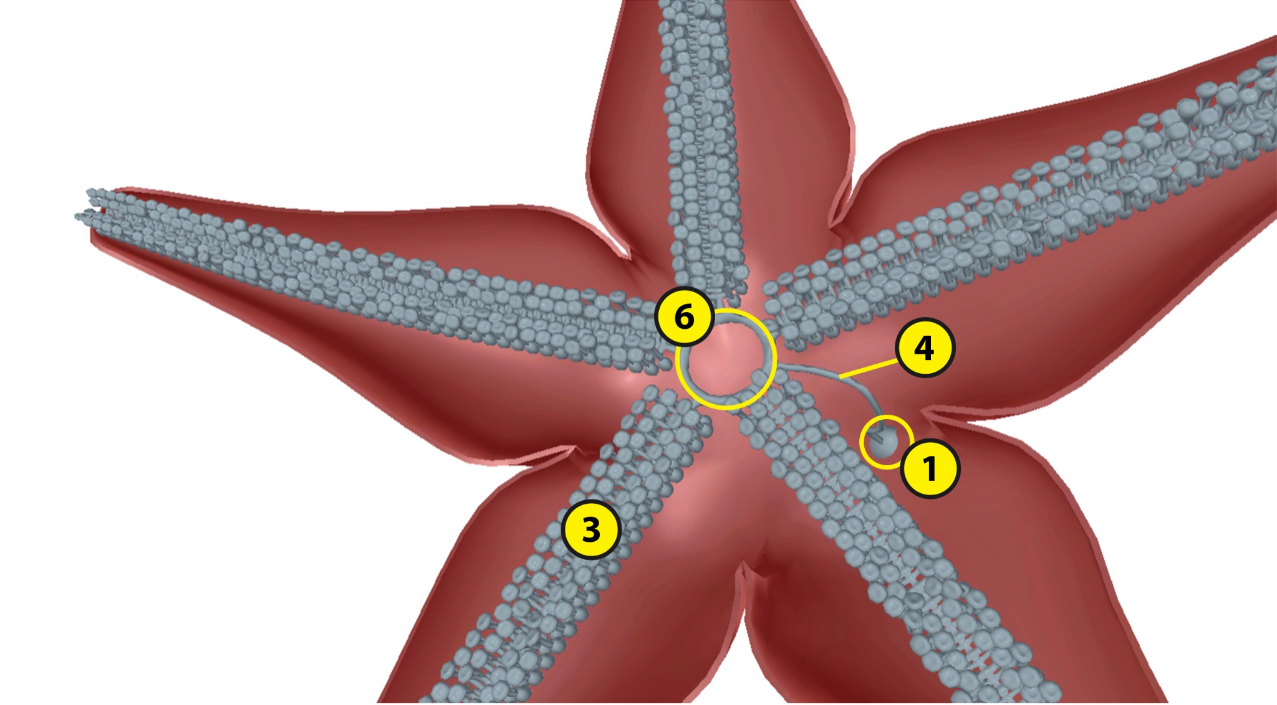
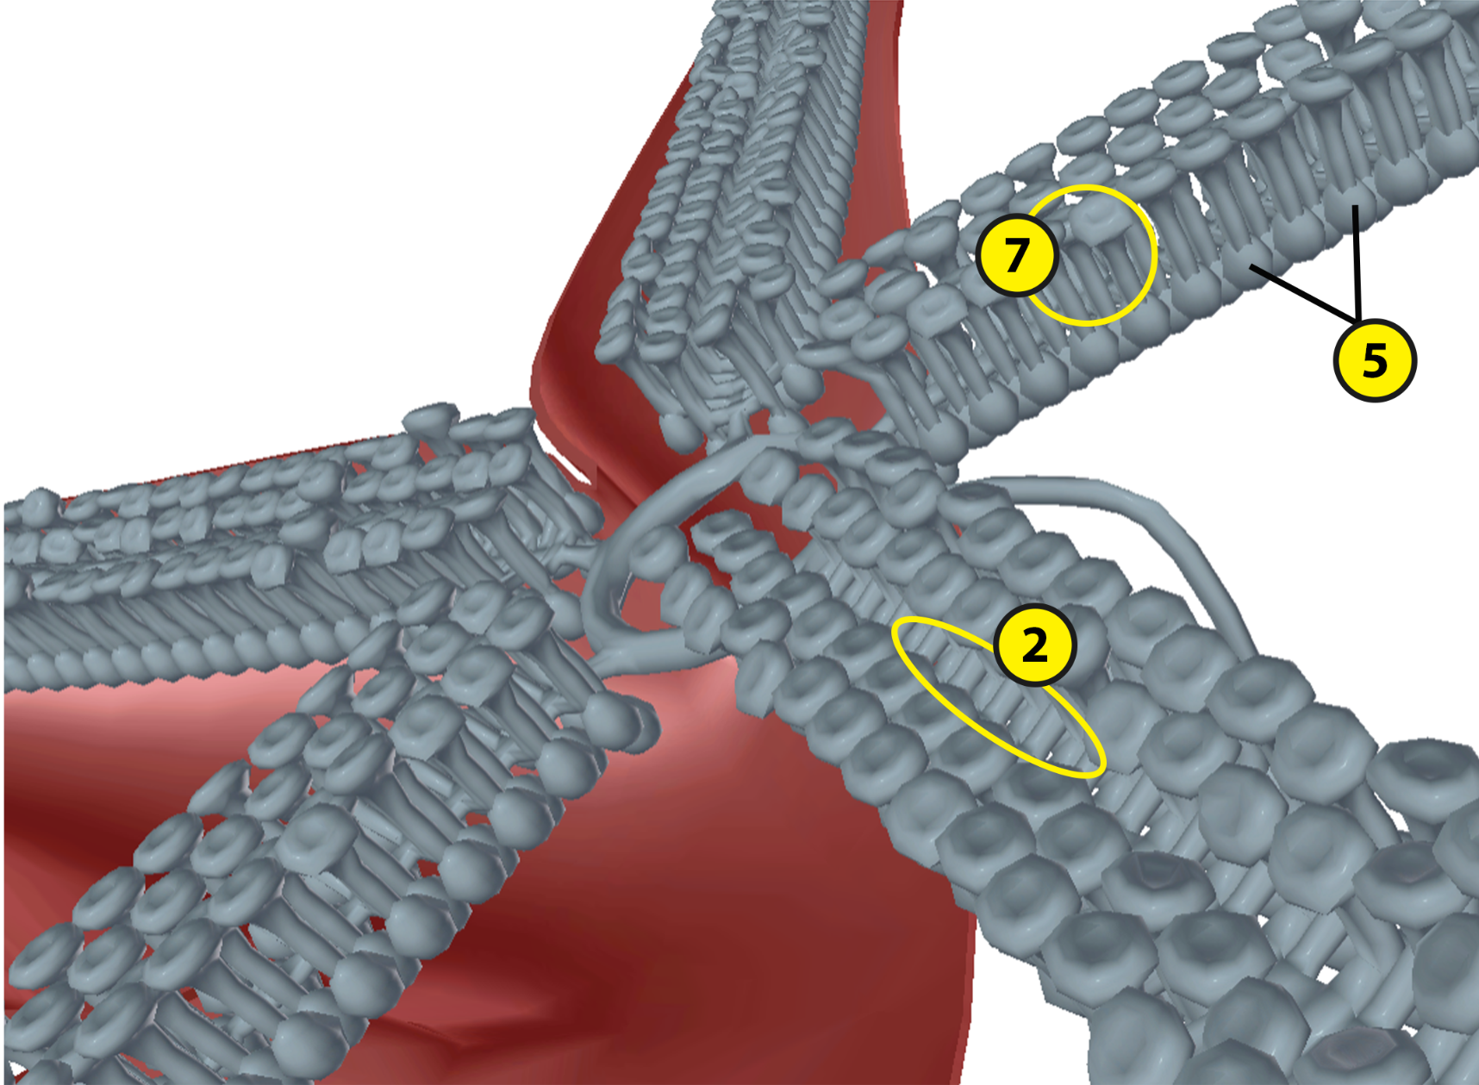

Name: Date:

Lab 1: Circulatory Structures

Activity 2: Label the earthworm’s circulatory structures

- Launch the view
  - Launch Visible Biology.
  - Navigate to Study/Lab Activities, and find the Evolution: Animal Diversity Lab section.
  - Select view 6. Earthworm, Circulatory.
- Label the image below
  - Explore the 3D model of the earthworm to find the structures you need to label.
  - Fill in the blanks to label the structures from the list below.
Word List:
Dorsal blood vessel
Hearts (aortic arches)
Ventral blood vessel

___
___
___

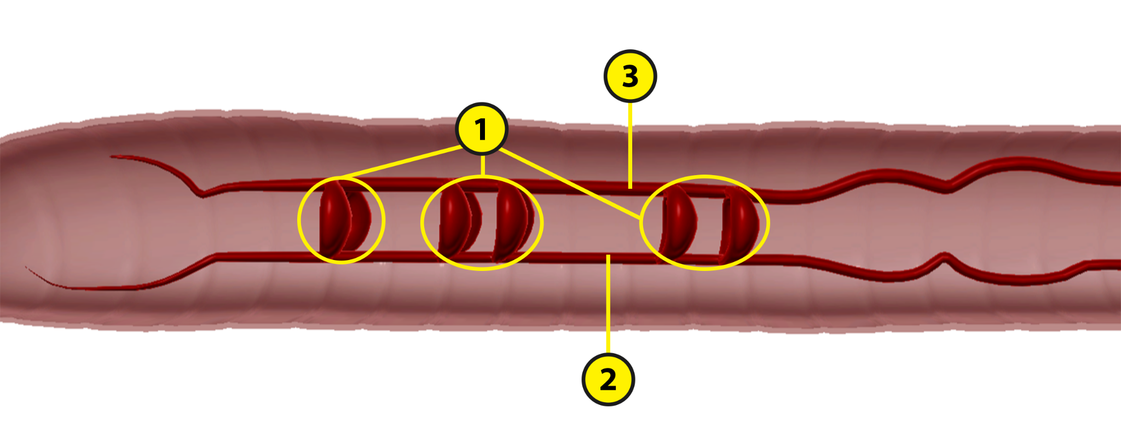

Name: Date:

Lab 1: Circulatory Structures

Activity 3: Label the frog’s circulatory structures

- Launch the view
  - Launch Visible Biology.
  - Navigate to Study/Lab Activities, and find the Evolution: Animal Diversity Lab section.
  - Select view 7. Frog, Circulatory.
- Label the image below
  - Explore the 3D model of the frog to find the structures you need to label.
  - Fill in the blanks to label the structures from the list below.
Word List:
Anterior vena cava
Aortic arches
Arteries
Dorsal aorta
Left atrium
Posterior vena cava
Pulmonary vessels
Right atrium
Spleen
Systemic arches
Veins
Ventricle

___
___
___
___
___
___
___
___
___
___
___
___

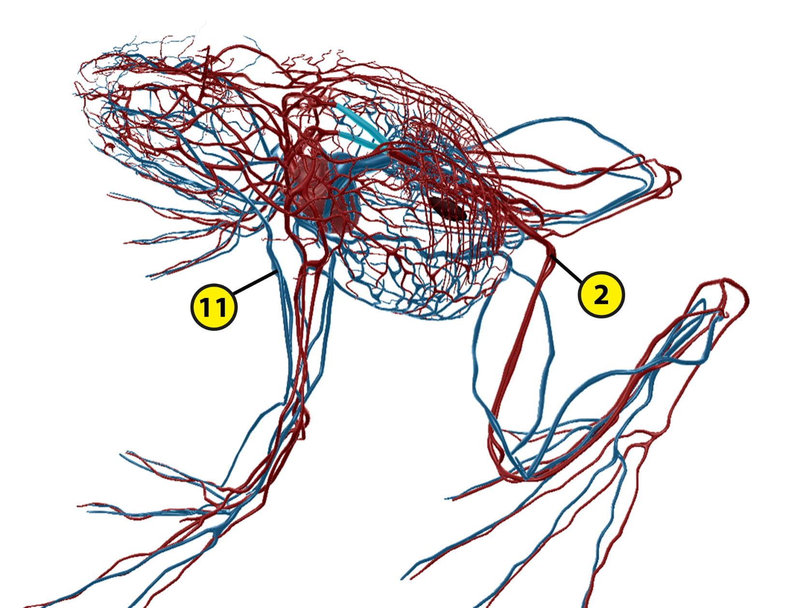

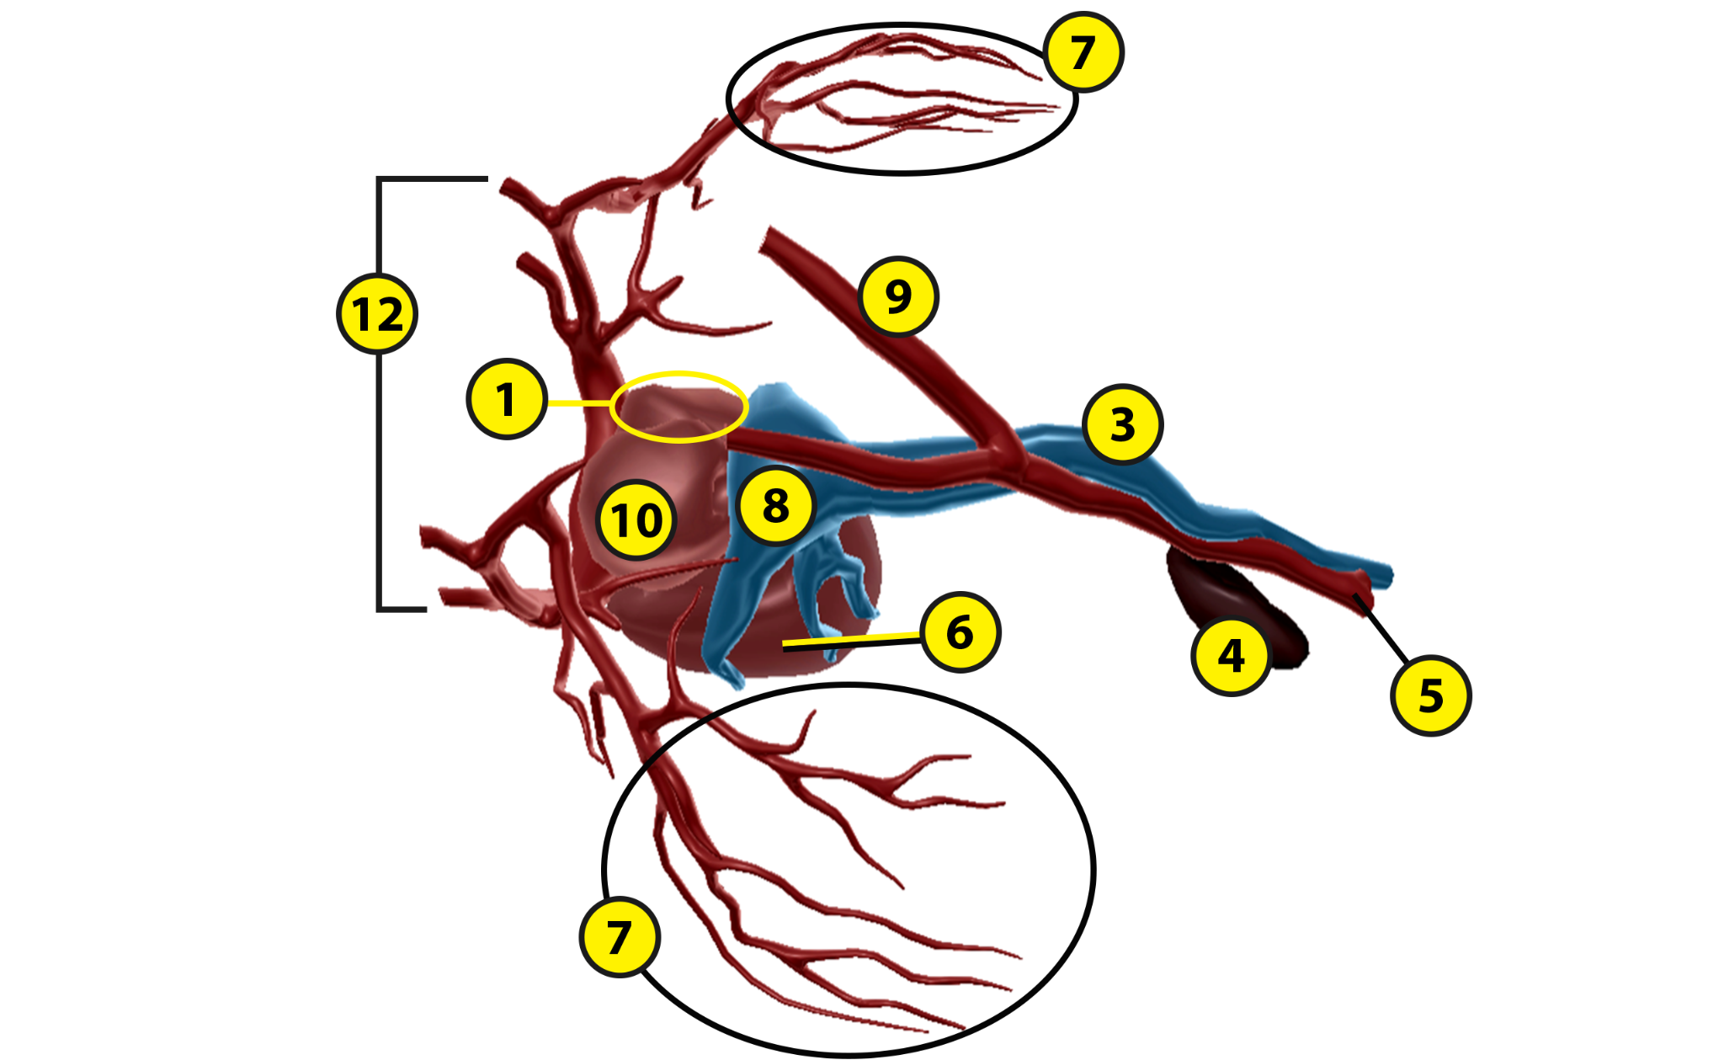

Name: Date:

Lab 1: Circulatory Structures

Activity 4: Label the pig’s circulatory structures

- Launch the view
  - Launch Visible Biology.
  - Navigate to Study/Lab Activities, and find the Evolution: Animal Diversity Lab section.
  - Select view 8. Pig, Circulatory.
- Label the image below
  - Explore the 3D model of the pig to find the structures you need to label.
  - Fill in the blanks to label the structures from the list below.
Word List:
Anterior vena cava
Aorta
Arteries
Coronary arteries
Descending aorta
Left and right atria
Left and right ventricles
Posterior vena cava
Pulmonary arteries
Pulmonary veins
Spleen
Veins

___
___
___
___
___
___
___
___
___
___
___
___

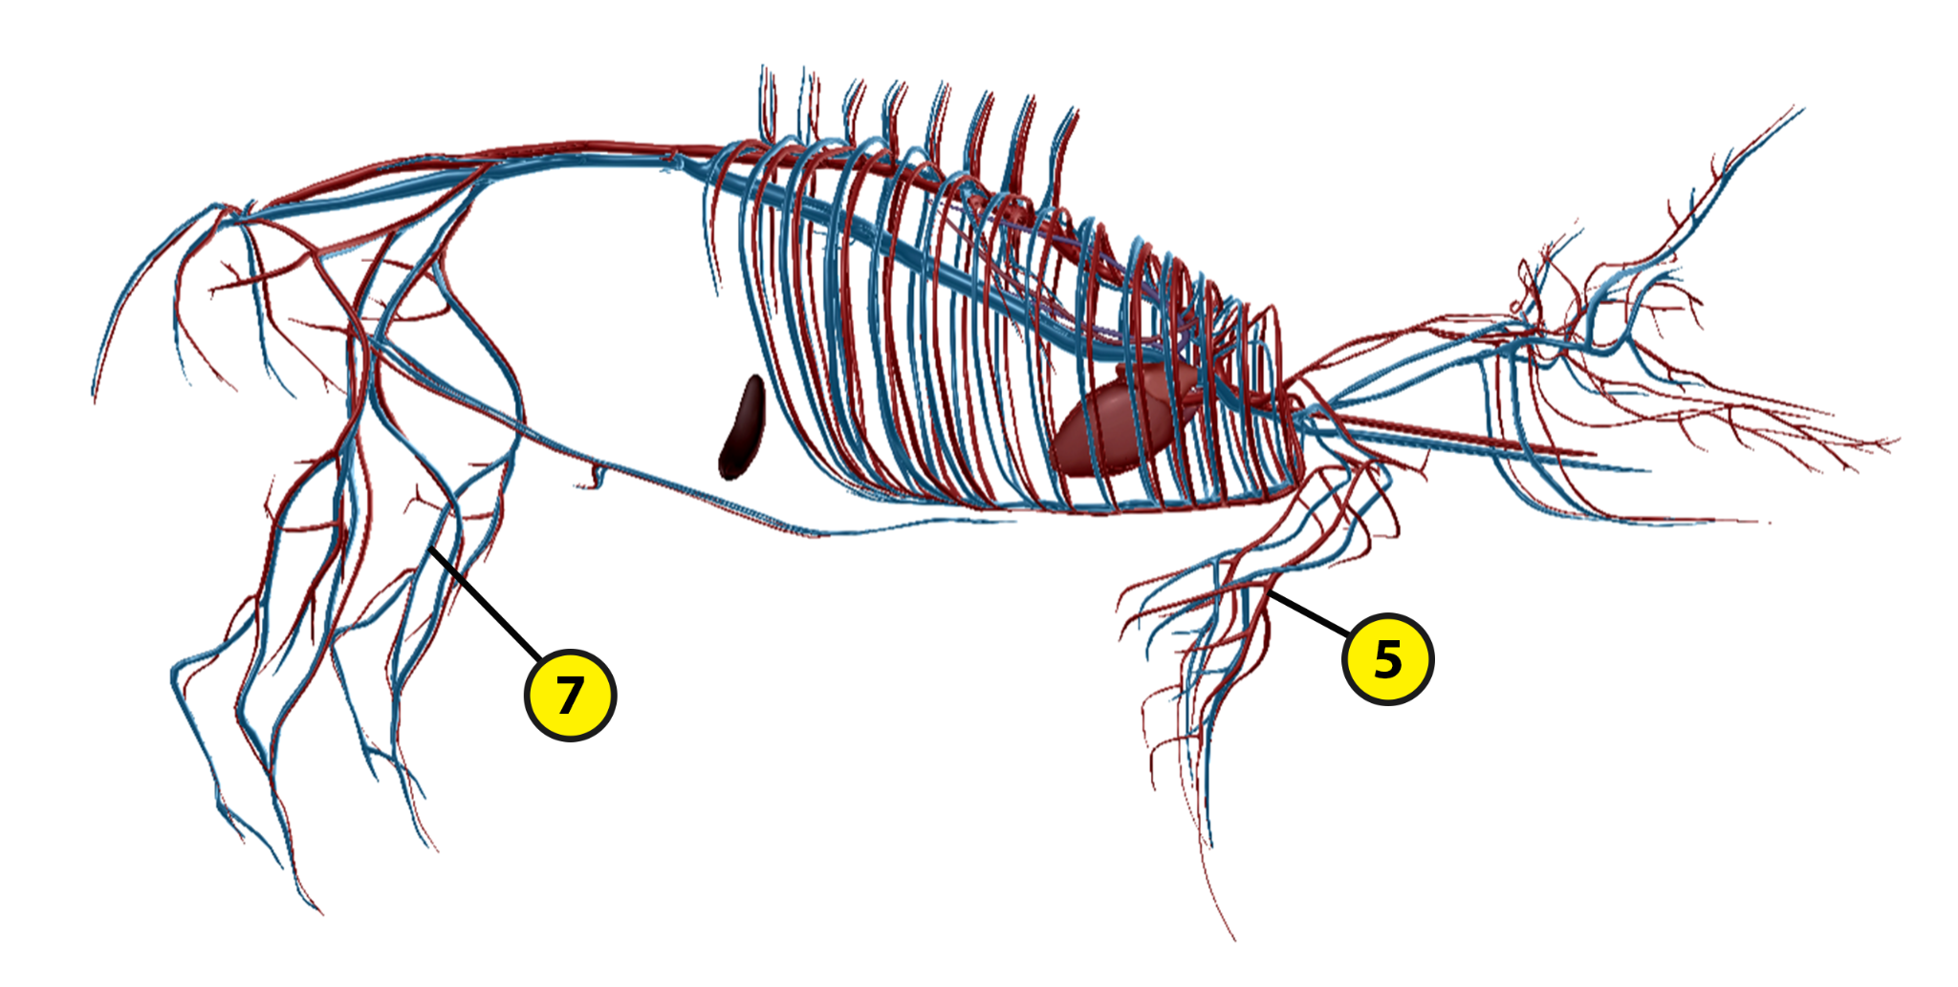
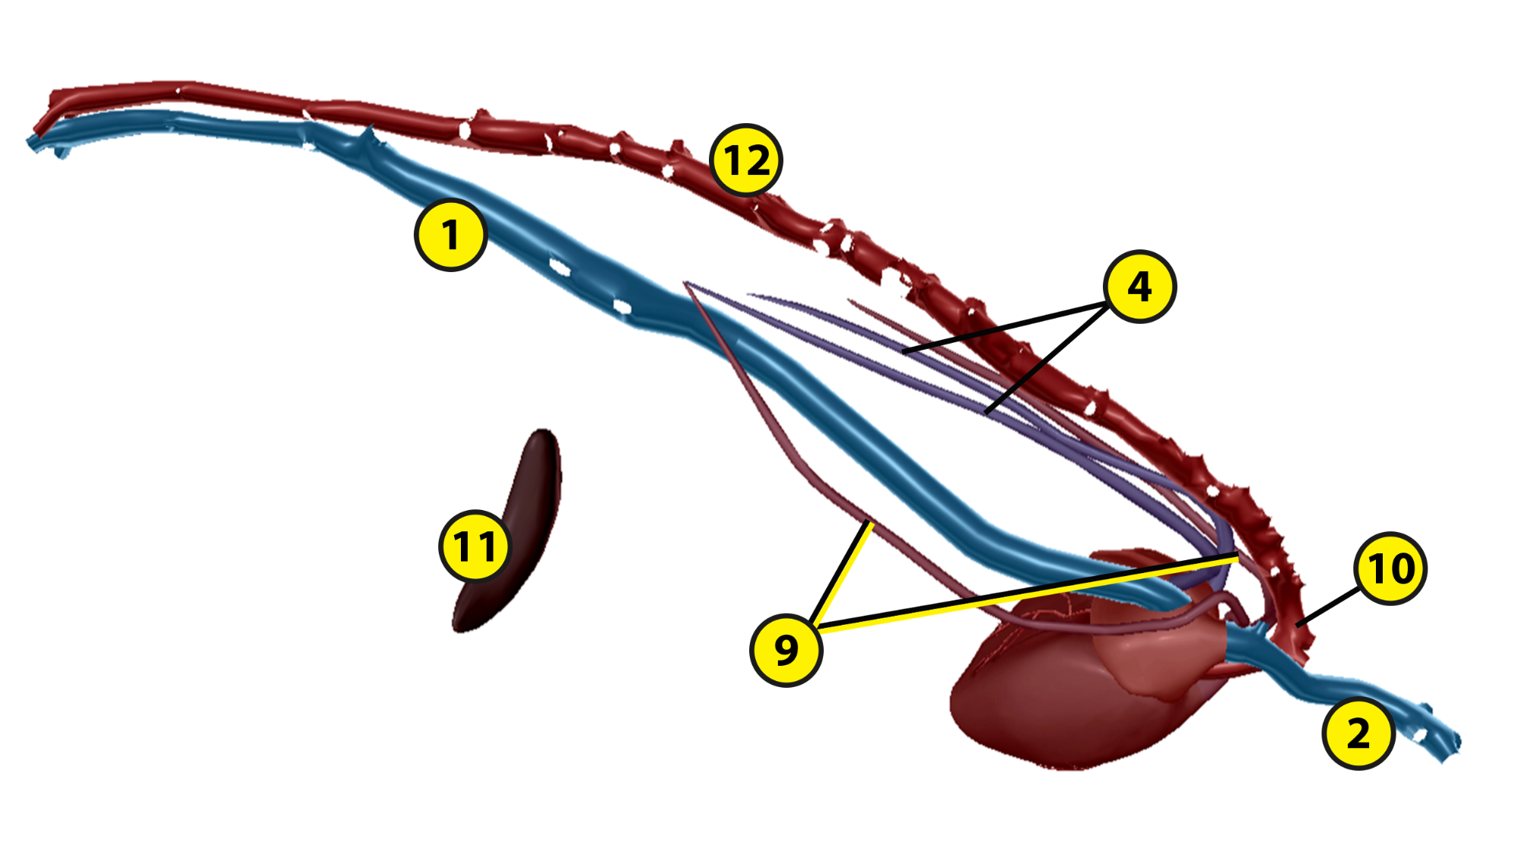
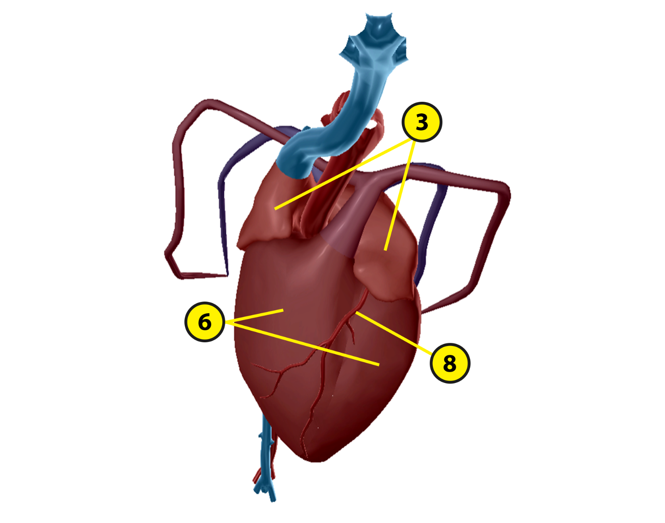

Name: Date:

Lab 2: Circulatory Functions

Activity 1: Explore the circulatory structures of the sea star and their functions

Refer to your labeled sea star images from Lab 1, Activity 1 and the content in Visible Biology. Based on what you’ve learned, match each of the following structures with the brief description of its function.

Structures:
- Ampullae
- Lateral canals
- Madreporite (sieve plate)
- Radial canals
- Ring canal
- Podia of tube feet
- Stone canal

Descriptions:
___ Water moves from the ring canal into these structures, which run down each arm and empty into the lateral canals.
___ Water moves from the madreporite into this structure on its way to the ring canal.
___ These structures are water-filled sacs connected to the podia and lateral canals.
___ This structure circles the sea star’s central disk and carries water to the radial canals.
___ Water moves from the radial canals into these structures, which empty into the ampullae.
___ These muscles project out of the sea star’s body on the oral surface to help it move.
___ This structure allows water to enter the sea star’s water vascular system.

Name: Date:

Lab 2: Circulatory Functions

Activity 2: Explore the circulatory structures of the earthworm and their functions

Refer to your labeled earthworm image from Lab 1, Activity 2 and the content in Visible Biology. Based on what you’ve learned, match each of the following structures with the brief description of its function.

Structures:
- Dorsal blood vessel
- Hearts (aortic arches)
- Ventral blood vessel

Descriptions:
___ These structures pump blood through the earthworm’s body.
___ This structure, located above the digestive tract, carries blood from the posterior end of the earthworm to the anterior end.
___ This structure, located below the digestive tract, carries blood from the anterior end of the earthworm to the posterior end.

Name: Date:

Lab 2: Circulatory Functions

Activity 3: Explore the circulatory structures of the frog and their functions

Refer to your labeled frog images from Lab 1, Activity 3 and the content in Visible Biology. Based on what you’ve learned, match each of the following structures with the brief description of its function.

Structures:
- Anterior vena cava
- Aortic arches
- Arteries
- Dorsal aorta
- Left atrium
- Posterior vena cava
- Pulmonary vessels
- Right atrium
- Spleen
- Systemic arches
- Veins
- Ventricle

Descriptions:
___ This structure pumps oxygenated blood from the lungs to the rest of the body.
___ This heart chamber receives deoxygenated blood from the veins.
___ These structures carry blood from the heart to the body tissues.
___ The ventricle pumps deoxygenated blood through these structures to the lungs.
___ Branching from the sinus venosus, this structure brings blood from the anterior end of the body to the heart.
___ This heart chamber pumps oxygenated blood through the aorta to the body.
___ Branching from the sinus venosus, this structure brings blood from the posterior end of the body to the heart.
___ This structure stores mature blood cells and cleans the blood by removing old red blood cells.
___ The truncus arteriosus divides into these structures, named by their locations within the circulatory system.
___ The dorsal aorta forms where these structures meet.
___ This heart chamber receives oxygenated blood from the lungs and skin.
___ These structures carry deoxygenated blood from the body tissues to the heart.
Name: Date:

Lab 2: Circulatory Functions

Activity 4: Explore the circulatory structures of the pig and their functions

Refer to your labeled pig images from Lab 1, Activity 4 and the content in Visible Biology. Based on what you’ve learned, match each of the following structures with the brief description of its function.

Structures:
- Anterior vena cava
- Aorta
- Arteries
- Coronary arteries
- Descending aorta
- Left atrium
- Left ventricle
- Posterior vena cava
- Pulmonary arteries
- Pulmonary veins
- Right atrium
- Right ventricle
- Spleen
- Veins

Descriptions:
___ This structure stores mature blood cells and cleans the blood by removing old red blood cells.
___This structure branches into smaller arteries that supply structures and tissues throughout the body.
___ These structures carry oxygenated blood from the lungs to the heart.
___ This structure carries deoxygenated blood from the anterior end of the body to the heart.
___ These structures carry deoxygenated blood from the body tissues to the heart.
___ These structures carry deoxygenated blood from the heart to the lungs.
___ This heart chamber pumps oxygenated blood out to the body.
___ This structure, the pig’s largest artery, carries oxygenated blood from the heart to the body.
___ This heart chamber receives deoxygenated blood from the anterior and posterior venae cavae.
___ These structures supply blood to the heart tissue.
___ This heart chamber pumps deoxygenated blood out to the lungs.
___ This structure carries deoxygenated blood from the posterior end of the body to the heart.
___ These structures carry blood from the heart to the body tissues.
___ This heart chamber receives oxygenated blood from the pulmonary veins.

Name: Date:

Lab 3: Evolutionary Similarities and Differences

Based on what you’ve learned about the circulatory structures of the sea star, earthworm, frog, and pig, answer the following questions about their evolutionary similarities and differences and the adaptations that help them survive in their environments.

- Most animals have a circulatory system that moves fluid, nutrients, and gases throughout the body. The earthworm, frog, and pig have some similarities in their circulatory structures and functions. In contrast, the sea star has a very unique circulatory system.
  - Each of the four animals has a system of vessels or canals that move fluid through the body. Earthworms, frogs, and pigs all circulate __________ through their circulatory vessels. Sea stars are unique because they have a __________ vascular system.
  - The earthworm, frog, and pig all have a __________ circulatory system, which means the blood stays contained in the blood vessels. In contrast, the sea star has an open circulatory system, which allows fluid to leak out of sinuses throughout the body.

- These animals also have some unique circulatory structures that distinguish them from each other.
  - Only two of these animals have arteries and veins, like humans do. Which ones are they?

  - What are the functions of the sea star’s tube feet and how does the water vascular system contribute to these functions?

  - How does blood get to each end of the earthworm’s body?

  - Earthworms, frogs, and pigs all have hearts that pump blood throughout their bodies. However, they have some key structural differences. In 3–5 sentences, describe how their hearts differ from each other.

- Match each of the following animals with one of its key circulatory adaptations.

Animals:
- Sea star
- Earthworm
- Frog
- Pig

Circulatory Adaptations:
___ This animal has a complex network of blood vessels that move blood between its three-chambered heart, lungs, and body tissues.
___ This animal circulates water through a series of canals to the tube feet to help it move through its environment.
___ This animal has a complex network of blood vessels that move blood between its four-chambered heart, lungs, and body tissues.
___ This animal pumps blood from its five hearts through two main vessels that supply the anterior and posterior ends of its body.

- Based on what you’ve learned by labeling the circulatory structures of these animals in Lab 1 and matching the structures with their functions in Lab 2, put these animals in order, from simplest to most complex (where 1 has the simplest circulatory structures and 4 has the most complex circulatory structures).
___ Frog
___ Sea star
___ Pig
___ Earthworm

