Student Name: Date:

Heart Zone Lab
Adapted from the American Heart Association
Last updated: 9/29/22

Introduction
During exercise, there is a high demand from your muscles to receive more oxygen. To keep up with the demand the heart beats faster to get more oxygen to power your activity. In this lab, you will observe how changes in your activity will either increase or decrease your heart rate. The number of times your heart beats while working at its maximum capacity is called your maximum heart rate. Your target heart rate is a healthy range that represents the number of times your heart should beat during physical activity.
To begin, calculate your maximum heart rate and target heart rate using the following equations:
- Maximum Heart Rate (MHR) = 220 − age _____
- Target Heart Rate Zone (THRZ) = 50% to 85% of maximum heart rate _____

Resources
- Stopwatch (or clock/watch with second hand)
- Pencil
- Student worksheet with graphs and discussion questions
- Visible Body Suite

Directions

Part 1: Activity
Count your heart beat and record it after each activity listed below. Between activities, you will remain seated for 3–5 minutes. The information will be used to plot a bar graph in the second part of this lab.

Physical Activities | Heart Rate
1. Sit in a chair, relaxed (3–5 minutes)
2. Stand, relaxed (3–5 minutes)
3. Walk at a leisurely pace for 3 minutes
4. Speed walk for 2 minutes
5. Jog in place for 2 minutes
6. Do 25 jumping jacks
7. Run in place for 1 minute

Part 2: Thought Questions
Review what you recorded in Part 1 and plot it on the graph provided below. Then answer the discussion questions.

Create your graph here:
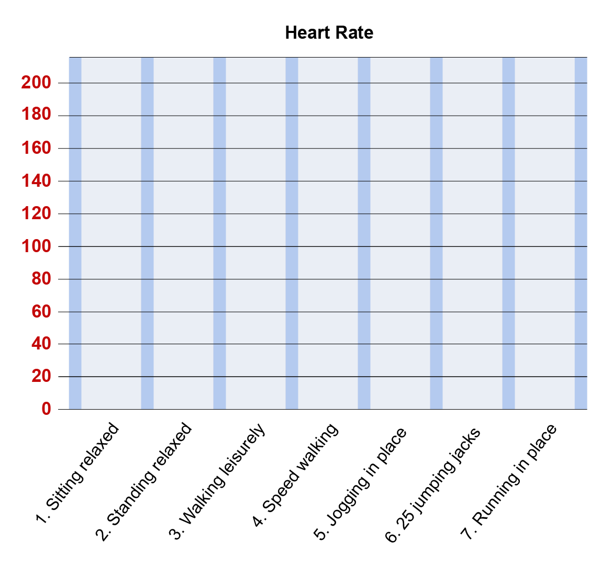

Answer the following questions:

- Go to Visible Body Suite and search for the My Heart Rate asset. Select the heart icon to input your heart rate at various levels of activity as graphed above.
  - Observe the visual differences when the heart rate slows, speeds up, and slows again. See your heart rate on the ECG. Look at the muscle working and hear the increased heartbeat. The heart beats faster to get more oxygen to power your activity. What observations did you make?

- When you look at your tracked heart rate data, what activity were you doing when your heart beat the fastest?

- During the recovery time after an activity, what happened to your heart rate?

- Describe how you felt physically during activity and at rest.

- Could you tell when your heart rate was increasing or decreasing?

- Could you tell when your heart rate was within your target heart rate zone?

- What activity were you doing?

- Could you tell when your heart rate was at or close to your maximum heart rate?

- What activity were you doing?

Bonus Question:
Why does your heart rate need to change with various levels of activity? What would happen if your heart rate did not change?

