Name: Date:

Rotator Cuff Tear Lab
Last updated: 10/17/22

Activity 1: Shoulder Anatomy and Function
- Launch Muscle Premium.
- Navigate to Pathologies, then find Rotator Cuff Tear under Shoulder.
- Under Related Content, select the first video, “Shoulder Anatomy and Function,” featuring a presentation by Lenny Macrina.
- Watch the video and answer the questions below in 1–2 sentences:

- The shoulder joint is formed by which two bones?
- Describe the amount of movement in the shoulder joint compared to other joints in the body.

- Name the two categories into which the anatomy of the shoulder joint can be classified.

- Name three static stabilizers for the shoulder and explain the overall function of this group of tissues.

- Dynamic stabilizers consist of muscles that surround the joint and contract to produce movement. One group of these muscles is called the rotator cuff. They compress the head of the humerus into the glenoid fossa and stabilize movements in all directions. Name the four muscles of the rotator cuff.

- What is the overall purpose of the rotator cuff muscles?
Name: Date:

Rotator Cuff Tear Lab

Activity 2: Rotator Cuff Anatomy and Function
- Launch Muscle Premium.
- Navigate to Pathologies, then find Rotator Cuff Tear under Shoulder.
- Using the right arrow, navigate to slide 3 of 3 entitled “Normal Anatomy.”
- In the view, select each muscle and bone to learn its name.Then, identify the structures indicated by each letter on the image below, and fill in their names in the corresponding spaces beneath the image.

Posterior view of the right shoulder
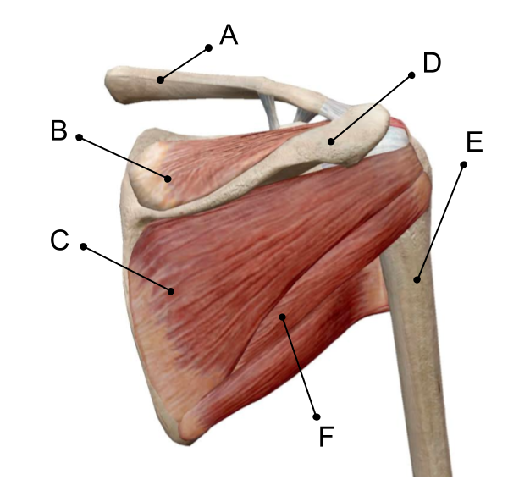

Anterior view of the right shoulder
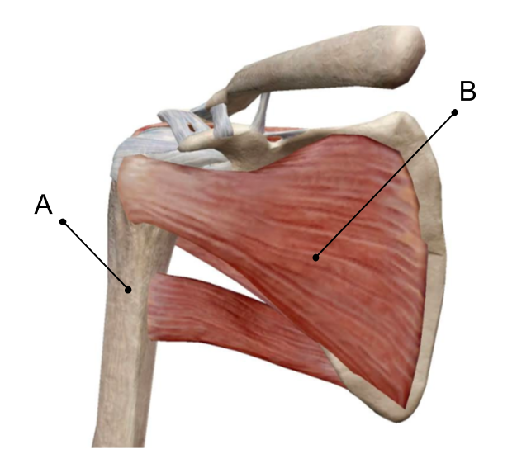

- Select each muscle, then select the icon to learn their actions. List their actions in the table below.

Rotator Cuff Muscle | Action
Supraspinatus
Infraspinatus
Teres minor
Subscapularis

Name: Date:

Rotator Cuff Tear Lab

Activity 3: Rotator Cuff Tear

Part 1: Rotator Cuff Pathology
- Launch Muscle Premium.
- Navigate to Pathologies, then find Rotator Cuff Tear under Shoulder.
- Select theicon and read the description of rotator cuff tears. Then answer the following questions in 1–2 sentences.

- Gradual degeneration or a sudden traumatic event can tear what structures of the rotator cuff?
- What are the symptoms of this injury?

- Where is the common location of rotator cuff tears?

- Tears are usually categorized in two ways. Explain the two categories.

- Which muscle of the rotator cuff is most commonly torn?

Part 2: Partial Tear of the Supraspinatus
- Navigate to Pathologies, then find Rotator Cuff Tear under Shoulder.
- Using the right arrow, navigate to slide 2 of 3 entitled “Partially Torn Supraspinatus.”

- Note the tear in the tendon of the supraspinatus. Describe the location and type of the tear in 1–2 sentences.

- Select the icon to learn more about the partially torn supraspinatus. In 1–2 sentences, describe the normal function of the supraspinatus.
- The supraspinatus tendon can begin to fray from overuse, poor posture, or the wear and tear of aging. It can also fray due to excessive strain. Based on what you’ve read, list two examples of actions that may involve excessive strain and cause a tear.

- Fill in the blanks: A traumatic event such as __________ can also cause tears of the supraspinatus tendon. Fraying and degenerative tears can also be caused by chronic __________.

