Name: Date:

Planes and Positions Lab
Last updated: 10/17/22

Activity 1: Overview of Planes and Positions

Resources
- Visible Body Muscles Premium app
- Visible Body Planes and Positions eBook: https://www.visiblebody.com/hubfs/Assets%20for%20Workflows/MP%20workflow/VisibleBody_Planes%20and%20Positions_071917.pdf

Part 1: Anatomical Position

- The model above is standing in anatomical position. Using the Visible Body Planes and Positions eBook as a reference, in 1–2 sentences describe the features of anatomical position.

- In 1–2 sentences, explain why anatomical position is used as a common point of reference.

Part 2: Anatomical Planes
- Review the different anatomical planes using the Visible Body Planes and Positions eBook. Using the knowledge you’ve gained on anatomical planes, match the following terms to the appropriate description:

____ Sagittal
____ Midsagittal
____ Coronal
____ Axial

- Divides the body into a front and back
- Divides the body into a top and bottom
- Divides the body vertically into equal right and left sides
- Divides the body vertically into right and left sides

- From what you learned above, label the images below as axial, coronal, or sagittal.
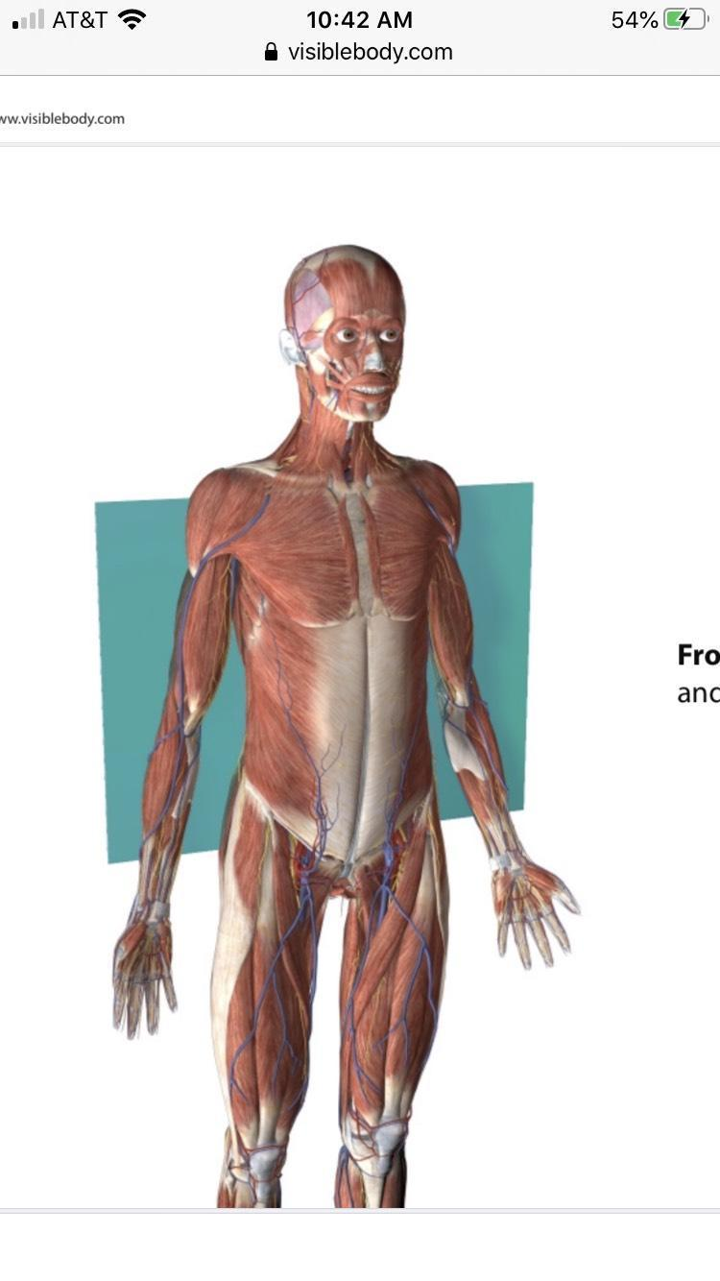
- ________

- ________
- ________

Name: Date:

Planes and Positions Lab

Activity 2: Directional Terms

Part 1: Terms of Relationship
- Launch Muscle Premium.
- Navigate to Normal Anatomy, under Pelvis, select 2. Pelvis. Explore the structures and use the model as a reference to complete the activity below.
- Tip: Not sure where these muscles are? Select "anatomy search" at the bottom of your screen and type in the muscle. Then select "show me."
- Using your knowledge on directional terms, circle or make bold and red the correct answer that completes each sentence.

- The superior gemellus is (superior/inferior) to the obturator externus.

- The quadratus femoris is (anterior/posterior) to the obturator externus.

- The coccyx is (inferior/superior) to the sacrum.

- The pubic symphysis is (medial/lateral) to the inguinal ligament.

- In the app, navigate to Normal Anatomy, under Lower limbs select 7. Dorsiflexion.
- Explore the ligaments that support and stabilize the ankle joint. Use the model as a reference to answer the following questions.
- Using the knowledge gained on anatomical terms, fill in each sentence with the directional term that completes the sentence.

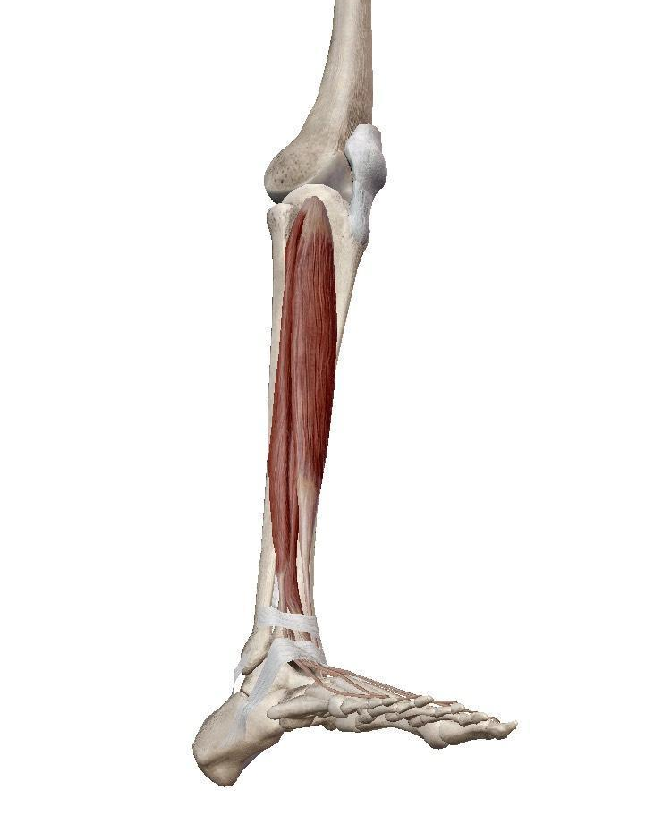

- The flexor retinaculum is __________ to the superior peroneal retinaculum.

- The superior extensor retinaculum is __________ to the inferior extensor retinaculum.

- The inferior peroneal retinaculum is __________ to inferior extensor retinaculum.

Part 2: Supine vs Prone
- Review the supine and prone positions using the Visible Body eBook. Based on what you have learned, answer the following clinical correlation questions.

- A patient comes to you complaining of pain in the lower back. You decide to palpate the problematic area and instruct the patient to lay prone on the exam table. When the patient asks you what prone means, how do you respond?

- You are in the gross anatomy lab preparing to dissect the pectoral region. Should you have the cadaver in a prone or supine position?

