Name: Date:

ACL Tear Lab
Last updated: 10/17/22

Activity 1: Knee Anatomy

Part 1: Knee Anatomy Basics
- Launch Muscle Premium.
- Navigate to Pathologies, then find Partially Torn ACL under Lower Limbs.
- Using the right arrow, navigate to slide 2 of 2 entitled “Normal Anatomy.” Under Related Content, select the third video, “Knee Anatomy,” featuring a presentation by Joaquin Barrios.
- Watch the video and answer the questions below:

- The knee joint complex consists of three bones. Please name them:

Fill in the blanks for the following questions:
- The two joints of the knee complex are the __________ and the __________.

- The meniscus is joined by other passive, non-contractile structures to provide stability to the knee. These include the joint capsule, the __________, the posterior cruciate ligament, the medial collateral ligament, and the lateral collateral ligament.

- The wedge-shaped meniscus accommodates the shape of the __________ and enhances the stability of the knee.

Part 2: Visualize the Anatomy of the Knee
- Navigate to Pathologies, then find Partially Torn ACL under Lower Limbs.
- Using the right arrow, navigate to slide 2 of 2 entitled “Normal Anatomy.”

- In the view, select each structure to learn its name. Then, identify the structures indicated by each letter on the image below, and fill in their names in the corresponding spaces beneath the image.

Anterior view of the right knee
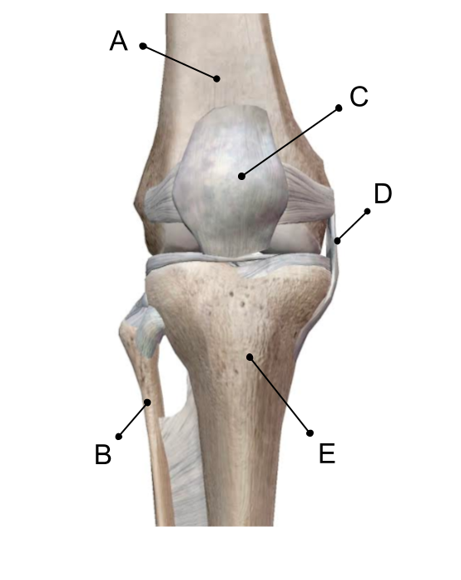

- Select the patella and then select “Hide” to hide it. Repeat this process with the lateral patellofemoral ligament and the medial patellofemoral ligament. (These are the ligaments on the lateral and medial sides of the patella.) You now will be able to see into the knee joint.

- Now, select each structure to learn its name. Then, identify the structures indicated by each letter on the image below, and fill in their names in the corresponding spaces beneath the image.

Anterior view of the right knee with patella hidden
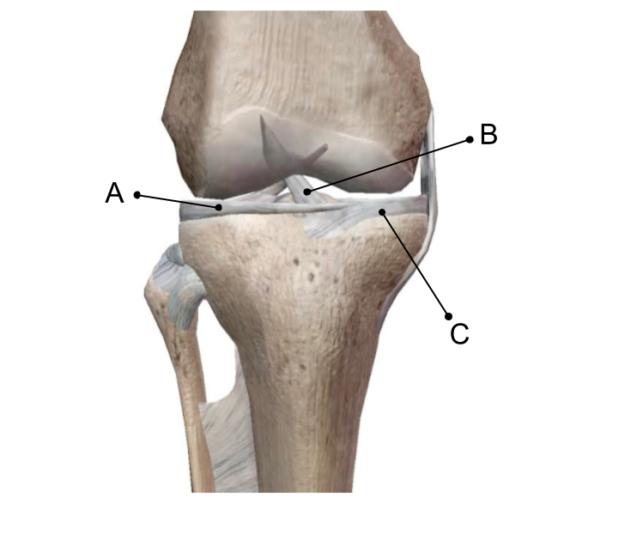

- Select the anterior cruciate ligament (ACL), then select the icon to learn about this structure. The cruciate ligaments (anterior and posterior) are situated in the middle of the joint. In 1–2 sentences, describe what the name “cruciate” means and why the word is used in naming the ACL.

- In the app, rotate the knee joint to view it from the posterior side. Select each structure to learn its name. Then, identify the structures indicated by each letter on the image below, and fill in their names in the corresponding spaces beneath the image.

Posterior view of the right knee
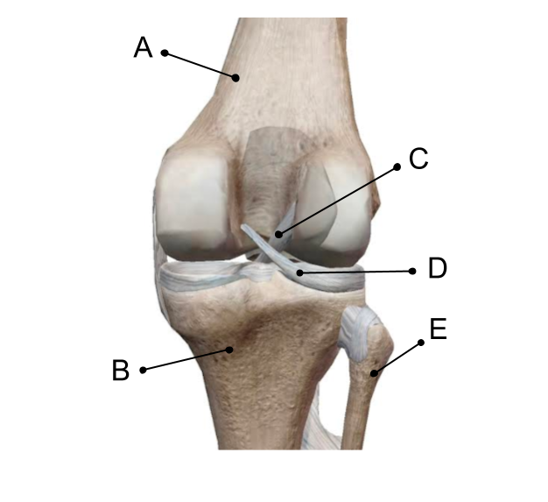

Name: Date:

ACL Tear Lab

Activity 2: ACL Tear

Part 1: Visualize a Partially Torn ACL
- Launch Muscle Premium.
- Navigate to Pathologies, then find Partially Torn ACL under Lower Limbs.
Select the partially torn anterior cruciate ligament (ACL), then select the icon to learn about the ACL and the associated injury. Then answer the following questions.

- Which two bones does the ACL attach to?

- When the ACL sustains a force that exceeds the strength of the ligament, what can result?

- Return to the Pathologies section, then navigate to Knee Sprain under Lower Limbs. Select theicon and read the description of the different grades of ligament tears. Then, go back to Partially Torn ACL and observe the view. What grade would you classify the tear showing in Partial Torn ACL?

Part 2: ACL Function
- Navigate to Pathologies, then find 4. Partial ACL Tear under Lower Limbs.
- Using the right arrow, navigate to slide 2 of 2 entitled “Normal Anatomy.” Under Related Content, select the first video, “Knee Anatomy,” featuring a presentation by Joaquin Barrios.
- Begin the video at 1:00. Answer the following questions in 1–2 sentences.

- What is the function of the ACL in the aspect of the sagittal plane?

- After seeing the sagittal plane stability of the ACL, list mechanisms that could cause the ACL to tear in the sagittal plane.

