Name: Date:

Planes and Positions Lab
Last updated: 6/15/2023

Activity 1: Overview of Planes and Positions

Part 1: Anatomical Position
- Open Visible Body Suite.
- Search for and select the Muscular System View "Muscular System View."

- In the image above, the model is standing in anatomical position. Using the Visible Body Planes and Positions ebook as a reference, in 1–2 sentences, describe the features of anatomical position.

Part 2: Anatomical Planes
- Visible Body Suite includes Cross Section views. Radiological cross sections, such as MRI and CT scans, are two-dimensional images through gross anatomy structures that allow us to see the insides of those structures. They are obtained to help diagnose and treat patients.
- Search for "axial" and select each of the Head cross sections. Note that in the Cross Section "Head (Orbit)," the cut is made in a transverse plane above the eyes and after the section is flipped, you are looking at the underside of the eyes.
- Search for "coronal" and select each of the Head cross sections. Note that in the Cross Section "Head (Orbit)," the cut is made in a vertical direction behind the eyes. Once the front section of the face is removed, you see an outline of the eyes, nose, and mouth, as if the model were looking at you.
- Search for "sagittal" and review the first two Head cross sections. Note that in the Cross Section "Head (Orbit)," only one hemisphere of the brain is seen. Therefore, the cut must have been in a vertical plane through the middle of the head.

- Using the Visible Body Planes and Positions ebook as a reference, in 1–2 sentences, define the term "anatomical planes."

- Using the information learned in this activity, match the following terms to the appropriate description:
____ Sagittal
____ Midsagittal
____ Coronal
____ Axial

- Divides the body into a front and back
- Divides the body into a top and bottom
- Divides the body vertically into equal right and left sides
- Divides the body vertically into right and left sides

- From what you learned above, label the images below as axial, coronal, or sagittal.
- ________

- ________

- ________

Name: Date:

Planes and Positions Lab

Activity 2: Overview of Directional Terms

Part 1: Directional Terms
- Review directional terms using the Visible Body Planes and Positions ebook.
- Open Visible Body Suite.
- Search for and select the Muscular System View "Knee." Explore the view and select the structures to learn their names.
- Tip: Not sure where these muscles are? Select "anatomy search" at the bottom of your screen and type in the muscle. Then select "show me."
- Using your knowledge on directional terms, circle or make bold and red the correct answer that completes each sentence.

- The vastus intermedius is (superficial/deep) to the rectus femoris.

- The tibialis anterior is (medial/lateral) to the tibia.

- The gastrocnemius is (superficial/deep) to the soleus.

- The knee is (proximal/distal) to the hip.

- The vastus lateralis is (ventral/dorsal) to the semitendinosus.

- The extensor digitorum longus is (inferior/superior) to the tensor fascia lata.

- Search for and select the Gross Anatomy Lab View "Intraperitoneal Organs."
- Explore the view and select the structures to learn their names. Use the model as a reference to answer the following questions.
- Using the knowledge you’ve gained for directional terms, fill in each sentence with the directional term that completes the sentence.

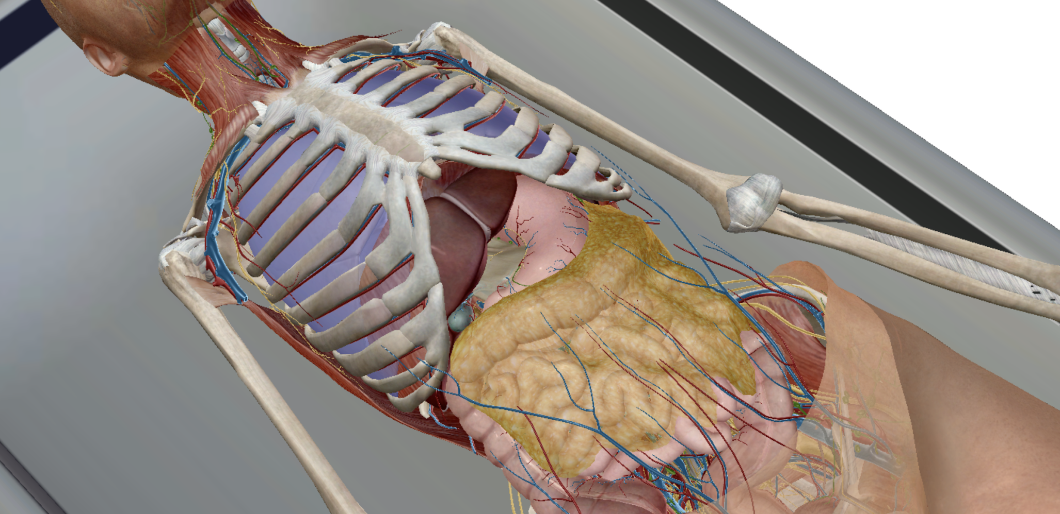

- The greater omentum is __________ to the small intestine.

- The ascending colon is __________ to the small intestine.

- The ileum is __________ to the transverse colon.

- The descending colon is __________ to the sigmoid colon.

Part 2: Supine vs Prone
- Search for and select the Gross Anatomy View "Abdomen." In the settings menu, make sure the sex is set to female. Explore the view by selecting supine and prone to change the position of the model.

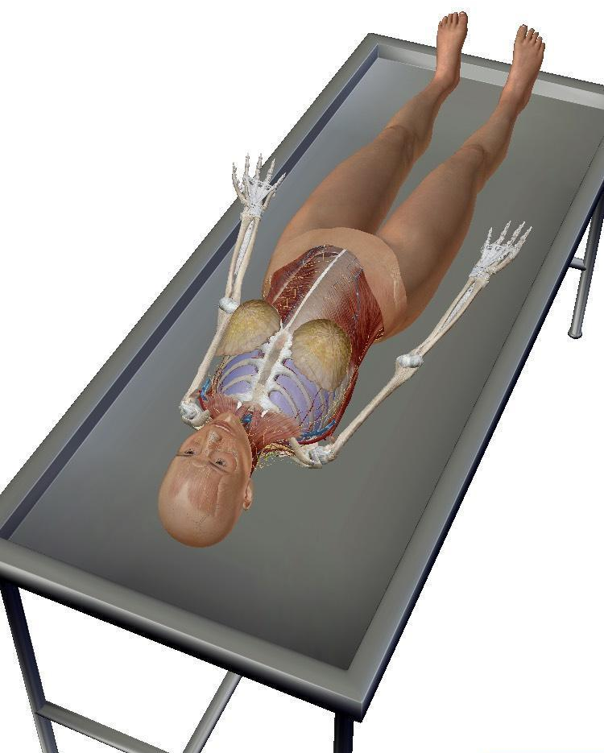

- In the image above, is the body lying supine or prone?

- In 1–2 sentences, compare and contrast supine and prone.

