Name: Date:

Integumentary System Lab
Last updated: 6/15/2023

Activity 1: Skin Overview

Part 1: Skin Overview
- Open Visible Body Suite.
- Search for and select the Animation "Function of the Skin."
- Watch the animation and answer the following questions.

- List the functions of the integumentary system.

- Homeostasis is the process by which a healthy internal bodily state is maintained through physiological regulation. In 1–2 sentences, explain how the skin is involved in homeostasis.

- All skin tissue is composed of three main layers. Name the three layers of skin from superficial to deep.

Part 2: Touch
- Open the Integumentary System View "Touch Receptors." Explore the touch receptors found in the dermis and epidermis. Select the structures to learn their names and functions.

- Using the information learned in this activity, match the following terms to their respective function:

____ Tactile (Merkel) epithelial cells
____ Tactile (Meissner’s) corpuscles
____ Free nerve endings
____ Lamellar (Pacinian) corpuscles

a. Detect pain, temperature, itch, and tickle
b. Transmit signals related to touch and vibration
c. Transmit signals related to touch
d. Detect light touch, pressure, and vibration

Part 3: Melanin and Melanocytes
- Open the Integumentary System View "Skin (Dark Pigmentation)." Explore melanocytes by reading their definition to learn how melanin and melanocytes are related.

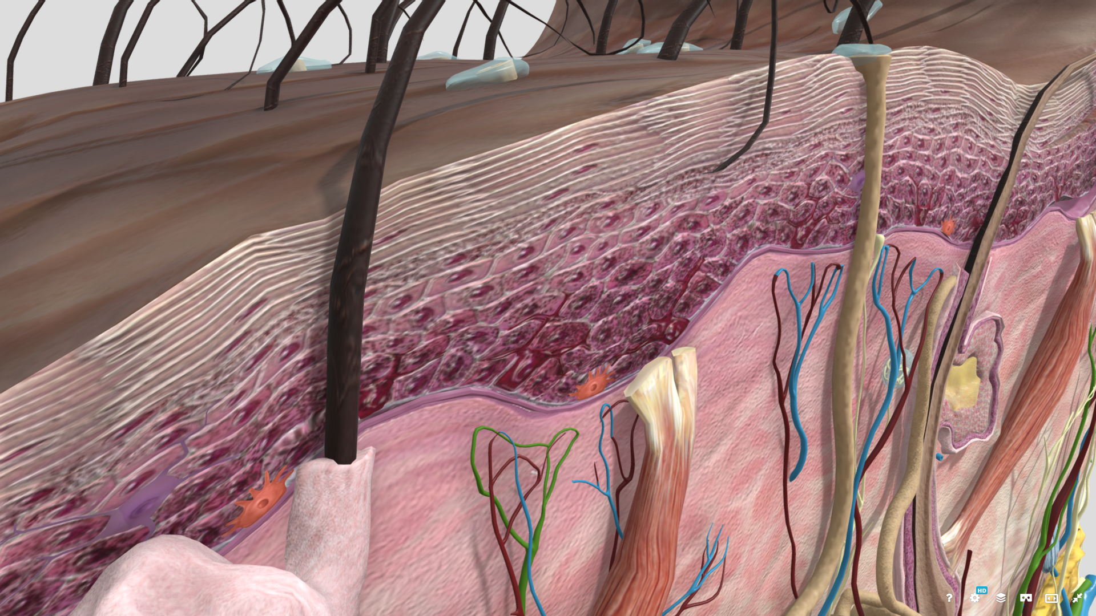

- In 1–2 sentences, describe the role of melanocytes.

- In 1–2 sentences, compare the melanocytes of individuals with darker skin to the melanocytes of individuals with lighter skin.

Activity 2: Hair Overview

Part 1: Hair Overview
- Open the Integumentary System View "Hair Follicle (Curly Hair)" and select any part of the hair follicle. Click the drop down arrow next to the structure name and you should now see the structure "Hair." Click on "Hair" and read the structure definition.

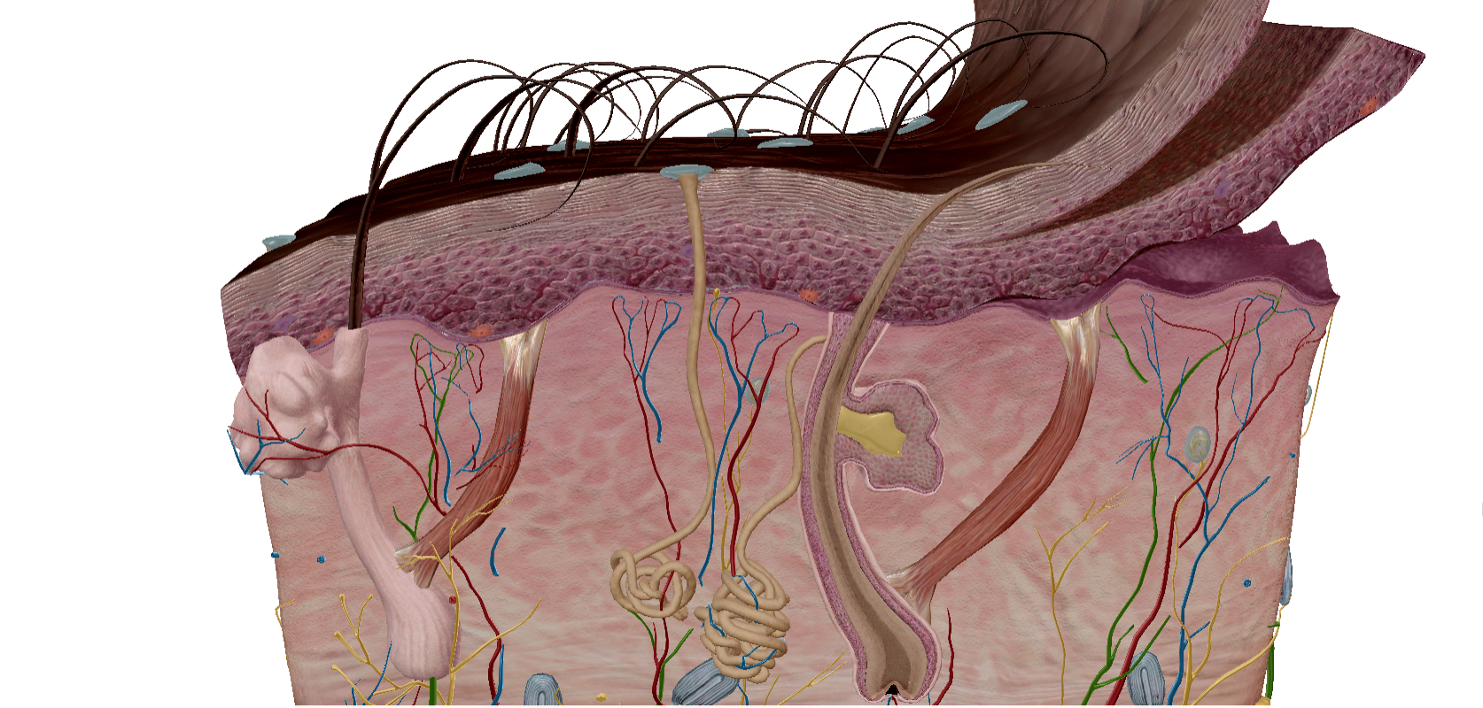

- List the functions of hair.

- Remember that homeostasis is the process by which a healthy internal bodily state is maintained through physiological regulation. In 1–2 sentences, explain how hair is involved in homeostasis.

Part 2: Curly Hair vs Straight Hair
- Open the Integumentary System View "Hair Follicle (Curly Hair)." Explore the structures to learn their names and functions.
- Open the Integumentary System View "Hair Follicle (Straight Hair)." Explore the structures to learn their names and functions.
- Use what you have learned in those two models to answer the following question.

- In 2–3 sentences, describe some of the factors that influence the appearance of hair in straight hair vs. curly hair.

